**Campus Dining Services**

at

**Oberlin College**



&

Student Employee Handbook

|  |
| --- |
|  |
|  |
|  |
|  |
|  |
|  |
|  |
|  |
|  |
|  |
|  |
|  |
|  |
|  |
|  |
|  |
|  |
|  |
|  |
|  |
|  |
|  |
|  |

Notes:

**WELCOME TO**

**CAMPUS DINING SERVICES**

This handbook has been established to inform you of our standards and policies. If you feel that you need information beyond the scope of this handbook, please contact your building manager, come to the CDS office in Stevenson, or call the Student Coordinator at (440) 775-8101 to discuss your concerns/questions.

We strive to maintain customer satisfaction and to create an atmosphere for student employee satisfaction; therefore, the following standards and objectives have been established:

* To maintain a high standard in food presentation, customer satisfaction, and facility cleanliness.
* To establish a productive and strong service team.
* To provide a good working environment through acting fairly, honestly, and ethically with our employees.
* To offer the opportunity for employee development and empowerment of job responsibilities and accomplishments.

The most important part of your job is to provide excellent service to our customers, your fellow students, faculty, and staff.

Each time you make contact with a diner, you are involved in a “**moment of truth**”.

How well you handle that momentoftruth determines how the customer feels about you, the service you give, and the organization for which you work. The many “moments of truth” add up to create our ***service image*** in the eyes of our diners. We want that image to be the best it can be. It is our goal to create a positive service image for our diners and a positive experience for our employees. Try to send each diner off feeling good about having been in contact with you. We hope the satisfaction of a job well done will make you to feel good about yourself.



Campus Dining Services

155 North Professor Street, Room 109

Stevenson Building, Griswold 1st Floor

(440) 775-8101

[cdsjobs@oberlin.edu](mailto:cdsjobs@oberlin.edu)

Wayne Wood, General Manager

Kathy Mueller, Office Manager

Tiwauna Daniels, Student Employment Assistant

**Management**



Most CDS facilities have a management team, all of them participating in the daily operation and success of their dining facility. All members of the management team are there to provide training, supervision, support, and direction of your work. You are expected and required to cooperate with all members of management. You can expect the managers to work cooperatively and communicate effectively with one another so that you need only contact one manager in communicating attendance issues, addressing policies and procedures, and discussing concerns or problems you may have.

CDS is also staffed by full and part time non-student employees. These employees are knowledgeable in the work they do for CDS and in food service in general. You must consider them your supervisors and cooperate in the instructions you are given. They will also be a valuable resource to you in learning what you need to know to be a quality food service employee.

**Student Managers**

During some shifts you work for CDS, you may report to a student manager. These students have worked at least one full semester for CDS, have shown leadership qualities, and have taken an interest in learning more about the student positions in CDS (and have worked multiple positions). These students earn a slightly higher wage and are given more responsibility during their shifts as student manager.

The role of the student manager is to help the facility manager keep an eye on all the different areas that work together to make each meal a pleasant experience for every customer. Some of the tasks that a student manager might perform include:

* 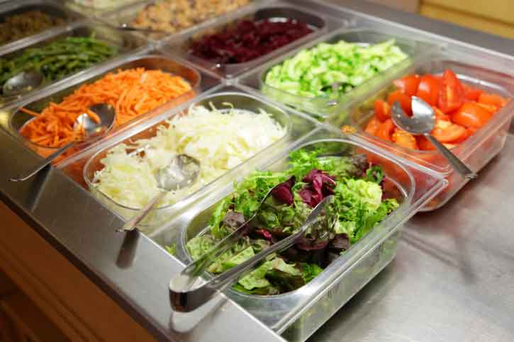Instructing student employees to fill items on a salad bar, dessert bar, or other area of the dining hall or event
* Reminding student employees of dress code, and referring the student employee to the manager if there is refusal to comply
* Informing student employees that it’s time for a break
* Retrieving student employees from breaks, especially if they’ve been gone too long

Some things student managers are *not* permitted to do:

* Give student employees permission to leave the building/event
* Authorize extra food or additional meals for student employees
* Give permission for anyone to leave a shift early or come in late

Student managers are chosen by a process that includes facility managers’ observation and recommendation, attendance record, and other factors. There is no application process for this role.

**Employee Rights**

Campus Dining Services is committed to treating all employees with respect and fairness. To demonstrate CDS’s commitment, it guarantees the right of every student employee:

* To voice a complaint or concern.
* To be heard in an atmosphere of respect and cooperation.
* To have the complaint acknowledged by a member of management in a timely manner.
* To have the complaint acknowledge by successively higher levels of management or school officials if the employee is not satisfied with the response or does not receive it in an appropriate time frame.
* To have no fear of retaliation for presenting a complaint or concern.

Student Employees are encouraged to voice a complaint or concern to the Student Manager in a timely manner so the matter can be investigated and resolved promptly.

* Within three (3) working days of an incident, the employee should discuss the complaint or concern with his/her student or regular manager.
* The manager should respond to the employee within three working days of receiving the complaint or concern.
* If the employee is not satisfied with the response, or does not receive it in a timely manner, he/she should contact the Student Employment Coordinator for further and timely response to the complaint.

  **In the Work Place** 

Whether it’s your first day or your fourth year of employment with CDS, there are some practices which are constant. We strive to provide the highest in quality service to our customers and this begins in the smooth and healthy operation of each of the campus establishments.

**Arriving at your shift**

You should arrange your schedule and your life so that you are able to arrive about 5 to 10 minutes early to work. Your scheduled work start time means that this is the time you are literally ready to work after getting punched in and suited up and in the indicated service area.

When you arrive, you should find your time card (or a new one) and get punched in. You should also find a manager and get checked in with them to both confirm your presence and to confirm the job you will be performing. You should then locate a hair net, an apron, and clean gloves and follow the sequence for proper and hygienic personal preparation, to follow:

**Working Clean**

* Arrive to work recently bathed/showered with clean and combed hair, clean clothes following the dress code, and with a fresh and neat appearance.
* Once checked in with the manager, collect up a fresh apron, hair net, and a set of new disposable gloves.
* Put on your hair net, covering and restraining all your hair.
* Put on your apron and tie securely. Remember to remove your apron and store it in a clean location during meal breaks and trips to the bathroom. Try to keep it clean. Replace with a fresh clean apron if it becomes visibly soiled.
* Using proper hand washing technique, wash and dry hands thoroughly. After drying your hands, use your paper towel or an elbow to turn faucet handles off and avoid re-contaminating your hands.
* Put on fresh disposable gloves.



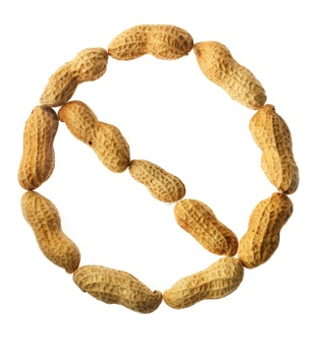

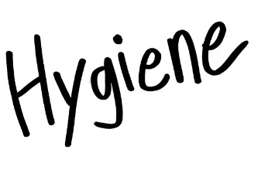

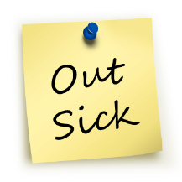



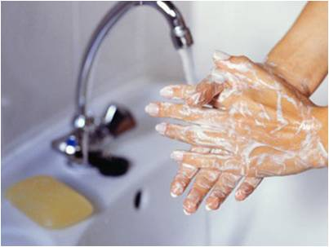

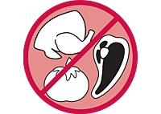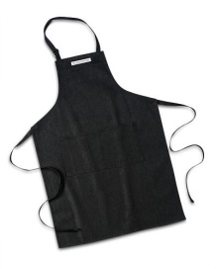

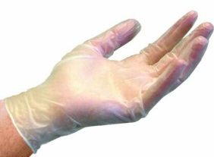

**Food Handling – Just the Basics**

* Always wear a hairnet and apron while serving or transporting food, washing dishes, washing pots, or line running;
* Never handle food, dishes, or food preparation equipment if you are sick. This could lead to a food borne illness;
* Poor personal hygiene could lead to a food borne illness;
* No eating on the serving line – not even a taste! Drinks are allowed in your work area, provided they have a lid and straw and they are stored as low as possible, eliminating the possibility of your drink spilling into food products
* Wash your hands and put on gloves every time your hands or gloves did or even could have been contaminated … touching anything besides the pan and/or utensil(s) of the food you have been assigned to serve is contamination!
* Line servers will only serve food onto a clean plate that has been handled only by them:
  + This means a plate handed to you by a customer is not acceptable;
  + Never serve food onto a plate with food on it that has been presented by a customer … serve their food on a new plate;
* Keep your area clean and free from spills and debris;
* Be sure that you adhere strictly to instructions regarding the handling of left-overs.

|  |
| --- |
|  |
|  |
|  |
|  |
|  |
|  |
|  |
|  |
|  |
|  |
|  |
|  |
|  |
|  |
|  |
|  |
|  |
|  |
|  |
|  |
|  |
|  |
|  |

Notes:

**Hand Washing**

You have many, many years of hand washing experience. Chances are, though, you do not take the time to consciously wash your hands properly every time.

Proper hand washing is required by all laws regarding food service. Running water, soap, and disposable towels are required. Please use the following instructions for washing your hands before, during, and after your CDS shift.

1. Find a sink designated for hand washing. Turn on water. Wet both hands.
   * Water must be at least 100° - should feel warmer than your hands, but it is not necessary for it to be scalding hot.
2. Apply soap to hands.
   * Liquid or bar, either is fine. Anti-bacterial is not necessary. The important part is the lather!
3. Briskly rub hands together to wash.
   * Be sure to wash front and backs of hands and wrists, between each finger and your thumb, and around the edges of and under your nails, working lather over all parts of hands and wrists.
4. Rub/wash hands for at least 30 seconds.
   * You can count, watch a clock, or sing “Happy Birthday” two times fast.
5. Rinse your hands in running water until all soap has been removed.
6. Dry your hands using disposable towels.
7. Use the towel with which you just dried your hands to protect your hand when turning off the water faucet!

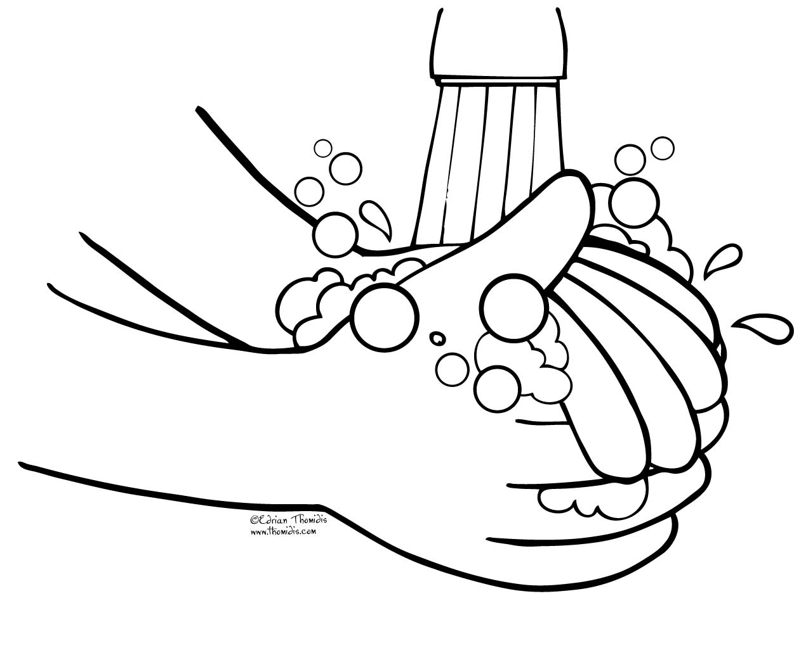

* 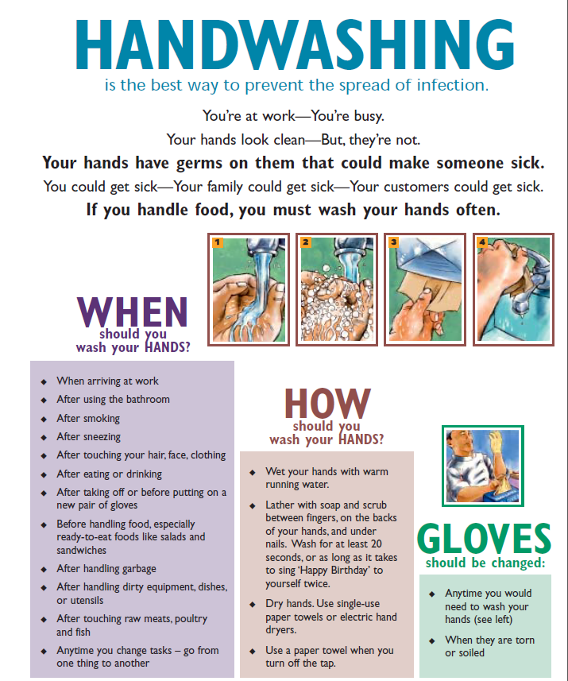

**Glove Usage**

During your shift, you should change your gloves multiple times. We have plenty of gloves available, and expect to go through a lot of them. This is part of how we keep the campus safe and free of foodborne illness.

If you ever ask yourself if you should change your gloves, change them! It’s far better to change them more frequently than you need to than to skip changing them and put people’s safety at risk. Studies show that we engage in behavior that warrants handwashing and a glove change an average of more than 8 times per hour. Yet, glove changes aren’t happening that frequently, let alone handwashing. Bon Appetit at Oberlin College aims to change this statistic, at least in your kitchens.

After you’ve properly washed your hands, here’s how to put on gloves and some times when you should change them:

Remove and dispose of gloves, wash hands, and put on fresh gloves every time your gloves become contaminated, including but not limited to:

* + Touching your hair, hands, face, any part of your body, your clothes;
  + Touching any non-food service surface, including door knobs, elevator buttons, and the like;
  + After going to the bathroom;
  + After eating or drinking;
  + After leaving your work area;
  + After handling trash or trash receptacles;
  + After using any cleaning chemicals, including sanitizer solution;
  + Before changing tasks;
  + 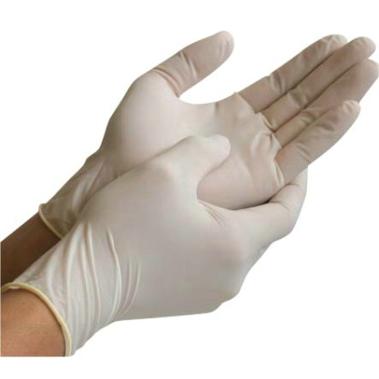After coughing or sneezing … every time, even if you cough or sneeze into your elbow/sleeve (as you should always do)!

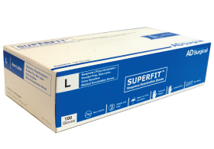

**Customer Service**

The following critical actions, known as “The Code of Quality Service”, will help provide quality service while bringing a sense of pride and satisfaction to the work place:

* Greet the diner immediately.
* Give the diner your undivided attention.
* Make that interaction time count.
* Be natural, not phony or mechanical.
* Be energetic and cordial.
* Be the customer’s agent. (Assisting with their needs and concerns)
* Think! Use common sense.
* **NOTE:** Portion control is also a requirement of any food service job. Portions per food item may vary in each dining hall. Seek out and follow all portion controls told to you by the manager or cook.
* In DeCafe, Sky Bar, or Azariah’s there may be times when you will be required to answer the phone. You will be trained on phone etiquette in those buildings.

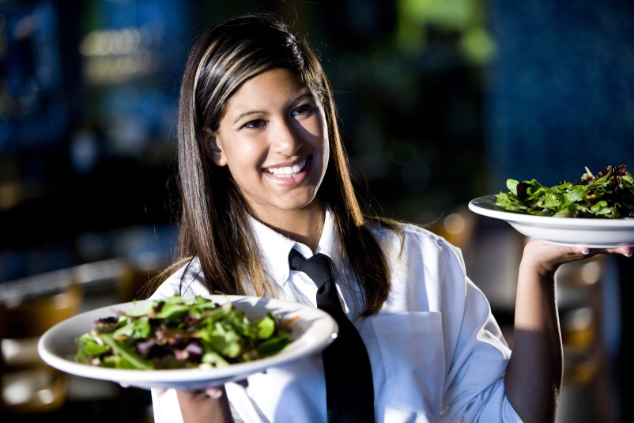

vs.

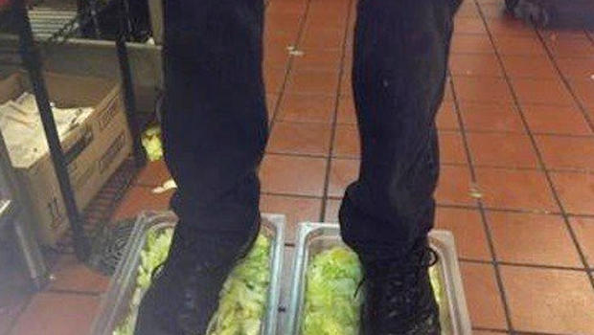

**Knives**

As these are a relatively dangerous item, compared to some kinds of work place tools, there are strict guidelines about their use. Some student positions in some locations are required to use knives for the work they perform. In general, only counter workers and dessert line runners use knives. Students use them for dividing cakes and pies and cutting sandwiches and wraps. If you are not employed in a job or position that uses a knife, please do not handle them for any reason unless instructed to do so by a manager.

Using a knife requires using a cut glove that will protect your hand:

* Go to the manager (not another employee) and get a cut glove issued directly from them.
* ***The cut glove is worn on the hand that will not be holding the knife.***
* Put the cut glove on and then put a rubber/plastic glove on over top of it.
* Avoid getting the cut glove soiled or wet.
* Remove and replace the cut glove when washing hands. Whenever it is removed, make sure to use a new rubber glove over the top.
* When your task or shift is over, the cut glove must be returned to the manager. Do not leave it at your workstation or hand it to anyone else to use.

Please speak to your manager for the rules about knives and cut gloves for each location. Each dining hall has established its procedures that work best for that location.

Use of can openers, manual or electric, is not permitted by student employees. If anyone directs you to open any kind of can, please remind them that this is prohibited in any student job.

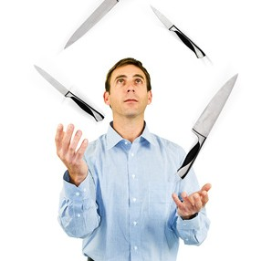

Don’t be this clown. Just don’t.

**Safety and Sanitation**

We serve a large quantity of people, both over summer and during the academic year. We must take safety seriously in order to keep our dining halls operating. To this end, some guidelines have been established.

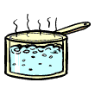As you begin working for CDS, you may hear people yell “behind you!” or “coming through, hot pan” or some other variations of these kinds of things. This is to keep everyone safer. In a kitchen, it is imperative that you are aware of your surroundings. Since you can’t do what you’re doing and look in all directions at the same time, you must sometimes depend on your hearing to avoid potential disasters. If you’re washing dishes and someone walking behind you says, “behind you with a knife”, you know not to turn around; this keeps you safe from being cut. Frequently, your first instinct when you hear someone yell will be to turn around and see what’s going on. It’s important that you learn to ignore that instinct in our kitchens. We would rather have to wait a couple seconds for your attention than have you injured because you turned too quickly.

You may not wear ear buds or headphones while working for CDS. This is not only due to the risk of loss or damage to your personal items, but it’s truly a matter of safety. If you can’t hear that person behind you say “coming through, hot pan!” you can’t be sure to stay put and avoid an injury. Anything that impedes your ability to be aware of your surroundings is a safety hazard in a food service setting.



Occasionally, you may be the first to notice a spill or other safety hazard. For this reason, it is important that you know how to handle the situation. First, if others are in the area, try to clear the area if it can be done safely (a simple, “please step back so we can handle this spill” is usually enough). Then, you would need to place a wet floor sign (even it it’s a dry spill, it alerts people to avoid the area). We do not expect you to clean up spills, but we do expect that if you’re the first one to notice it, that you take precautions to help avoid injury to our staff or to our customers and then notify someone whose job it is to get the spill cleaned up (a manager or an Oberlin College maintenance employee in a light blue shirt). The main focus in this situation is to avoid injury to you, to other students, to our customers and to the rest of the staff.

**Safety and Sanitation, continued**



You should have with you a bucket of clean sanitizer solution with a clean rag when working in food prep or serving areas. The water and/or rag should be changed out as needed to keep both clean.



First aid kits are located in the manager’s office. Please first ensure your own safety and the safety of anyone else in the area, tend to your first aid needs and then inform a manager of the need for first aid (or ask someone else to inform the manager while you’re tending your needs).

**Food Allergies and allergens**

Food allergies are a growing concern. Here at Oberlin College, we take this matter very seriously. Efforts are made to cook with as few potential allergens as possible. However, **only a manager can address questions from customers about what allergens may be present in a dish**. You should never, ever answer this question. Ever. There is simply too much potential for error or lack of information and in the case of allergens, someone’s life may be at stake.

If you’re asked what the ingredients of a dish are, your answer should be to repeat the name of the dish only, not to list ingredients that are or that you think may be in the dish. If the customer asks about allergens, your only answer is, “I will get a manager to answer that for you.”

Even the most harmless-sounding dishes may contain traces of an allergen. This is a serious matter and if you are found to be in violation of this rule, you will be disciplined as such.

**Breaks & Meals**

Most CDS student employment locations have some sort of food that is produced and distributed during meal times. Most CDS student shifts fall during some portion of the meal period. Neither of these facts encompasses all locations perfectly but they are generally true.

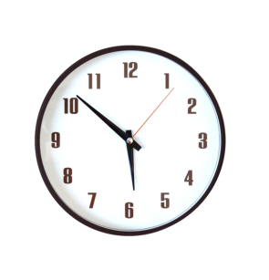In general, all students who work a shift several hours in length will be permitted to take a 15 minute break. This is somewhat dependent on the location and the job being performed; each management team in each location has established guidelines that are appropriate for the jobs and the shift times in their facility.

Break time is 15 minutes. The student employee does not punch out for this break; it is paid time. The student will be permitted to take their break only at a time designated by the manager. It is the student’s responsibility to know what time they started their break and to return in the allotted 15 minutes. Failure to return to the assigned work station in a timely manner will result in disciplinary action. If the break time significantly exceeds the 15 minute mark, the manager may note the break stop and start times on the student time card so that paid working hours are reduced by the time of the unauthorized/extended break.

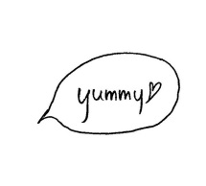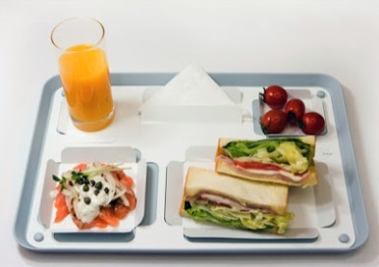In dining hall facilities where it is possible, if a student employee is authorized for a break, they are usually authorized to eat a meal at no charge from that facility on their break. All permitted student employee meals will be eaten in that facility (no carry-out) and during that break period. No left-overs from that meal may be carried out.



Each location unit manager will establish what constitutes a meal for student employee meals. As the focus of a food service operation is customer service, if quantities of any given meal item are limited, they may not be included in that day’s meal options for student employee consumption but reserved for customers and guests of that establishment. Pre-packaged food and/or beverage selections may not be included in the meal. Details about the meals specific to your situation should be referred to your manager for further information.

Please remember that food service is a live improvisational performance at every meal. Although there may be a “usual” break time or meal composition, the manager is the final authority on when a break may take place and what items on that day’s menu may constitute a meal. Special circumstances may require fluctuations or adaptations in the “usual”. Your cooperation in this is required.

**Disciplinary Action**

Campus Dining Services intends to provide a safe, productive, and pleasant work environment for all employees to enable them to achieve the highest level of productivity and fulfillment. The success of Campus Dining Services depends on food quality and customer service. It is everyone’s responsibility to treat customers and co-workers with respect and understanding. If an employee does not meet these standards for performance and behavior, constructive counseling action may take place to improve performance or correct behavior. CDS will attempt to address most types of unsatisfactory performance or conduct through this method.

A variety of actions can warrant disciplinary action up to immediate termination, including but not limited to the following list of examples:

* Theft and attempted theft. This includes any food and beverages, supplies, utensils, equipment, personal items belonging to co-workers or customers, and cash. This also includes giving away or discounting item prices and improperly portioning items for yourself and others. (You are authorized to eat a meal while you are working. It must be consumed in the facility and may not be carried out.)
* Willful misuse or destruction of college or co-worker property.
* The possession, sale, or consumption of illegal drugs or alcoholic beverages, or being under the influence of illegal drugs or alcoholic beverages during working hours or on the work premises.
* Falsification of company related documents, including time cards, for yourself or another employee.
* Insubordination or failure to carry out reasonable requests.
* Any disorderly conduct, such as profanity, yelling, or vulgar, abusive, or obscene language to fellow employees and customers.
* Abandonment of job … no call/no show
* Three (3) written warnings in one semester.
* Unwillingness to comply with requirements of health or safety policies.
* Failure to maintain proper standards for hygiene and appearance in the work place.
* Sexual harassment, other harassment, or discrimination of any kind.
* Repeated tardiness/absenteeism. This also includes over-use of the sub policy to staff the shift(s) assigned to you.

**Disciplinary Action, continued**

A student may have more than one job with CDS. If the student is terminated from only one position, an evaluation will be made to determine if the student should retain the other position or be released from all jobs.

A student who has been terminated will be unable to work for Campus Dining Services for the remainder of that semester and all of the next semester.

When infractions are less severe, a student can receive verbal and/or written warnings from a manger, supervisor, or student manager. Written warnings will be communicated via email. In regard to these less serious infractions, a student cannot be terminated until he/she has acquired three (3) written warnings per semester. Three written warnings, though, will result in termination. The reasons for the warnings do not have to be the same and can be three infractions per semester in any of the buildings operated by Campus Dining Services.

Notes:

|  |
| --- |
|  |
|  |
|  |
|  |
|  |
|  |
|  |
|  |
|  |
|  |
|  |
|  |
|  |

**Hiring & Scheduling**

This is all handled on-line through our CDS Student Employment web page and via email:

[oberlin.edu/dining-services](https://www.oberlin.edu/dining-services)

cdsjobs@oberlin.edu

**Applications**

When you submit an application, it is a fast track to employment. This process does not involve weighty consideration and interviews; if you are smart enough and motivated enough to be accepted at Oberlin College, you have what it takes to work in our dining services positions. Your dining hall application is the process by which you can request individual working shifts that work with your class and life schedule. When that application is processed, you will receive an email indicating which of your requested shifts have been assigned to you and the date you are scheduled to start.

The Student Employment Assistant, Tiwauna Daniels, handles the hiring process for CDS, both dining hall and catering. She is also the person who handles all job related communication through the email address noted above. Please use this email address when communicating about CDS employment and its related issues.

***Being hired to work through a dining hall application means that you are agreeing to work all of your assigned shifts every week from the start date assigned through to the end of exam week.*** The only exceptions to this are when you make advanced arrangements as detailed in the Attendance section in this handbook. Regular attendance is required and poor attendance will result in the termination of your shift(s).

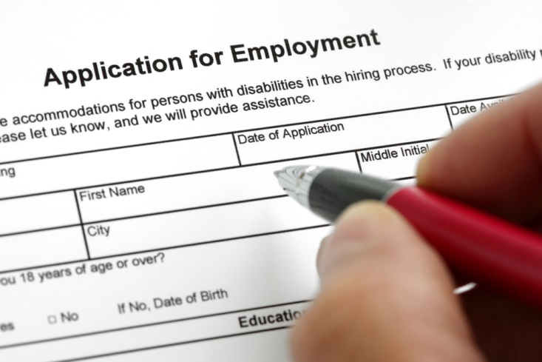





**Applications, continued**

When applying, please carefully read the information about answering the questions or completing the required fields. The application asks for you to indicate how many shifts you are requesting for that application only. Do not use this field to indicate how many shifts you want to end up being assigned for the semester in total. Please provide us with a good phone number to use in the event we need to call you about attendance issues or the like. Also, note the earliest date you are willing to start working; if you do not indicate a specific date, you will be assigned the first possible working date.

Open shifts are listed as an open box on the application. Some of these boxes contain numbers. Those numbers indicate how many other applicants have requested that particular shift. Applications are processed in the order in which they are received. When choosing a shift with other requests, understand that that shift may not be assigned to you.

You are always welcome to accompany your application submission with email to [cdsjobs@oberlin.edu](mailto:cdsjobs@oberlin.edu) indicating your preferences in the shift options you have presented in your application. Please be as specific as you can. The Job Coordinator will make best efforts to accommodate those preferences.

**Class Breaks**



C:\Program Files (x86)\Microsoft Office\MEDIA\CAGCAT10\j0298897.wmfDuring Fall Break and Spring Break, the dining halls are closed. You are not expected to work during these breaks. The managers will inform you of the close down and re-opening dates. If your transportation leaving or returning from these breaks interferes with this, you must discuss it with the managers well in advance and provide them proper notice.

**End of Semester**

Exam week is a busy time for students. As the end of the semester approaches, the dining hall managers will notify students of the opportunity to communicate your need to work or not during this period. This may be done through sign-up sheets or by face-to-face conversation. It is important to communicate openly and accurately and early with the managers about your job during test time and ending the semester.

**Your Schedule**

The schedule times that you choose should be ones you can be sure you can attend. As discussed below in the Attendance section, the intention is that you are in place and ready to work (punched in with hair net and apron on, hands washed and gloved) by the start time of your shift. If you have class until 2:30, you cannot be on time for a 2:30 shift. You may not have time to make it at 2:30 if your class ends at 2:20. Be careful in scheduling.

There are some occasions when a manager can and will approve a slight shift in your actual working time. This must be addressed directly with the manager; sometimes the flow of business is such that they can work with you, other times not.

**Add/Drop Shift Period**

During the first add/drop class period of every semester, the Job Coordinator allows for students to work around the policy of 2 weeks advance notice to terminate a shift and reduces it to 2 full days (48 hours) advance notice. Any time you wish to remove a shift, you must contact [cdsjobs@oberlin.edu](mailto:cdsjobs@oberlin.edu) to make that request. Again, ***48 hours advance notice before the start time of the shift is required during add/drop to drop or eliminate a scheduled shift.*** Without this notice, the manager will be left without employee coverage and will be short-handed for that position. If you fail to follow this rule, you will be written up as No-Call No-Show for the shift missed.

Any time you wish to add a shift, you must apply on-line. There is no “switching”. All applications are processed in the order in which they are received. If there are complications in processing, you will be contacted in a timely manner with details on how to resolve the issue(s).

**Shift Limits**

Incoming first year/freshman students are limited to a maximum of 2 shifts during their first term. All other students are limited to a total of 4 assigned shifts per term. Contact the Job Coordinator to discuss raising those limits to accommodate your special needs.

**Between Semesters**

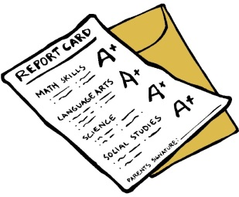At the end of each semester, you will be notified of the opportunity to retain the shifts you actively held through the end of the term. You will be emailed with a link to a Retain Shifts Form and can choose to keep any or all of your shifts for the coming semester. Failure to complete this on-line form will result in removal of all shifts that you held during the term.

You will be also be notified of when hiring will begin for the new semester. Students who have worked for CDS and have at least a month of regular term dining hall experience will be permitted to submit applications well before those students who have not.

**Special Schedules**

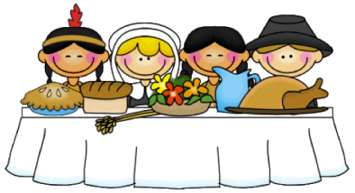

Special schedules include Early Arrival/Orientation, Thanksgiving break, Winter Term, Commencement, and Summer. When you are currently signed up for shifts, you will be notified of opportunities to apply to work during these special periods. If you are not currently signed up for shifts, you can always find this information on our Employment web page.

Most special schedules require submission of a special application, also to be found on our Employment page. Because of student transportation and cost issues, the application periods for these special schedules are usually opened and closed in a time frame to allow at least a one-month notice to the students hired. Early application is always recommended. We give preference in the hiring for these positions to current CDS employees.

Commencement Week is a very special schedule period, indeed. Although CDS will have links and information about the hiring, the Res Ed department is actually the office that handles the application process and employment offers.

******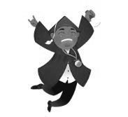**

**Attendance**

Your job is an agreement that you will be there when you are scheduled and do the work that is indicated and we agree to pay you the established wages for doing that job.

Attendance is a really big issue.

As your employer, it is VERY important to us that you are here. When you aren’t in your scheduled place for your assigned shift (even when it’s scheduled ahead of time) it can be frustrating for your co-workers and an expense to CDS and the college.

We understand that you are here to go to school, that this is and should be your priority. It is the same way that our priority in CDS is to provide a quality dining experience on campus. We understand that there are going to be issues come up that will conflict with your work schedule, regardless of how dedicated an employee you are.

The only solution to reduce the cost associated with an employee absence (a cost counted in both aggravation and in dollars) is effective communication between the employee and the manager. When it comes to your attendance, please note the following really important rules:

* Always communicate any attendance issues in person or on the phone directly to your manager. ***Never use email!***
* Always direct your communication about attendance to your manager. Contacting the CDS office is not acceptable or effective.
* The more notice you can give, the better it is for everyone.



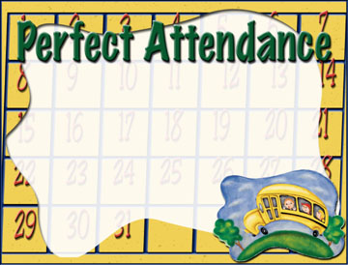

Never call off via email. Always call.

**Your name here!**

**Attendance, cont’d: excused vs. unexcused absences**

Absences are acceptable only when they are excused ones.

An unexcused absence (often referred to as a “no-call no-show”) will result in termination of your employment if 2 incidences occur in a school year. When you are terminated, you will not be permitted to work for CDS for the remainder of that semester, for the following semester, and the “special schedules” for which we often hire through the year (including Winter Term and Commencement).

When a conflict with your work schedule arises, you must contact your manager as soon as possible, at least 5 days in advance. Again, do so by phone or in person – NO EMAIL!

The manager will assist you in the process of posting a Sub Slip (a request to all workers to take over an individual shift). After notifying the manager of the conflict, it is up to you to find a replacement for yourself. The Sub Slip process will be the most effective but you need to make an effort to speak to your co-workers and other folks you know who are working for CDS.

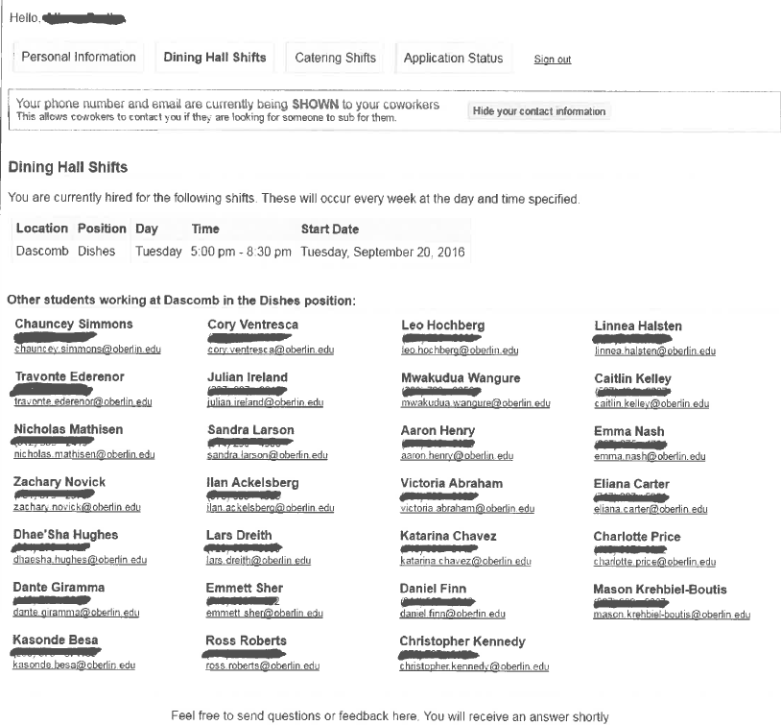If you do not follow this process, you will be written up for an unexcused absence (aka “no-call no-show”). One incident will be tolerated. If a second occurs, your employment will be terminated.

***Know where to find this. Use it.***

**Illness or Emergency**

When significant illness or a personal or family emergency occurs, you are required to provide at least 2 hours’ notice by phone to the manager. If you work a 4th meal shift, we ask that you call by 4:00 pm at the latest.

We realize that the manager is not always available to answer the phone. They check the voice mail with great regularity. If leaving a message, please be sure to clearly state your name, the time of your shift, and what position you are working along with any message you have. The voice mail does time and date the call so you can be sure that they will know when you have called off with proper notice.

The policy of 2 hours’ notice for illness or emergency is NOT extended to cover general conflicts with your schedule. This process only applies to significant illness or emergencies.





**Excessive Absence**

Even when you follow proper procedures, if you call off or substitute on your shift with frequency, you can be written up or terminated, depending on the severity of the issue. If you have a shift, you are expected to work it. It belongs to you.

If you are not available for a regular schedule, you may want to explore other options of employment in Campus Dining and on campus. Please contact Kathy in the CDS office to discuss the best options available through CDS for your circumstances.

**SUB SLIPS**

Your job belongs to you. It is up to you to find a replacement for yourself when you know you need to be off.

**When you NEED a sub:**

* *A sub slip needs to be posted at least 5 days before the date you need to cover.*
* Come in to see the manager in person. Tell the manager the circumstances and request a sub slip from them.
* Complete the top portion of the slip accurately and legibly.
* Punch the top of the sub slip in the time clock to date stamp your posting.
* 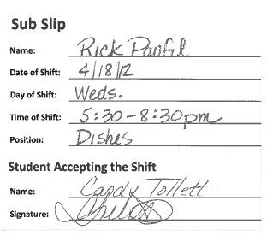Post the slip on the bulletin board provided.

**WAIT!!! You are NOT done yet!!!**

* The day before the date you have requested a sub, you need to take down your sub slip and see if it has been accepted.
* Turn it in to the manager and report the status.
* (Failure to complete this portion of the process can lead to a No-Call No-Show write up.)

**When you WANT TO WORK a sub shift:**

* Find the perfect shift.
* Legibly print your name and sign on the bottom of that slip.
* Tell the manager that you have accepted the shift.
* You are now officially responsible for the shift. It belongs to you and you can and will be written up if you fail to follow proper handbook attendance procedures if you end up with a conflict.
* *If you sign up to work a sub shift, do not scratch out or erase your name once it has been posted!* If you realize that you made a mistake while completing the slip, take the slip to the manager so that the manager can prepare a new slip.
* Writing another student’s name on a slip to accept the shift falsely will be grounds for immediate and permanent termination from CDS.

**Dining Hall Dress Code**

All employees are expected to arrive looking clean and neat. You will be recently bathed or showered. Your clothes will be clean and free of holes. Your hair will be clean and restrained.

The dress code is set forth to comply with the Health Department standards and in consideration of the safety of all employees:

**Shirts**

Must have a sleeve that is at least a short sleeve (this means at least as long as half way to your elbow); must be long enough to cover your midriff, even when your arms are held out to your sides; must not contain messages or language that could be considered offensive by customers or co-workers. No tank tops, spaghetti straps, sleeveless, backless, tube tops, or cap sleeves.

**Pants**

Must be standard, long pants/trousers. No shorts, skirts, skorts, sweat pants, Capri length, gauchos, extraordinarily long, or baggy pants. Leggings, stretch pants, and tights are not acceptable alternatives to pants.

**Shoes**

Must fully enclose your toes and your heels and be worn with socks or hose. Non-skid soles are suggested, rubber or crepe soles are fine. Heels should be ½” high or less (anything higher will be tolerated only at the discretion of the manager and in consideration of employee safety). No bare feet, flip-flops, sandals, clogs, cleats, or any other shoe that poses a safety issue.

**Jewelry & Etc.**

No rings on hands. No false nails. Necklaces will be worn inside of your shirt. Earrings or facial piercings will be small studs/bars/rings that are worn close to the skin and firmly secured; no dangling or excessive jewelry. No hats, bandanas, or scarves; hair nets are required.

We also encourage you to leave your personal possessions at home. CDS will not be held responsible for loss, theft, or damage to possessions that you bring with you to work.

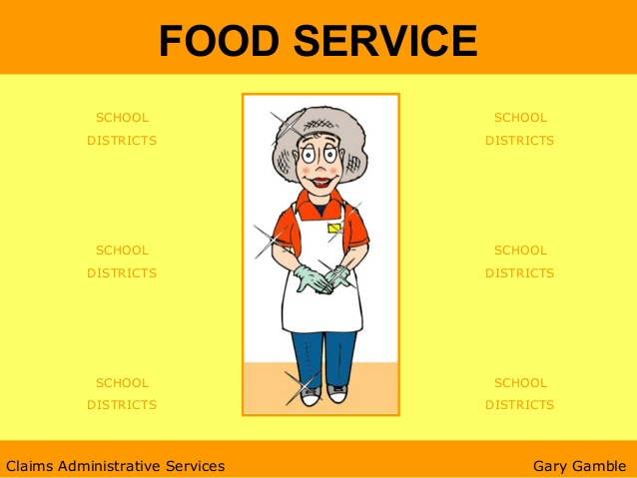

*Full length pants*

*Shoes cover heel and toes.*

*No jewelry, no cell phone.*

*Sleeves are at least halfway*

*to elbow*

*Clean hands in clean gloves*

*Clean apron*

*Hair is all contained by hairnet*

**Books & Devices**

No books or devices, including but not limited to electronic or digital devices, are permitted to be used while you are punched in on the time clock. This includes items such as the following:

* Laptop computers;
* MP3, Ipod, or other music/video/TV devices or media players and the head phones or earbuds that may go with them;
* Cell phones, PDA’s, or any Bluetooth device;
* Books, text books, or other reading/study material;
* Any form of a game device.



**Payroll**

No, really:

This is what working is all about!

**Student Employment Office**

To be eligible to receive a paycheck, you are required to complete important tax documents one time during your student career on campus. This documentation is handled through the Student Employment Office inside of Carnegie. For details about what you will need to successfully complete this paperwork, contact their office directly or visit their website at <http://new.oberlin.edu/office/student-employment/>. (For international students, this is handled through Josh Whitson’s office.)

Once this paperwork has been completed, please email [cdsjobs@oberlin.edu](mailto:cdsjobs@oberlin.edu) to report that an employment time record can be established.

**Timecards**

You will punch in and out on a yellow time card for regular dining hall work and a pink time card for catering work. If none are available by the time clock, the manager can make more available. The time cards are color coded and use of the wrong one will significantly delay processing those hours on the wrong color card.

You are the only person allowed to handle or punch your time card. You may not punch someone else’s card and they may not tamper with yours.

You must complete your information on every time card. It must have your legibly printed name, T# (never your Social Security number), job or position (pots, line runner, counter, etc.), and your signature. The “Crew” field should be filled in with your facility name. If you are working as a substitute, list the name of the person for whom you are subbing. If it does not include all of these items, your pay may be delayed or be paid at the incorrect rate.



Only one job on a time card. You can use that time card during the week for all the times you work that one job, but only that job. (Example: you work on Monday and Wednesday doing dishes and on Sunday as a line server. You will need two time cards, one with multiple sets of punches for dishes and another with one set of punches for server.)

Please note that the job you claim on a time card is required to be the correct one as scheduled. There may be a time that the manager may need you to work a different position. If this is the case, you will still list your scheduled position. The manager will then fill in the Sub field with the position you will work and initial. You will then be paid at which ever pay rate is highest.

**Getting Paid**

Your check will be direct deposited into a bank account. If there is a processing period, you will be issued a paper check that will be delivered to your OCMR box in the interim.

You can check your deposited pay through the Presto system.

Because of the high volume of time cards to process, our pay period does not exactly match the one listed on your pay record. A pay schedule listing the dates the pay is issued and the time period of work that it is paying is included below.



**Raises**

There is an on-going urban myth that students receive a raise for each semester or year that you work. This is not correct.

Every summer, the dining hall managers review a listing of all the folks who have worked for them during the previous academic year. Of those students who are eligible, the managers then make recommendations for raises for those students who have been the best workers: great attendance, good disciplinary record, good customer service skills, efficient at their job. Raises are issued based entirely upon merit. Excellence in the workplace is required.

To be eligible to receive a raise, you must have at least one full semester of CDS experience (about 12 weeks) and have completed CDS Student Training, a great attendance record for the previous year, no firings/terminations for the previous year, and a good disciplinary record.

When awarded, raises are 25¢. This is always yours and will never be taken away. This amount will be applied to the base rates of any position you may work for CDS. Raises can be achieved every year and are added together and applied to all base rates. CDS raises do not cross over to jobs in other departments on campus.

**Payroll Questions**

If you have questions or find an error, your first point of contact is the person who processes your time cards: Tiwauna Daniels in the CDS Office. Please feel free to contact her with any questions or concerns you may have. Stop in to the office in Stevenson, call at (440) 775-8101 or email [cdsjobs@oberlin.edu](mailto:cdsjobs@oberlin.edu).

|  |  |  |  |
| --- | --- | --- | --- |
| **Student Pay Schedule** | | | |
| **Start** | **End** | **Pay Date** | **PR#** |
| 07/19/19 | 08/01/19 | 08/09/19 | 016 |
| 08/02/19 | 08/15/19 | 08/23/19 | 017 |
| 08/16/19 | 08/29/19 | 09/06/19 | 018 |
| 08/30/19 | 09/12/19 | 09/20/19 | 019 |
| 09/13/19 | 09/26/19 | 10/04/19 | 020 |
| 09/27/19 | 10/10/19 | 10/18/19 | 021 |
| 10/11/19 | 10/24/19 | 11/01/19 | 022 |
| 10/25/19 | 11/07/19 | 11/15/19 | 023 |
| 11/08/19 | 11/21/19 | 11/29/19 | 024 |
| 11/22/19 | 12/05/19 | 12/13/19 | 025 |
| 12/06/19 | 12/19/19 | 01/10/20 | 026 |
| 12/20/19 | 01/02/19 | 01/10/20 | 001 |
| 01/03/20 | 01/16/20 | 01/24/20 | 002 |
| 01/17/20 | 01/30/20 | 02/07/20 | 003 |
| 01/31/20 | 02/13/20 | 02/21/20 | 004 |
| 02/14/20 | 02/27/20 | 03/06/20 | 005 |
| 02/28/20 | 03/12/20 | 03/20/20 | 006 |
| 03/13/19 | 03/26/20 | 04/03/20 | 007 |
| 03/27/20 | 04/09/20 | 04/17/20 | 008 |
| 04/10/20 | 04/23/20 | 05/01/20 | 009 |
| 04/24/20 | 05/07/20 | 05/15/20 | 010 |
| 05/08/20 | 05/21/20 | 05/29/20 | 011 |
| 05/22/20 | 06/04/20 | 06/12/20 | 012 |
| 06/05/20 | 06/18/20 | 06/26/20 | 013 |
| 06/19/20 | 07/02/20 | 07/10/20 | 014 |
| 07/03/20 | 07/16/20 | 07/24/20 | 015 |
| *** Due to the way the dates/holidays fall, student payroll will not be processed in its normal time frame. | | | |

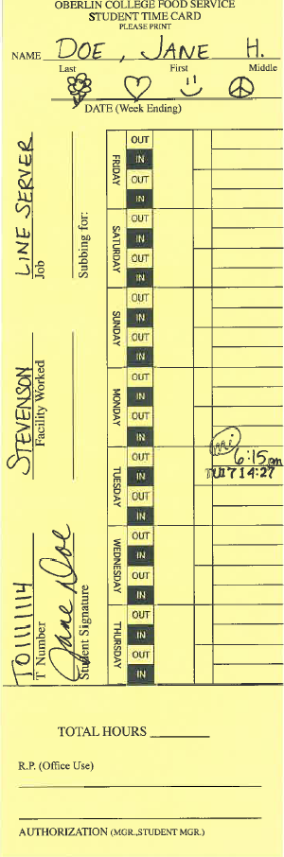**me Card Preparation Completing your Timecard**

**Only use a yellow time card** (pink if you are catering). All cards are color-coded and you may not be paid in a timely manner if you use any other color.

**Make sure all the following time card fields have been completed accurately and legibly**:

* Name: Last name first, first name last
* T#
* Signature
* Facility Worked: The facility or location for which you work
* Job: The position for which you have been hired and scheduled
* Subbing for: Must give student’s name

The time card has been sectioned into the days of the week, listed in the order of our pay week. For each day, there are is a space for you to punch in and out twice. In each day section, you will start at the bottom and work up with the placement of your time punches. **Make sure that each punch is readable**.

* If your punch is hard to read, please let the manager know as soon as possible so that they can do something about it in a timely fashion.
* If you forget to punch and then remember at some later point, do NOT punch in at that time. Simply take the card to the manager (or call, if you have left the building) and ask the manager to handle the situation.
* Only write and punch on your own time card. Handling anyone else’s time card is not allowed and may be grounds for disciplinary action.

**Only one job may go on any one card.** You may have multiple days’ punches on one card for a job but only one job on a card.

**Quitting Your Shift**

**(“Terminating” “Cancelling” “Giving Up” “Dropping” “Resigning” “Leaving” etc.)**

**CDS policy requires that you provide notice 2 weeks in advance of your last working day.**

* 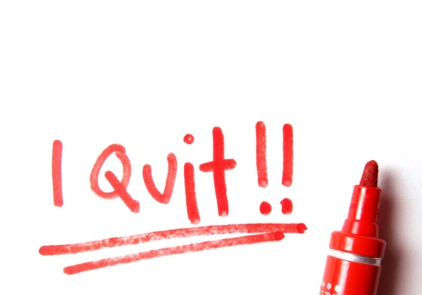You must speak directly to your manager, in person or by phone. No email or voice mail!
* You must also contact Tiwauna Daniels, Student Job Assistant, and provide the same notice to her. She can be reached in the CDS Office in Stevenson – Griswold, by phone at (440) 775-8101, or through [cdsjobs@oberlin.edu](mailto:cdsjobs@oberlin.edu)

The only exception to this in the event of a medical condition and is accompanied by a written statement from your physician.

**Once you have provided your 2 week notice, you are required to personally work your shift(s) for the next 2 weeks or secure a reliable replacement.**

* Your replacement must be a current CDS employee;
* You must provide the name of the person to your manager in advance.

If you do not follow these procedures, you will be written up!

* Improper Notice of Resignation
* No Call No Show
* 3 Write Ups or 2 No Call No Show will result in termination.



Yes, you can still be fired after you quit.

* You will not be hired by CDS for the remainder of this semester;
* You will not be hired by CDS for the next semester;
* You will not be hired by CDS for catering, special events, or schedules during that time.

**Dining Hall Contact Information**

**Stevenson**

155 North Professor Street

Office is located in the north corner of the kitchen … go to the back of the building and enter through the small door by the loading dock, turn right to the elevator, take to the second floor and turn right.

(440) 775-8993

**Azariah’s Cafe**

Located inside Mudd Library

Please make all calls and report to work at Wilder DeCafe. Check in directly with DeCafe manager when reporting for work.

(440) 775-8426

**Wilder Decafe & Rathskellar**

135 West Lorain Street

The manager’s office is in Wilder DeCafe … it is located in the northwest corner of the dining room closest to the “Sco.”

(440) 775-8426

**Lord/Saunders**

126 Forest Street

Office is located in the west corner of the kitchen … enter through the dock door on Forest Street.

(440) 775-8735

**South Bake Shop**

121 Elm Street

Office is located in the kitchen … enter through the center dock doors on the west side of South Hall. (Please ring doorbell on left.)

(440) 775-8625 or (440) 775-8735

**Catering Office**

When you are notified that you have been assigned a catering shift, a detailed schedule is available on-line. The catering offices are located in the Stevenson Building, 1st Floor. You can enter through the Biggs Entrance and take a left through the double doors. To clock in for your catering shift, go to the back of the building and enter through the small door by the loading dock, go through the door at the first landing and turn left. The catering time clock is located on the left. You will always use a “pink” colored time card when working for our catering department.

(440) 775-8976 or (440) 775-8420

**On-Line Employee Resources: oberlin.edu/dining-services**