OCOPE Supervisor Training
  - Time Clock Plus Guide

Contents
TimeClock Plus – Supervisor 4
Accessing TimeClock Plus 4
Approving Individual Employee Worked Time 4
Individual Time Considerations 6
Editing or Adding a Segment 7
Group Hours Approvals 9
Approving Shifts 10
Deleting Segments 11

TimeClock Plus – Supervisor
Approval Guide

Accessing TimeClock Plus

- Access TimeClock Plus through Oberview.Oberlin.edu
  - Search “TimeClock Plus Manager Portal” and select it from the drop down list
  - Click “Start” to be directed and to TimeClock Plus
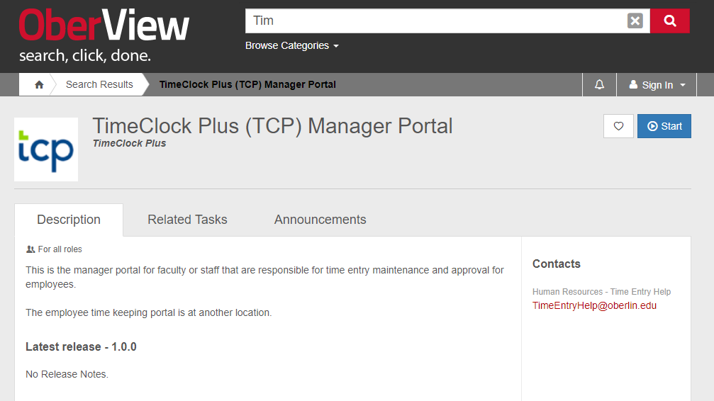

- Once you click start, you should be automatically logged in through Single Sign-on if you have an active session. Otherwise, use your user ID and password that you would use with Oberlin e-mail address or Banner.

- Once logged in, you will be able to see your Dashboard and the green Menu bar across the top.

Approving Individual Employee Worked Time
- From the menu bar, select Hours and Individual Hours

- You will then be able to see a list of all employees assigned to you.

*If you are unable to see an employee, contact TimeEntryHelp@oberlin.edu for assistance.

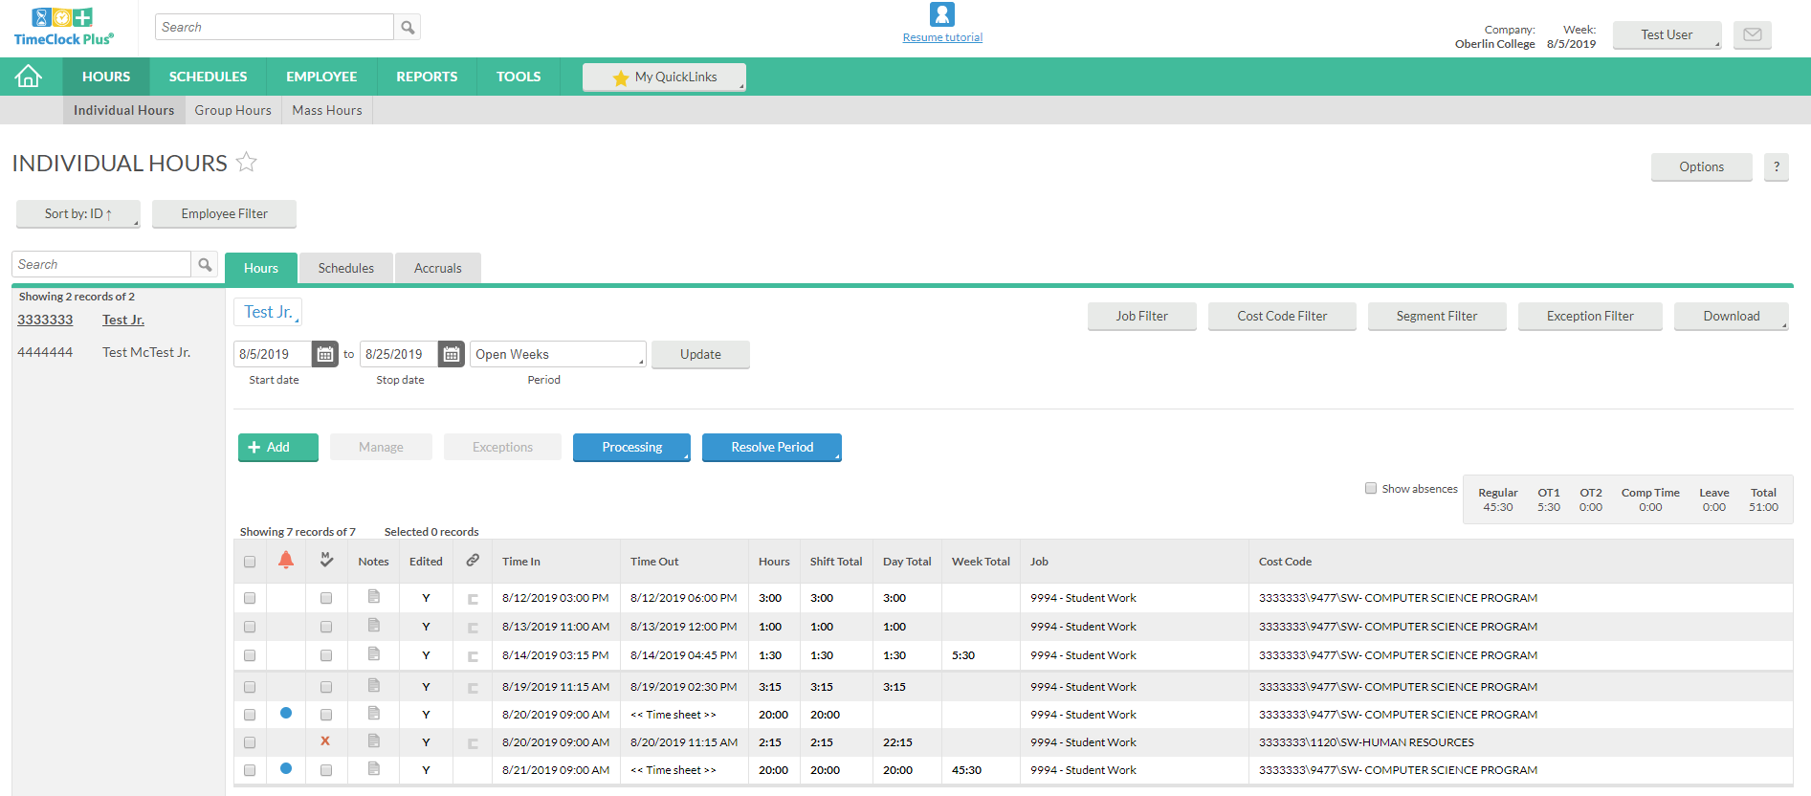
- To view and approve an individual employee, click on the employee name and their time sheet will populate.
- Once you have reviewed the time and ensured accuracy, click on the square to the left of the orange bell; this will check all entries.
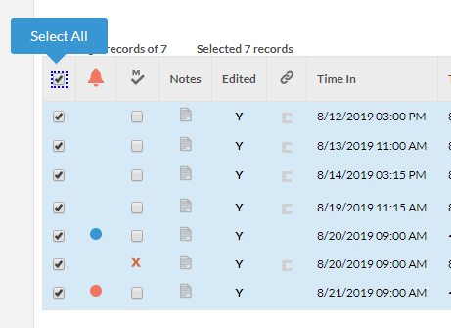

- Once all entries have been checked, you’ll want to select Resolve Period
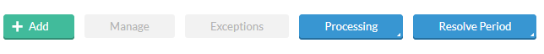

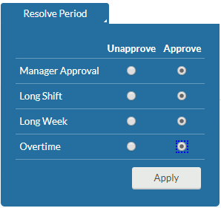
- On the drop down options you will be able to “Approve” or “Unapprove” all checked segments, confirm action by clicking Apply.

- Once applied, you will be able to verify approved segments by seeing the checked M column
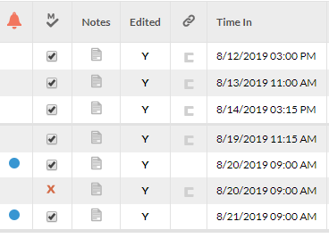

Individual Time Considerations

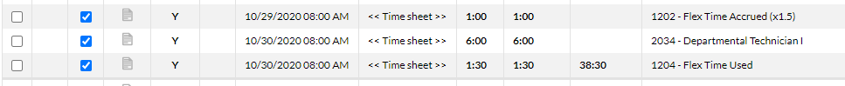
- Employee’s log all their segments on the specific job (vacation, sick, flex, etc.). You’ll be able to differentiate these segments by the separate entries created on the respective day.
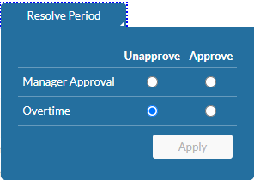

- Overtime: This is a notification that an employee has clocked Overtime hours during a workweek. Please pay particular attention to these segments. All prior Overtime should have been discussed and approved with the respective supervisor.
- Flex-Time: Flextime should be earned and used within the same pay period. Any flex time not taken should be converted to Overtime, to be paid at 1.5.
**These instances will require supervisor recognition and approval.

Editing or Adding a Segment

A Supervisor has access to add worked segments for an employee if they wish, or edit a recorded segment if they notice a discrepancy. The following instructions will guide you on how to make these edits.

- To edit an employee’s time, click on the segment you wish to edit.
- Next, you will want to select Manage and Edit.

- Here, you are able to edit Time In and Time Out segments, complete edits by pressing Save**.
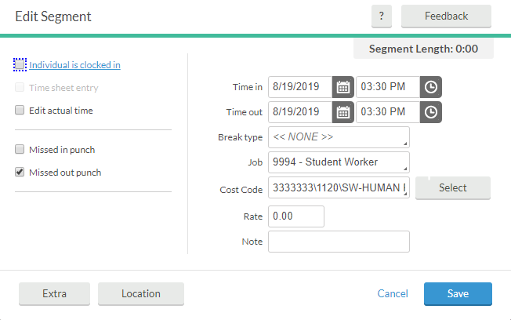

- To add missed segments, click Add

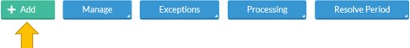

- To add a segment, you’ll want to make sure the correct Time In/Time Out hours are recorded, and select the appropriate Job. Click Save to complete segment add.

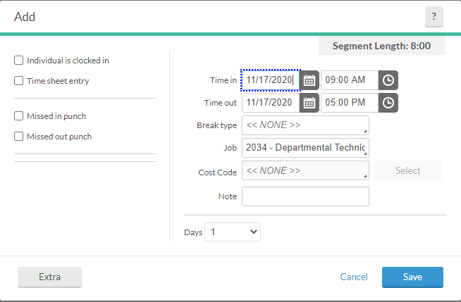

This may be done for a full segment, or a missed punch.

** When editing a segment, you may need to uncheck the “Individual is clocked in” box to edit time.

Time sheet entry: Allows time to be recorded without a clock out segment, for use to record the total number of hours worked.

Edit Actual Time: Allows edits to all time in and/or time out segments.

Missed in punch: Allows supervisor to add a punch in segment so that the employee can clock out.

Missed out punch: Allows supervisor to add the time out segment if an employee is unable to clock out.

Group Hours Approvals

Group hours allows viewing and approving of time segments for multiple employees at the same time.

- From the menu bar, select Hours and then Group Hours
  - Be sure to reference the Payroll Calendar for the correct pay period date to filter by.
  - The Cost Code Filter can be used to narrow down positions you see. If you supervise students, they will also be included in this area. To separate staff from student, you may use the “Employee Filter”. Choose Employee Role and AA’s to narrow down your results to only OCOPE employees
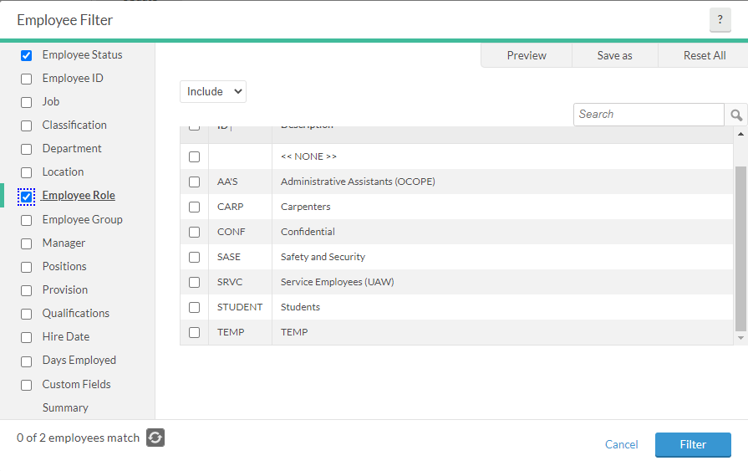

This will render the view of all your employees who are not students.

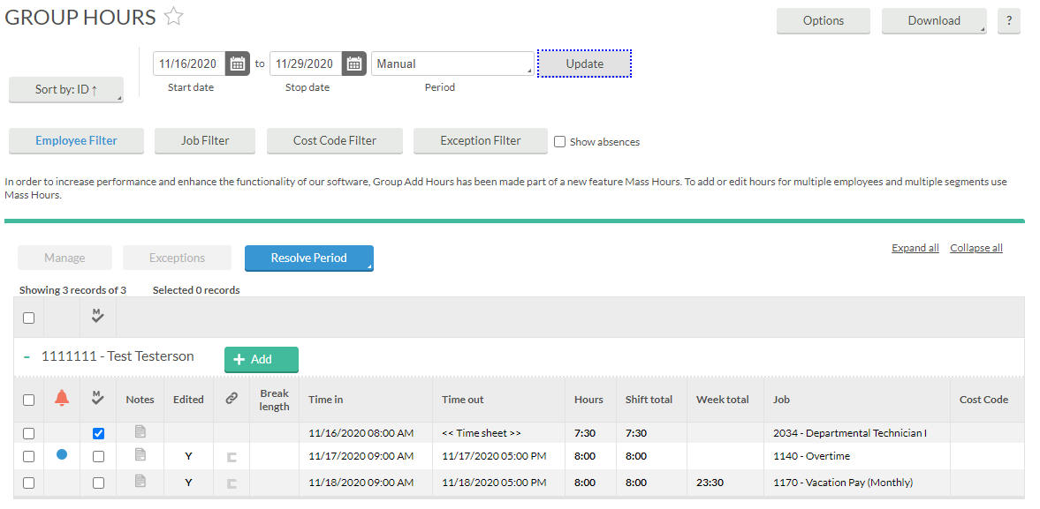

Approving Shifts
- To approve a segment, click on the checkbox under the appropriate header (M for Manager, E for Employee, and O for Other). To approve all the segments currently displayed for each of the displayed employees, click on the appropriate approval column headers.
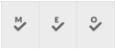
- Once the approval boxes have been checked, you can then click on the blue Apply Changes button to lock the approvals into the system, or the gray Discard Changes button to clear out the changes.

Deleting Segments
Multiple segments can be deleted across multiple employees within Group Hours.
- Select one or more segments that you would like to delete.

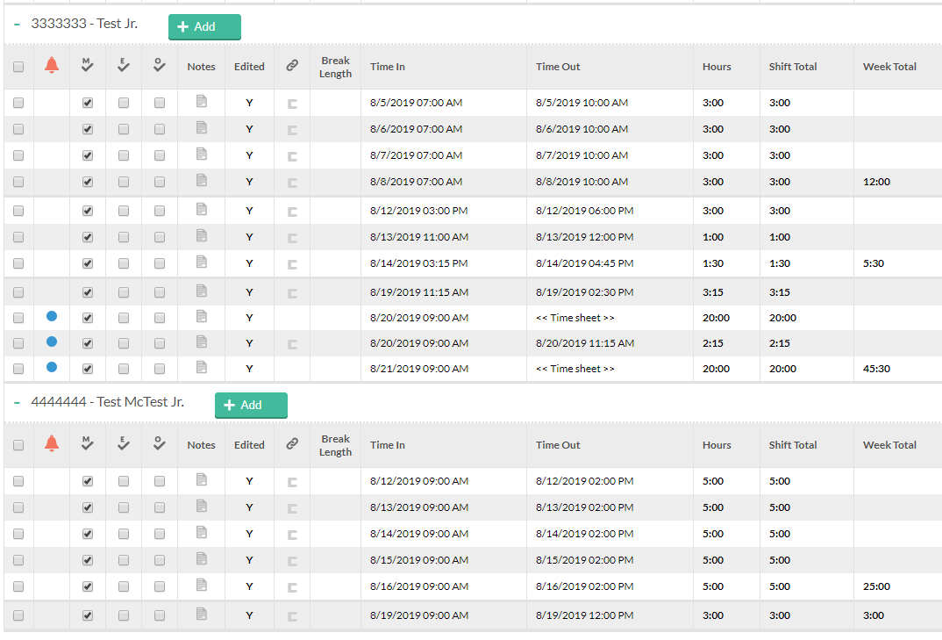

- Select the Manage button in the information bar, and select Delete.
