Instructions for Accessing CITI IRB Courses
- If you have not done so already, you must register as a user. Please select to register under “Organization Affiliation” and select Oberlin College. You will need to check both pop-up boxes for terms and affiliation. You will not get the Continue to Create user button without checking these boxes.
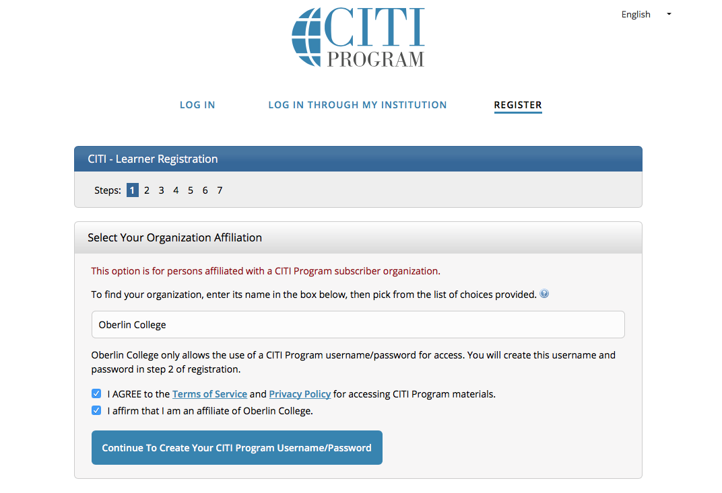
- Once you have registered, you can log in to the training site.
  - Click the Log in button, and add your username and password.
  - Click the blue View Courses button next to Oberlin College.
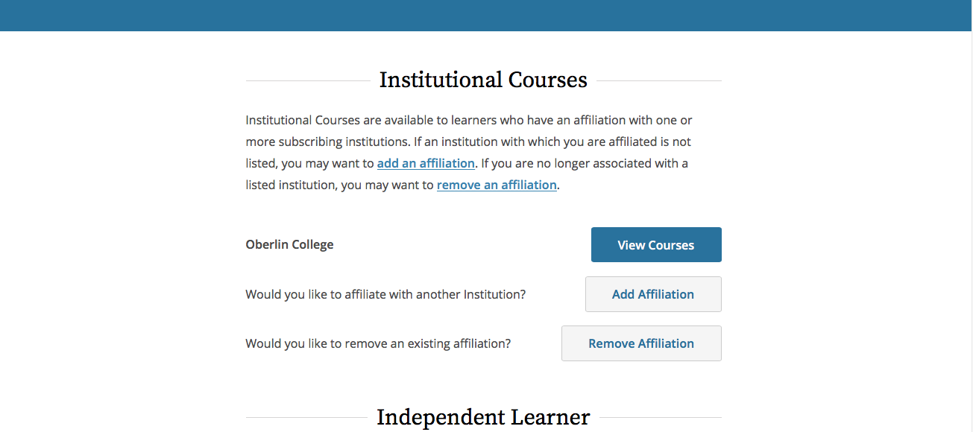
- On the next page, if courses are not listed for you, scroll down until you get to the Learner Tools for Oberlin College to add your course(s).
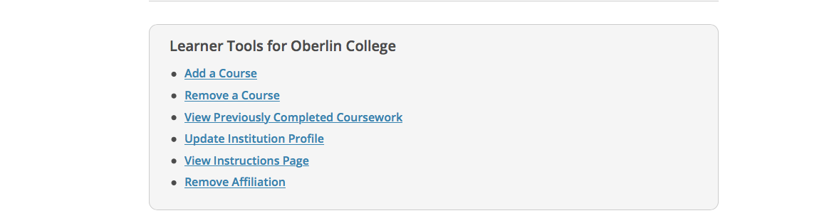
- On the Select Curriculum page, students should select the following:
  - Question 1- Not at this time(*Note- if selecting this option does not generate courses, select Students and Postdocs: RCE for Physical Science)
  - Question 2- Social & Behavioral Research Investigators OR students conducting no more than minimal risk research (only one can be selected)
  - Question 3 does not apply to IRB.
  - Click Submit.
- Your courses will generate on the screen as Active Courses or Courses Ready to Begin.
- Print any completion certificates to include with your research.

