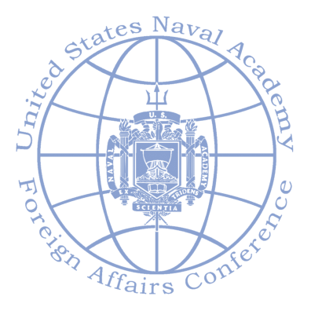59th Annual Naval Academy Foreign Affairs

Student Conference

“Coming Apart: The Fate of the Rules-based Order”

April 8-11, 2019

**DEADLINE TO APPLY: Thursday, 2/7 by noon**

**Submit applications to: ttucker@oberlin.edu**

|  |  |  |  |
| --- | --- | --- | --- |
| Full name: |  |  |  |
|  | **First** | **Last** | **.** |

|  |  |  |
| --- | --- | --- |
| Home address: |  |  |
|  | Street Address |  |

|  |  |  |  |
| --- | --- | --- | --- |
|  |  |  |  |
|  | City | State | ZIP Code |

|  |  |  |  |
| --- | --- | --- | --- |
| Phone number: |  | OCMR Box: |  |

|  |  |
| --- | --- |
| Email: |  |

|  |  |  |  |
| --- | --- | --- | --- |
| Class standing: |  | Major: |  |

Please list courses you have taken relevant to the topic of the Naval Academy Conference:

|  |  |  |
| --- | --- | --- |
|  |  |  |
|  |  |  |
| Relevant experience: |  |  |
|  |  |  |
| Paper topic: |  |  |
|  |  |  |
|  |  |  |

Please write a paragraph that explains why you are suited to attend the Naval Academy conference.