Levine Scholarship Application
Please submit this form by Wednesday, Nov 30th, 2022 4pm US Eastern Time to
Emer O’Dwyer eodwyer@oberlin.edu and Sachiko Kondo skondo@oberlin.edu

Applicant Information
Name:
Class of:
☐First-year ☐ Second-year ☐Third-year ☐Fourth-year
EAS Major? ☐ Yes ☐ No
Other Major(s):
Minor(s)

Project Information
Title:
Content of the project (250- 500 words. Use separate sheet if needed)
Please include:
a) Tentative plan of activities, b) Places you might visit, and c) Long-term value of this project to you

Proposed Dates of Stay in Japan for this project
Your study away program ends on:

Dates of your stay for the project:

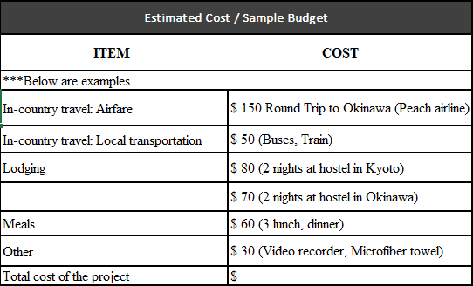

* Note: Original receipts for these items must be retained and submitted to EAS after the completion of the project.

Reading List
Please provide list of readings relevant to your project. Please consult with an EAS faculty member for advice on your bibliography/reading list.

Others
Visa:
Awardee is responsible for having a valid visa to remain in Japan during the time of the project.

I acknowledge that I am responsible for having a valid visa for this project: ☐ Yes ☐ No

Report:
Awardee is required to submit a three (3) page written report about the project to the EAS Director within one month of its completion.

I agree to write a report on my project upon its completion: ☒Yes ☐ No

