



Contents
TimeClock Plus – Supervisor 2
Accessing TimeClock Plus 2
Approving Individual Employee Worked Time 2
Individual Time Considerations 4
Editing or Adding a Segment 5
Group Hours Approvals 7
Approving Shifts 8
Approving Exceptions 9
Mass Approving Exceptions 9
Deleting Segments 10


TimeClock Plus – Supervisor
Approval Guide

Accessing TimeClock Plus

- Access TimeClock Plus through Oberview.Oberlin.edu
  - Search “TimeClock Plus Manager Portal” and select it from the drop down list
  - Click “Start” to be directed and to TimeClock Plus
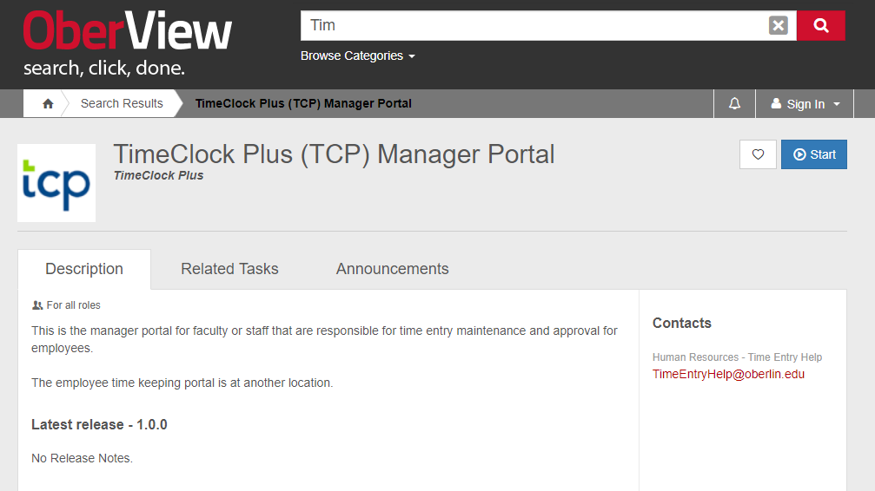

- Once you click start, you should be automatically logged in through Single-Signon if you have an active session. Otherwise, use your user ID and password that you would use with Oberlin e-mail address or Banner.

- Once logged in, you will be able to see your Dashboard and the green Menu bar across the top.
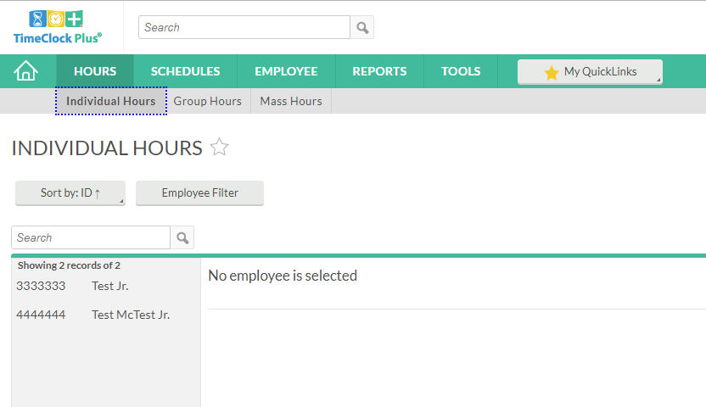

Approving Individual Employee Worked Time
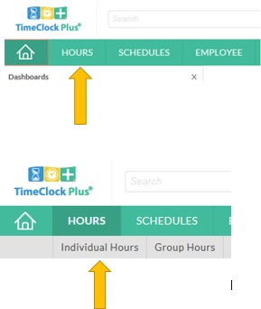
- From the menu bar, select Hours and Individual Hours

- You will then be able to see a list of all employees assigned to you.

*If you are unable to see an employee, contact Student Employment Office to check on the status of their position set up.

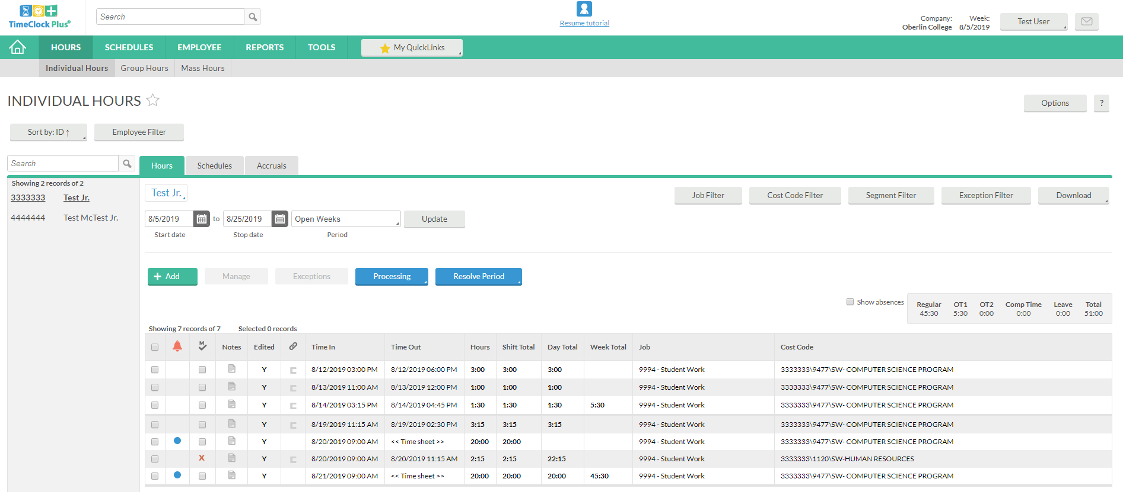
- To view and approve an individual employee, click on the employee name and their time sheet will populate.
- Once you have reviewed the time and ensured accuracy, click on the square to the left of the orange bell; this will check all entries.
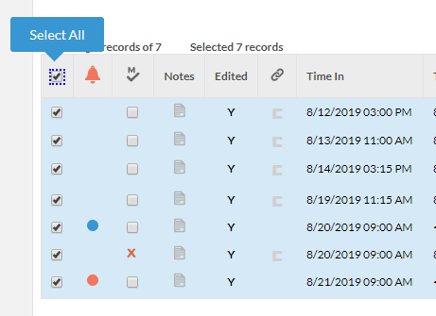

- Once all entries have been checked, you’ll want to select Resolve Period
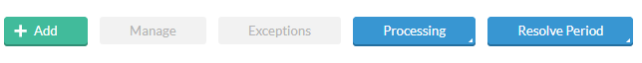

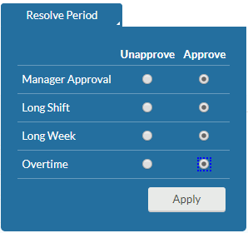
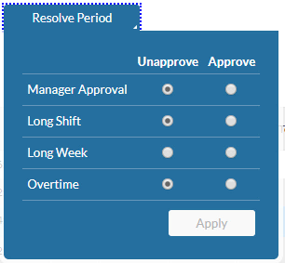
- On the drop down options you will be able to “Approve” or “Unapprove” all checked segments, confirm action by clicking Apply.

- Once applied, you will be able to verify approved segments by seeing the checked M column
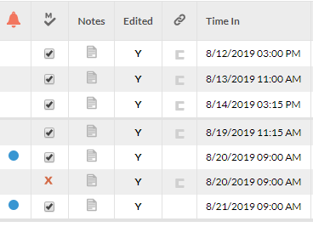

Individual Time Considerations

- You will be able to see time segments for other positions your student may hold, but you will only be able to approve jobs you supervise. These positions are identified by a red X in their time segments
- When you resolve all time instances, you will receive error codes for segments you are not a supervisor for; this is ok and the system will still approve your segments.

- Long Shift: Any time worked over 8 hours in a single day/shift. Any time over 8 hours will need to be approved,
- Long Week: Any time worked over the 25 hours standard. This will be applied to the position that places the time worked for 25 hours and above, and each subsequent worked segment.
- Overtime: This is a notification that a student has worked over 40 hours during a workweek. This will be applied to the position, which places the student in overtime status and will continue to be placed on any new-clocked time afterwards. This will not pay students overtime, student will continue to receive regular pay.
**All these instances will require supervisor recognition and approval.

Editing or Adding a Segment

A Supervisor has access to add worked segments for a student if they wish, or edit segment put in by a student if they notice a discrepancy. The following instructions will guide you on how to make these edits.

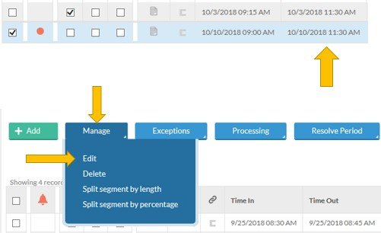
- To edit an employee’s time, click on the segment you wish to edit.
- Next, you will want to select Manage and Edit.

- Here, you are able to edit Time In and Time Out segments, complete edits by pressing Save**.
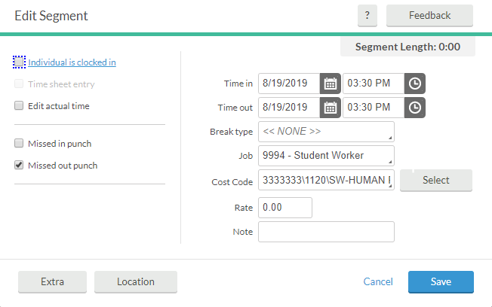

- To add segments for missed a student, click Add

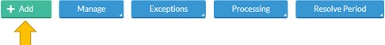

- To add a segment, you’ll want to make sure the correct Time In/Time Out hours are recorded, and select the appropriate Cost Code belonging to the job you’re adding on behalf of the student (only positions you supervise, other positions will need to be added by that approving supervisor). Click Save to complete segment add.
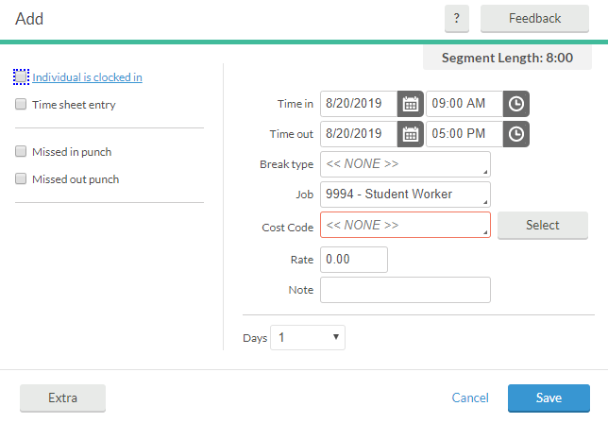

This may be done for a full segment, or a missed punch.

** When editing a segment, you may need to uncheck the “Individual is clocked in” box to edit time.

Time sheet entry: Allows time to be recorded without a clock out segment.

Edit Actual Time: Allows edits to all time in and/or time out segments.

Missed in punch: Allows supervisor to add a punch in segment so that the student can clock out.

Missed out punch: Allows supervisor to add the time out segment if a student is unable to clock out.

Group Hours Approvals

Group hours allows viewing and approving of time segments for multiple employees at the same time.

- From the menu bar, select Hours and then Group Hours
  - Be sure to reference the Payroll Calendar for the correct pay period date to filter by.
  - The Cost Code Filter can be used to narrow down positions you see from all to only the ones you supervise. When filtering be sure to select “User Accessible Only” from the Filter by drop down menu and click Filter.
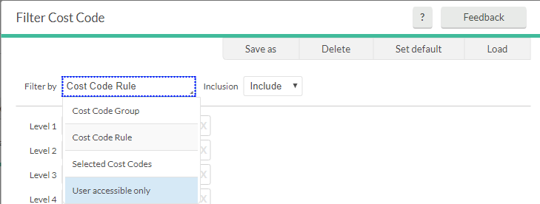

This will render the view of all your students with only your positions.
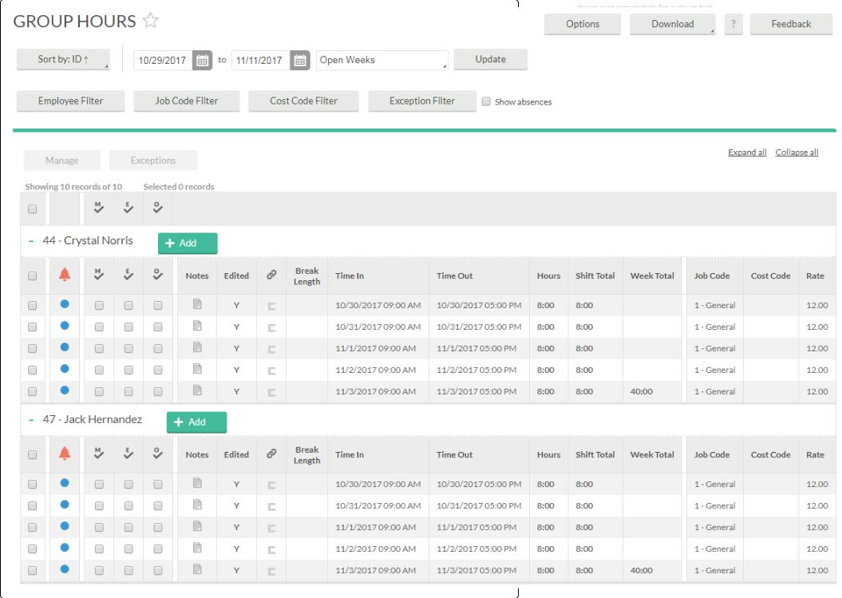

Approving Shifts
- To approve a segment, click on the checkbox under the appropriate header (M for Manager, E for Employee, and O for Other). To approve all the segments currently displayed for each of the displayed employees, click on the appropriate approval column headers.
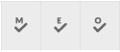
- Once the approval boxes have been checked, you can then click on the blue Apply Changes button to lock the approvals into the system, or the gray Discard Changes button to clear out the changes.
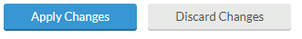

Approving Exceptions
Exceptions can be approved for multiple employees at the same time within Group Hours. To approve exceptions:
- Select one or more segments that you would like to approve.
- Select Exceptions in the information bar.
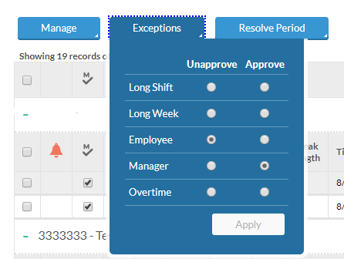

- Here you will see all the applicable exceptions for the selected segment(s), like Long Shift or Long Week. You have the option to approve or unapprove the selected segment(s). If multiple segments have been selected with different approval states (e.g., some have been approved, some have not), neither option will be selected.
- Click the Apply to approve that exception for the selected segment(s).

Mass Approving Exceptions
All exception types for the displayed range can be approved or unapproved at once by selecting the Resolve Period button and choosing which exceptions you would like to approve. Finalize by clicking Apply.
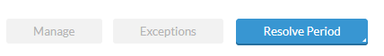

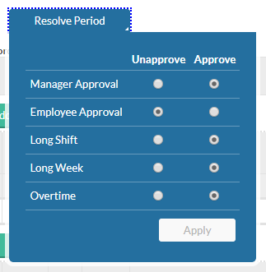

Deleting Segments
Multiple segments can be deleted across multiple employees within Group Hours.
- Select one or more segments that you would like to delete.

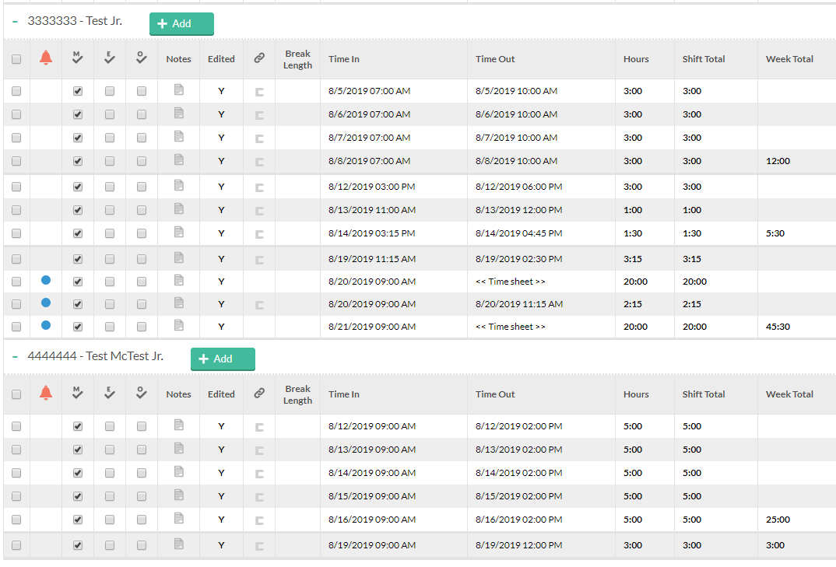

- Select the Manage button in the information bar, and select Delete.
