Margaret Zimmer
Lauren Schwartzman
Corey Patrick Harkins
17 Dec 2010
Systems Ecology – ENVS 316

Continuous dissolved oxygen measurements reveal metabolic patterns in a mixed land use stream
[Nice title]
By Margaret Zimmer, Lauren Schwartzman, and Corey Patrick Harkins

Abstract

Streems in small, mixed land use watersheds, like Plum Creek in northeast Ohio play an important role in processing nutrients and organic matter that enters the Great Lakes. Metabolic activity in stretches of a stream can serve as an indicator of stream structure and function, including stream response to inputs from various types of land use. Continuous dissolved oxygen (DO) monitoring in a stream can be used to estimate primary productivity and respiration, the main components of stream metabolic activity. Stream metabolism has never been studied in Plum Creek using in situ, continuous measurement methods. We deployed two DO probes with temperature and light loggers at each of three sites in Plum Creek and collected data at thirty minute intervals for ten days. Diel patterns were evident in DO in association with light and dark periods. On a multi-day scale, temperature proved to be the strongest influence on DO patterns. After a rain event, we observed an increase in net primary productivity (NPP) and a decrease in respiration (R), which we attribute mainly to inputs from agricultural and urban land [From these patterns, it seems like you might be able to speculate on potential importance of autochthonous vs. allochthonous input at this time of year]. Land use inputs may also explain differences in magnitude and patterns of DO between sampling locations, which suggest variations in metabolic activity. We concluded that continuous DO data combined with continuous measures of water flow [?] could allow researchers to analyze the function of Plum Creek. These studies could inform future management and policies regarding runoff.

[Nice abstract]

Introduction

[Since you paper focuses on short term DO patterns, your introduction should very quickly lead into this – in the first paragraph. Someone reading the paragraph below completes it with no sense of what your study is about]
Scarcity of freshwater resources is of growing concern on local, regional, national, and global scales. Protecting aquatic ecosystems and water quality in our surface fresh waters should be a priority for citizens and policymakers alike. This topic is of special relevance to the Great Lakes region, as the Lakes contain 84% of North America’s surface fresh water and 21% of the entire globe’s supply (Great Lakes: Basic Information updated 2008) [easy to cite a peer-reviewed article or source on this and always preferable to do this]. Plum Creek in northeast Ohio, the site for our study, feeds into the Black River, which in turn empties into Lake Erie. Plum Creek is a second order stream (a stream formed by the confluence of two first-order streams), and Bishop et al. (2008) state that first and second order streams set the water quality for the region [excellent use of literature to establish importance of your study]. Thus, inputs and outputs of small streams like Plum Creek have a significant effect on Great Lakes watersheds.

Many studies have documented detrimental effects of anthropogenic land use on stream structure and function (Brisbois et al. 2008; Mallin et al. 2008; Vidon et al. 2008). Land use effects include degradation of riparian vegetation, increased sediment loads, and modified flow and disturbance regimes (Bernot 2010). Additionally, the U.S. Environmental Protection Agency’s National Water Quality Inventory identified agriculture as a major source of excess nitrogen and phosphorus to surface waters (Caskey et al. 2009). Eutrophication may result as the influx of nutrients elevates algal growth, which in turn cause anoxic conditions that kill stream organisms and degrade water quality (Biggs 2000). Urban runoff has been documented to contribute organic matter, bacteria, nutrients, metals, and other pollutants to streams (Almeida et al. 2007; Girija et al. 2007; Paul and Meyer 2001). A 2008 study by students at Oberlin College found that the urban area of the City of Oberlin contributed significant amounts of fecal coliform to Plum Creek (Santino et al. 2008). The most recent EPA assessment of Plum Creek (2006) designated it as impaired due to siltation and nutrient and organic enrichment attributed to crop production, pasture land, urban runoff, and septic tanks (Watershed Assessment Unit Summary).
[You have done some fin background research. Nice job of summarizing information relevant to your work, but organizationally, you are taking too long to bring the reader to the particulars of the gap in knowledge that you intend to address]

Previous studies of Plum Creek by students at Oberlin College have assessed water quality and steam conditions with a focus on system structure, by testing water samples for such parameters as turbidity, pH, and nutrients in the form of nitrogen and phosphorus ions (Fessenden and Timberlake 2000, Cummings et al. 2004; Feeser et al. 2006; Allen et al. 2007). Organic matter content was also assessed with ex situ biological oxygen demand tests (Feeser et al. 2006; Allen et al. 2007). However, no studies have been done in Plum Creek that focus on stream function.

[This is probably where you want to start your paper because it communicates to the reader what your study is actually about and begins to build a specific gap in knowledge. Some of the material you have above can then be moved below, but your introduction should really focus on using dissolved oxygen to measure metabolism in stream ecosystems and in this stream in particular] Metabolic activity can serve as an indicator of the function of a stream ecosystem, including its reaction to inputs from runoff (Bernot 2010). Living organisms within stream ecosystems use nutrients and organic matter in their metabolic cycles. Rates and magnitudes of metabolism may indicate the amount of nutrients and organic matter within the system (Gordon et al 2004). Also, stream metabolism is important to water quality because aquatic organisms consume organic matter, and take up potentially harmful inorganic dissolved nutrients and incorporate them into their biological tissue (Allan and Castillo 2007).

Because light drives photosynthesis, daily light cycles are another important control on stream metabolism (Mulholland et al. 2001; Naiman 1983; Bott et al.1985; Webster et al. 1995; Young & Huryn 1999). Primary production occurs during daylight hours. Respiration occurs at all times, but in the absence of primary production during dark hours. Consequently, daily light cycles create diel (24-hour) metabolic patterns. [Seems important to use a sentence or two to discuss the importance of autochthonous vs. allochthonous processes with respect to metabolism – primary productivity is obviously autochthonous carbon production, but it may be driven by allochthonous input of nutrients. Respiration can be driven by either autochthonous or allochthonous input of carbon]

This study used in situ continuous measurements of DO to examined metabolic patterns in Plum Creek in relation to daily light cycles at different points in the stream [There is a logical link to land use, but since each site is somewhat additive, it is not a direct relationship to land use and you don’t analyze it as such, so better not to overpromise what you can reasonably conclude]. By studying metabolism, we aimed to begin to fill the gap [which gap? Get specific] in knowledge about the function of Plum Creek. Our objectives were to conduct a trial for the method of in situ, continuous DO monitoring in Plum Creek, and to relate captured DO patterns to time, different land use types, and rain events.

Our mechanistic hypotheses were as follows:

Controls on metabolism at different time scales:
We hypothesize that visible diel patterns in DO would be revealed through continuous monitoring, and that these patterns would be the result of metabolism [how would you know if diel patterns were a function of some other factor?]. Primary production produces oxygen through photosynthesis, and would cause DO to increase during the daylight hours. Lack of light during dark hours would disallow primary production, but not respiration, which uses oxygen. This would cause DO levels to decrease at night. Biological activity will be the dominant control on DO [explain what other controls exist] at all time scales of the study period, including hourly, daily and multi-day scales.

[Seems like you need a clear explanation of factors affecting dissolved oxygen – primary productivity, respiration, diffusion, pre-existing DO of inflowing waters.]
[Also important to discuss seasonality of your study – how does the fact that you are working at this time of year affect what you observe?]

Land use effects on metabolism:
We hypothesized that land use types adjacent to stream study sites would influence DO levels. We thus predicted that Hamilton St, with runoff from recently fertilized fields, would have the lowest overall DO levels of the three sites. This is because an influx of organic matter and nutrient inputs from farmland has been found to increase production, depleting oxygen by increasing rate of respiration due to microbial activity and organic matter decomposition (Hauer and Lamberti 2006) [the restructuring makes clear that this is something that was found in this study]. Hwy 511 likely receives comparably less nutrients from the adjacent urban lands, so we predicted that DO levels there would be the highest of the three sites. Higher DO levels would indicate that there is less primary production occurring, thus less food for decomposers who respire and deplete oxygen. We hypothesized that Morgan St, the intermediate site, with highly mixed land use, would see intermediate ranges of DO between Hamilton and Hwy 511.

Rain event effects on metabolism:
In both urban and agricultural land, we hypothesize that the build up [do you mean delivery of?] of organic matter and nutrients from human activities cause rain events to have a profound effect on stream ecosystems. The influx of nutrients and organic matter from run off during rain events stimulate primary production, which would cause DO to spike during the day, but overall decrease due to a heightened level of R from decomposition [of allochthonous inputs?]. Thus, an increase in both NPP and R would be seen following a rain event, with an excess of R resulting in a decrease in DO.

Materials and Methods

Study Sites

Plum Creek (Fig 1) is a stream located in northeast Ohio and feeds into the Black River, then Lake Erie. It has its headwaters in agricultural land west of the city of Oberlin, and then flows east through a golf course, a forested park, and the city of Oberlin before joining the Black River (Orr 1998).

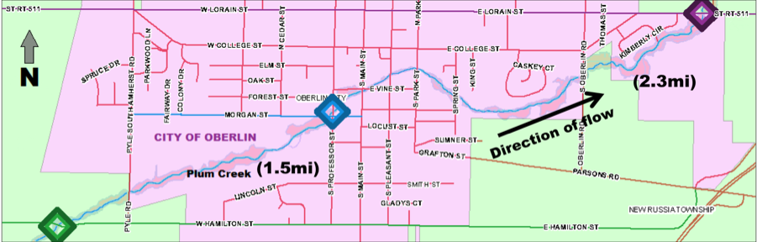
Figure 1: Map of study locations in Plum Creek, Lorain County, OH. Distances between sites are in parentheses. Diamonds indicate sampling sites: Hamilton St, Morgan St, and Hwy 511. Pink indicates Oberlin City limits, green areas are in New Russia township. [Nice figure]

For several years, Oberlin College Living personnel has been monitoring Plum Creek on a weekly basis at five distinct sites representing differing land use. It was originally assumed that they had been taking in situ DO measurements, so we chose our three project sites from their five with the hopes of comparing data [we have nutrient data for these sites, which is justification enough for using these locations.]. Said long-term DO values were ultimately not available; however, our sites were also chosen to represent different land use inputs. The sites used in this experiment represent the two end point sites at the outskirts of town and the intermediate site within the downtown portion of Oberlin.

The first site, Hamilton St, receives most runoff from farmland. The intermediate site, Morgan St, is located at the Morgan St-Professor St intersection, 1.5 miles downstream from the Hamilton St site. Morgan St. represents urban and residential land use, plus a golf course and a forested park that separates it from Hamilton. The third site is under Hwy 511, 2.3 miles downstream from Morgan St and just upstream of the Oberlin Waste Water Treatment Plant. The Hwy 511 site represents both upstream cumulative inputs and adjacent urban inputs.

Materials and Tools

Dissolved oxygen (DO) concentration has long been used as a way to measure stream system metabolism (Mulholland et al. 2001). When autotrophic organisms in a stream photosynthesize (primary production), they produce oxygen. When organisms in a stream respire, they consume oxygen. Thus, measured changes in DO can be used to estimate the components of stream system metabolism: GPP, NPP and R (Mulholland et al. 2001). [Since your study itself (including gap in knowledge) is very much focused on DO as a measure of metabolism, it seems like this paragraph should be integrated with your introduction rather than methods]

[Topic sentence? E.g., “The technology we employed at each site consisted of dissolved oxygen and light sensors and datalogging equipment”] We used six Oxyguard galvanic DO probes linked to portable Vernier dataloggers to take in situ DO readings in Plum Creek [Yes, THIS is the DO discussion that belongs in methods]. Two probes were linked to a datalogger. Each site had two DO probes and a datalogger for a total of six probes. Having two probes at each site allowed us to see variability in the technology. Deployment involved placing the datalogger and battery pack in a waterproof container and securing it in riparian vegetation up to 5 feet away from the stream. The actually probes were placed in the stream, near the bank, and secured by placing rocks on the cords that connected them to the loggers. [Nice clear description that would allow easy follow up]

Three Tidbit temperature and light intensity probes were also deployed at each location and data was collected using Hoboware software. An Onset Hobo Water Level Logger was deployed by Professor John Petersen at Morgan St to monitor stream depth. All probes took measurements at the same thirty minute intervals for the duration of the study period (October 24-November 4).

[Typically, the particular brand and model of equipment are included parenthetically. For example, “Galvanic oxygen probes (Oxyguard model XXXX…) were used to …”]

Calibration and Conversion

We calibrated the DO probes before and after the deployment period. A bucket of tap water was saturated with oxygen via an aquarium pump for over 24 hours. Probes collected measurements in the bucket for ten minutes at five-second intervals. After the probes were stabilized, which took roughly seven minutes, an average was taken from the accumulated values. The difference between calibration values before and after the deployment period was used to determine a pro-rated [running average?] correction for instrument drift for data throughout the measurement period [needs a bit more explanation].

The dataloggers took 524 data points at thirty-minute intervals throughout the study period. The dataloggers stored DO measurements as millivolts (mV), which were converted into milligram of DO per liter (O2 mg/L). Conversion was achieved by using saturated oxygen concentrations assuming 1 tam pressure at a known temperature and dividing that number by the calibration constant described above. This in turn was multiplied by the mV reading, which converted the value into mg/L (Garcia and Gordon 1992) [this citation implies that this paper is about converting mV readings into mg/L DO, is this correct?].

Data Analysis and Calculations

Once the calibration constant drift over time was taken into account, the data was smoothed and plotted for examination between and within sites. This step was taken to help filter out noisy data from overall patterns. Data was smoothed by averaging a data point with the point immediately before and after the point of interest. This approach of averaging three adjacent data points at a time smoothed the data substantially.

Metabolism was estimated by calculating NPP and R for each full day of DO data. Calculations are based on a lab manual provided by Petersen (2010) and units expressed as mg per L per hour (mg/l/hr). Daylight and darkness from our light sensor dataloggers varied throughout the week, so a fixed time interval was used to calculate daily NPP and R. The calculation for NPP was calculated as follows for 11:00 AM to 3:00 PM (daylight) on the days 24 Oct through 2 Nov:

NPP = ∆DO/∆t = (DO_{(t+1)} - DO_{t})/∆t

R was calculated as follows for 8:00 PM to 12:00 AM (darkness) on the days 24 Oct through 2 Nov:

R = ∆DO/∆t = (DO_{t} - DO_{(t+1)})/∆t

NPP and R were calculated at each site before (25 Oct) and after (average of 26-28 Oct) a rain event on 26 Oct in order to see the patterns in metabolism following the rain event. Although there were four rain events throughout our testing period, the event on 26 Oct had the most rainfall followed by no precipitation for a few days. We chose the three days following the rain event because previous studies have shown that rain events can take up to 72 hours to flush through an ecosystem (Detty et al. 2010).
Results

All sites showed diel patterns throughout the week, with increase in DO during the day, or light hours, and decrease in DO during the night, or dark hours (Fig 2). Average DO concentrations at the sites were higher downstream than upstream (511>Morgan>Hamilton). Hamilton St had larger daily fluctuations than the other two sites, with changes of greater than 3 mg/L on four days, versus the greatest fluctuation of 1.5 for one day at Morgan and 1 at Hwy 511 on one day [why not express this as rates of metabolism?]. DO at each site increased 24 hours after a ~0.5-inch rain event on 26 Oct. While Morgan St and Hwy 511 returned to pre-rain-event DO levels, Hamilton kept the same levels for the rest of the week, with heightened daily fluctuations starting 31 Oct and continuing throughout the week.

All sites had similar water temperature to each other throughout the study period (+/-1.5 degrees Celsius) until the last sample day, where there was a 5-degree range across sites. Because of the minimal overall difference in temperature across sites, we used temperature at Morgan St as the reference temperature. At Morgan St, temperature increased from 10 to 16 degrees Celsius from 25 October to 27 October, with average diurnal fluctuations of about 3 degrees Celsius. After 27 October, temperature decreased to a low at the end of the survey period of 4.6 degrees Celsius. This trend in decreasing temperature over the week was paired with a general increase in DO. Stream depth data at Morgan St showed a slight increase over the course of the week, with a .04 foot (1.2 cm) increase from small precipitation events throughout the week.
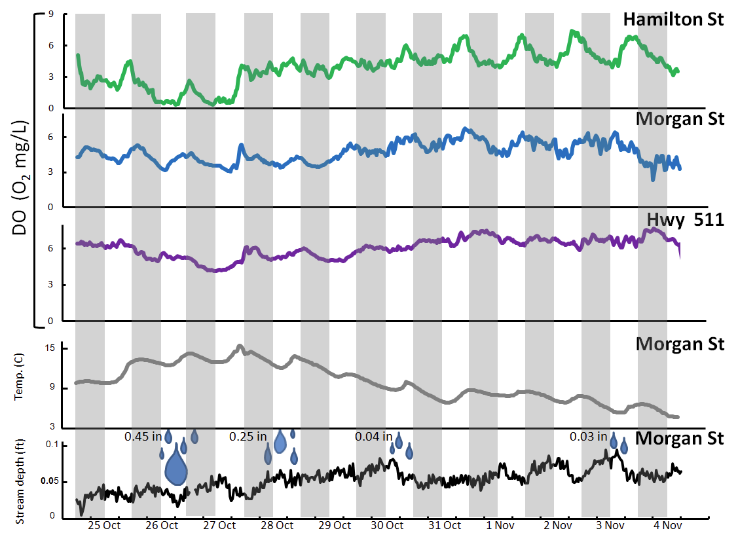
Figure 2: Data collected from Plum Creek, Lorain County, OH, including continuous DO concentration at three locations over ten-day period, water temperature at Morgan St, and precipitation indicated by raindrops and amount of rainfall (data courtesy of National Oceanic and Atmospheric Administration). Gray columns represent 6pm-6am (approximate dark hours) and white columns represent 6am-6pm (approximate light hours). [Very nice figure!]
Saturated DO is the maximum amount of oxygen able to be dissolved in water at a given temperature and pressure. We calculated saturated DO from temperature (pressure assumed to be 1 atm) for each data point from Morgan Street, as explained in our Methods section (Garcia and Gordon 1992). We then ran linear correlations between saturated DO and actual measured DO at Morgan Street for a 24-hour period (Fig 3) and for an eight-day period (Fig 4). The 24-hour correlation (R2=0.5914) showed a negative trend, while the eight-day correlation (R2=0.5252) showed a positive trend.

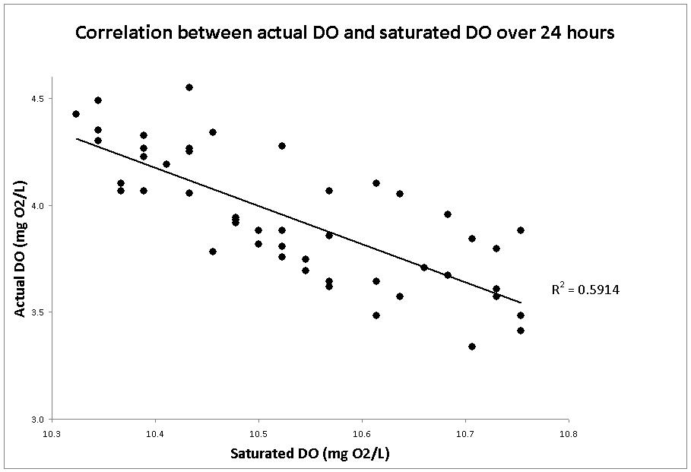
Figure 3: Correlation between saturated DO and actual DO in Morgan St location of Plum Creek, Lorain County, OH over a 24-hour period (27 Oct).

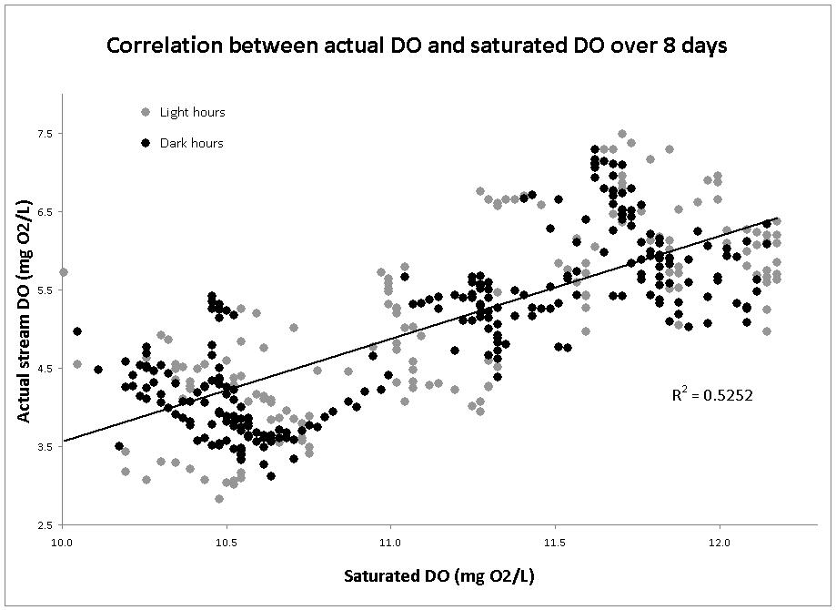
Figure 4: Correlation between saturated DO and actual DO in Morgan St location of Plum Creek, Lorain County, OH over an eight-day period (24-31 Oct).
Average NPP and R were highest at Hamilton St, intermediate at Morgan St, and lowest at Hwy 511 (Table 1). In response to a rain event on 26 Oct, NPP generally increased while R generally decreased at each site (Fig 5).

Table 1: Net primary productivity (NPP) and respiration (R) calculated for three locations (mg O₂/L/hour) in Plum Creek, Lorain County, OH. NPP was calculated from the change in DO from 11:00 AM to 3:00 PM. R was calculated from the change in DO from 8:00 PM to 12:00 AM.
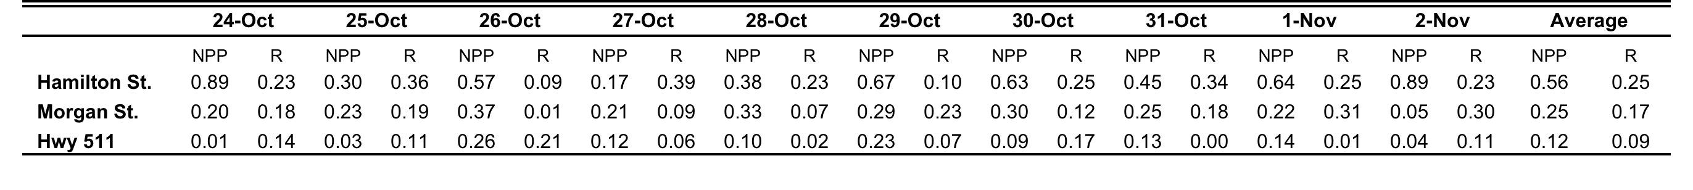

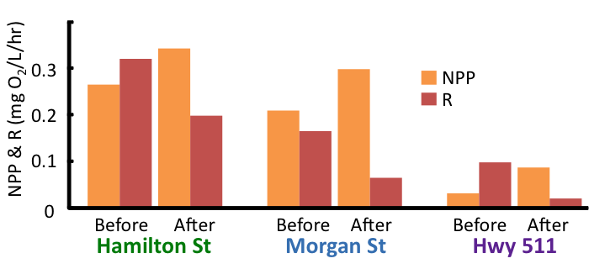
Figure 5: Net primary productivity (NPP) and respiration (R) at each site Before (25 Oct) and After (average of 26-28 Oct) a rain event on 26 Oct at three locations in Plum Creek, Lorain County, OH. After the rain event, NPP increased and R decreased at all locations.

Discussion

Our data supported the hypothesis that continuous data could reveal diel DO patterns [good]. DO generally increased during daylight hours, which we attribute to oxygen production by photosynthesis. DO concentration generally decreased during dark hours, which we attribute to oxygen consumption by respiration in the absence of photosynthesis.

We found a negative correlation between actual DO and saturated DO over a 24-hour time period. Since saturated is controlled by physical processes including temperature, this negative correlation suggests that processes other than temperature - i.e. biological metabolic activity - strongly influence DO on a 24-hour time scale. If the stream had no biological activity, we would expect to see a positive correlation at this scale (Petersen, pers comm) [Since this is a logical reality, I don’t think you need to cite anyone]. This is an important finding because it provides additional support for the claim that biological activity indeed occurs in Plum Creek [perhaps say something about seasonality]. In contrast, the positive correlation between actual DO and saturated DO over the entire study period (multi-day scale) means the two parameters show similar patterns of change, which indicates they are likely controlled by the same factor, i.e. temperature. This finding demonstrates the importance of continuous monitoring. If only one measurement a week were taken, temperature would likely show as the dominant control on DO, but continuous monitoring reveals that on a 24-hour scale, biological activity likely controls DO [Excellent explanation]. Weekly measurements cannot show the diel metabolic patterns seen in our data. This information is important for future studies of metabolism in Plum Creek. [Good]

The differences in magnitude of DO across sampling locations suggest variations in metabolic activity in stream stretches. Our hypothesis that Hamilton St would have the lowest DO concentration was supported. The DO concentration at Morgan St was higher than Hamilton St, and Hwy 511 had the highest DO concentration of all. The trends seen in DO concentration are exactly opposite with those of metabolism: NPP and R are highest at Hamilton St, intermediate at Morgan St, and lowest at Hwy 511. This indicated that increased primary production may indirectly cause decreases in DO levels [good]. The cause of the DO depletion is likely increased R of the consumers that feed on the primary producers (Hauer and Lamberti 2006). [speculate on autochthonous vs. allochthonous inputs] Hamilton St’s proximity to agricultural lands may explain its higher rates of NPP and R. Runoff from agriculture contributes a higher influx of nutrients to Hamilton than to the downstream sites, which several studies have shown to increase primary productivity and respiration (Bernot et al. 2010, Brisbois et al. 2008). Another factor, dilution, may work in tandem; accumulation of water at downstream sites may dilute nutrient concentrations and thus decrease metabolism downstream.

Of the three sites, Hamilton St had the largest fluctuations in DO concentrations. This could suggest that Hamilton St metabolism responds to nutrient or organic matter inputs more dynamically due to its close proximity to farmland. Brisbois et al. (2008) found that DO showed higher diurnal variations in an agricultural brook than a reference forested brook. They explained that nutrient enriched streams promote increased primary productivity of biomass, which increases photosynthesis during the day, and increases respiration at night as decomposers feed on the biomass. Loperfido et al. (2009) offer an alternative explanation for larger DO fluctuations upstream: they reported that upstream locations have shallower depth, which leads to a larger reaeration rate, or rate at which oxygen diffuses based on saturation [I like the fact that you are drawing on other studies to interpret your data, and this is an explanation that definitely bears consideration. But do consider how the particularities of Plum creek may lead to different explanations – for example, consider light exposure of different sites, depth at these particular sites, etc. e.g. re the upstream sites in our study really shallower? I don’t think so]. Thus, small changes in temperature affect upstream saturated DO more than downstream saturated DO. The diel patterns are almost certainly caused by biological activity, but DO concentrations are probably exaggerated by the process described in Loperfido et al.’s study. These exaggerated fluctuations are seen in our results, which show that Hamilton St has larger fluctuations in DO concentrations than downstream locations.

We found that following the rain event, NPP did indeed increase at all sites, which supports our hypothesis. This increase can likely be attributed to nutrient-rich runoff that enters the stream and increases primary productivity. Previous studies by System Ecology students at Oberlin College (Cummings, Reed, and Weinberger 2004) demonstrated that nutrients and turbidity in Plum Creek increased following rain events. Hamilton St NPP increased the most following the rain event, probably due to its closer proximity to the non-point source of excess nutrients. Other factors have been shown to decrease primary productivity following rain events, including turbidity and dilution of nutrients (Lloyd et al. 1987). However, our results suggest that metabolism increases overall after the rain event, which leads us to hypothesize that nutrients are the dominant control on metabolism in Plum Creek following rain events. [Whether correct or not, these are good logical interpretations of your data]

In contrast to NPP, R decreased following the rain event, which does not support our hypothesis that R would increase following rain events. We had expected R to increase due to the increase in production (plants also respire) and the increase in urban runoff containing organic matter, which would stimulate primary production and subsequent decomposition and respiration. Our expectations were not seen, but one study may shed insight into what occurred: In a study by Roberts et al (2007), rain events flushed streams of leaf litter downstream, which decreased the food supply of detritovores and reduced R [interesting]. This may explain the decrease in R we witnessed. This result is not to say that urban runoff from the city of Oberlin doesn’t affects water quality. Santino et al. (2008) found that fecal coliform levels increase following rain events, polluting Plum Creek. Further studies of metabolism would be wise to keep this in mind when analyzing data.

The absence of flow rate data limited the ability of our study to decisively measure metabolic activity in stream stretches . Instead of conducting between-site comparisons, we were limited to examining each finite site. We attempted salt slug injections early on in the study with no viable results, due to low flow rate. We instead used depth data as a proxy measure of flow. Depth data can show the stream’s general response to water inputs such as rain events, but cannot be used to calculate the change in DO between two sites. With flow rate data, future studies could track changes in DO within a parcel of water between sites in order to calculate whole-system metabolism. Flow rate measurements will be difficult to collect, but the data will allow stronger conclusions about the function of Plum Creek.

Longer-term data collection is needed to further understand seasonal and temporal controls on DO and metabolism. This study was only conducted in the fall, where flow, light, temperature conditions are drastically different than other times in the year. A Systems Ecology study at Oberlin College found that nutrient loads differed seasonally, with the majority of nutrient runoff occurring from August to November (Allen, King, Loope, and Wolfe-Cragin 2007). Continued research is important for future management, policy decisions, and monitoring of Plum Creek. [Good that you come back to seasonality in your conclusion. Worth making this a stronger component of your report – you measured in fall and data may be very different at other times of year – important to communicate this]]

Acknowledgments

We would like to thank John Petersen for his guidance, support, and data throughout this project. Map credits to Lorain County Auditor.

We affirm that we have adhered to the Honor Code on this assignment.
Literature Cited

Allan, J.D., and Castillo, M.M., editors. Stream Ecology: Structure and function of running waters. 2nd ed. The Netherlands: Springer. p. 8.
Allen, M., King, R., Loope, G., and Wolfe-Cragin, C. 2007. Seasonal Dynamics of Water Quality in the Plum Creek Tributary of the Black River in NE Ohio as a Function of Land Use Practices. Oberlin College, Systems Ecology (ENVS 316), Fall 2007.
Almeida C. A., Quintar, S., Gonzalez, P., and Mallea, M.A. 2007. Influence of urbanization and tourist activities on the water quality of the Potrero de los Funes River (San Luis Argentina). Environ Monit Assess. 133: 459-465.
Bernot, Melody J., Daniel J. Sobota, Robert O. Hall, Jr., et al 2010. Inter-regional comparison of land-use effects on stream metabolism. Freshwater Biol. 55:1874-1890.
Biggs, B. J. F. 2000. Eutrophication of Streams and Rivers: Dissolved Nutrient-Chlorophyll Relationships for Benthic Algae. J. of the N. Amer. Benthological Soc. 19:17-31
Bishop, K., Buffam, I., Erlandsson, M., Folster, J., Laudon, H., Seibert, J., and Temnerud, J. 2008. Aqua Incognita: the unknown headwaters. Hydrological Processes. 22: 1239-1242.
Brisbois, Marie Claire, Rob Jamieson, Robert Gordon, et al 2008. Stream ecosystem health in rural mixed land-use watersheds. J of Environ Engineering and Sci. 7: 439-452.
Caskey, B. J. and Frey, J. W. 2009. Biological-community composition in small streams and its relations to habitat, nutrients, and land use in agriculturally dominated landscapes in Indiana and Ohio, 2004, and implications for assessing nutrient conditions in midwest streams. National Water Quality Assessment Program: Scientific Investigations Report 2009-5055. United States Geological Survey.
Cummings, J., Reed, T., and Weinberger, K. 2004. The city of Oberlin’s effect on the Plum Creek watershed during a storm event: variation in upstream and downstream water quality during and after storm water run-off as a function of urban land cover. Oberlin College, Systems Ecology (ENVS 316), Fall 2004.
Detty, J. M. and McGuire, K.J. 2010. Topographic controls on shallow groundwater dynamics: implications of hydrologic connectivity between hillslopes and riparian zones in a till mantled catchment. Hydrological Processes 24: 2222-2236.
Feeser, J., Lauterbur, E. and Soong, J. 2006. Nutrient concentrations along an agricultural/urban stream during low flow and post-storm periods as a function of varying land-use and biological processing. Oberlin College, Systems Ecology (ENVS 316), Fall 2006.
Fessenden, R.B., and Timberlake, R.T. 2000. “A preliminary examination of the effects of land use on water quality using rather primitive analytical equipment.” Oberlin College, Systems Ecology (ENVS 316), Fall 2000.
Garcia, H.E., and Gordon, L.I. 1992. Oxygen solubility in seawater: Better fitting equations. Limnol Oceanogr. 37: 1307-1312.
Girija T. R., Mahanta, C. and Chandramouli, V. 2007. Water quality assessment of an untreated effluent impacted urban stream: The Bharalu tributary of the Brahmaputra River, India. Environmental Monitoring Assessment. 130: 221-236.
Gordon, N.D, McMahon, T.A., Gippel, C.J. and Nathan R.J. 2004. Stream hydrology: An introduction for ecologists. 204. Wiley and Sons. West Sussex, England.
Great Lakes: Basic Information [Internet]. [updated 2008 Oct 3]. U.S. Environmental Protection Agency; [cited 2010 Dec 16]. Available from http://www.epa.gov/glnpo/basicinfo.html.
Hauer, F.R. and Hill, W.R.. 2007. “Temperature, light and oxygen.” Pages 103-118 in F. R. Hauer and G.A. Lamberti, eds. Methods in stream ecology. Elsevier, San Diego.
Howarth, R. W. 1988. Nutrient limitation of net primary production in marine ecosystems. Ann Rev Ecol. 19:89-110.
Lloyd, D.S., Koenings, J.P., and Laperriere, J.D. 1987. Effects of Turbidity in Fresh Waters of Alaska. N Am J of Fisheries. 7:1833.
Loperfido, J.V., Just, C.L., and Schnoor, J.L. 2009. High-frequency diel dissolved oxygen stream data modeled for variable temperature and scale. J of Environ Engineering. 135: 1250-1256.
Mallin, M.A., Johnson, V.L., and Ensign, S.H. 2009. Comparative impacts of stormwater runoff on water quality of an urban, a suburban, and a rural stream. Environ Monit Assess. 159: 475-491.
Mulholland, P.J., Fellows, C.S., Tank, J.L., Grimm, N.B., Webster, J.R., Hamilton, S.K., Marti, E., Ashkenas, L., Bowden, W.B., Dodds, W.K., Mcdowell, W.H., Paul, M.J., and Peterson, B.J. 2001. Inter-biome comparison of factors controlling stream metabolism. Freshwater Biol. 46:1503-1517.
Orr, D.W. 1998. Speed. Cons Biol. 12: 4-7.
Paul, M.J. and Meyer, J.L. 2001. Streams in the Urban Landscape. In: Marzluff J.M., Shulenberger E., Endlicher W., Alberti M.m Bradley G., Ryan C, Simon, U., and ZumBrunnen C., editors. Urban Ecology (2008). Springer. Section III, p. 207-231.
Santino, I., Beresin, G., and Fenster, A. 2008. A spatial analysis of the influence of a rain event on fecal coliform, turbidity and nutrients in a small N.E. Ohio freshwater stream. Oberlin College, Systems Ecology (ENVS 316), Fall 2008.
Vidon, P., Tedesco, L.P., Pascual, D.L., Campbell, M.A., Casey, L.R., Wilson, J., and Gray, M. 2008. Seasonal changes in stream water quality along an agricultural/urban land-use gradient. Proceedings of the Indiana Academy of Science. 117: 107-123.
Watershed Assessment Unit Summary for Plum Creek [Internet]. [n.d]. Ohio Environmental Protection Agency, Division of Surface Water; [cited 2010 Dec 16]. Available from http://wwwapp.epa.ohio.gov/dsw/ir2010/wau.php?hu=041100010505.
[Excellent use of supporting literature!!!]

Appendix 1: Division of Labor
- Deployment of probes: Lauren Schwartzman and Maggie Zimmer
- Retrieval of probes: Corey Patrick Harkins, Lauren Schwartzman, and Maggie Zimmer
- Salt Slug Injection (not included in final report): Corey Patrick Harkins, Lauren Schwartzman, and Maggie Zimmer
- Salt slug and Storm event monitoring: Corey Patrick Harkins and Lauren Schwartzman
- Data analysis: Each group member converted the raw data into usable formats for one site and made inferences included in discussion section. Harkins: Morgan St. Schwartzman: Hwy 511. Zimmer: Hamilton St.
- Calculations of net primary productivity and respiration: Lauren Schwartzman and Corey Patrick Harkins
- Graph of overall data collected from survey dates: Maggie Zimmer
- Graph of dissolved oxygen correlations with saturated oxygen data: Lauren Schwartzman
- Before/after storm event analysis and graphic: Corey Patrick Harkins and Lauren Schwartzman
- Example graph of net primary productivity and respiration: Maggie Zimmer and Corey Patrick Harkins
- Long term data (not included in final report): Corey Patrick Harkins
- Poster and report production: Corey Patrick Harkins, Lauren Schwartzman, and Maggie Zimmer
[Very thorough description of breakdown. Sounds equitable
1. Title & Names of investigators
>Clearly indicates what you did and ideally what you found.
Yes
2. Abstract (250 word max)
>Summarizes what you did, how you did it, what you found, and why it is important.
Yes, excellent
3. Introduction/Background
>Sets context by describing the overall problem that research addresses and appropriately situates this in larger ecological and societal context.
See extensive comments. Too much general context at front – need to more rapidly bring reader to specific gap in knowledge that your study addresses. Organization could be tightened
>Cites relevant primary and secondary literature to support arguments (minimum of four citations).
Yes, excellent
>Problem statement establishes gap in knowledge, need for research, and describes how your research fills gap.
Yes, see comments
>Clearly states mechanistic hypotheses explaining what you expected to observe and why.
Yes, see comments
4. Methods (revised from proposal)
>Describes what you did in sufficient detail that someone could repeat your experiment.
Yes
>Answers what, where, when, and how you made your measurements.
Yes
>Includes diagrams, maps of sampling, tables, timelines as appropriate (only if appropriate).
Yes
>References literature where appropriate (who’s procedure did you follow?).
Yes
5. Results:
>Includes text, tables, graphs & figures that describe but do not explain results.
Yes
>Explains calculations.
Yes
>Indicates statistical significance.
NA
>Does not present same data in both tables and graphs.
Yes
6. Analysis & Discussion:
>Interprets and critically analyzes your findings.
Yes, excellent
>Explores connections between your findings and those of other studies (agreement, disagreement, relevance).
Yes, excellent, really FINE job of interpreting your data in light of other studies
>Addresses the usefulness and limitations of the methods you used.
Yes, see comments, more on seasons
>Addresses limitations of findings and suggests further research that might extend or more conclusively addresses your initial hypotheses and findings.
Yes
7. Literature cited:
>Uses the same format described in the “How to write ecological site assessments” handout.
OK
>Does not use footnotes. Y
8. Figures and figure legends: (tables, graphs, conceptual models, etc. that appear in introduction, results, and analysis & discussion sections)
>Text legend below each figure describes content in sufficient detail that reader can understand what the figure represents without reference to text in manuscript.
Yes
>Symbol legend within the frame of each graphic indicates what different color bars, lines or shapes represent.
Yes
>Figures are numbered sequentially in the order in which they appear in the paper.
yes
>Every figure that appears in paper is directly referenced within the paper.
Yes
>Units are indicated either within the figures (often in the x and y axis labels) or in the text legend.
Yes
9. Appendix 1: Division of labor:
>Describes role of each group member in developing and implementing the project.
Yes
10. General comments:

Maggie, Lauren and Corey:

I am particularly pleased with your efforts to dig into the literature and present your study and interpret results in the context of both local work of previous ENVS316 groups and peer reviewed studies. The component of your paper that stands the most room for improvement is the introduction. See extensive comments within your text. You obviously had some challenges associated with our inability to monitor flow, but you used the data to tell an interesting story that future researchers can build on in important ways. You obviously put a great deal into this project and I hope you feel that you were rewarded by the experience!

POSTER COMMENTS AND GRADE

>Introduction (Lauren): Nice job of setting very broad context for why stream are important to Lake Erie and then narrowing this down to establishing smaller-scale discussion of importance of metabolism as a measure of function and gap in knowledge addressed in this particular study.
>Methods (Corey): Nicely rehearsed and comfortable presentation
>Data presentation/interpretation (Lauren): Greater eye contact would have been beneficial to audience. Nice job of interspersing speculation on some of more ambiguous findings – e.g. decrease in respiration after storm
>Data presentation/interpretation (Corey): Generally solid clear presentation. Explanations of importance of flow rate and of inverse patterns in measured DO vs. Saturation for different time scales not as clearly explained as they might have been.
>General comments: Answers to questions were generally thoughtful and indicative of excellent understanding of material (but see comment above on measured DO vs. DOSat. The “Mixed land use” component of your poster did not really get much explanation or interpretation. A few more comments at the end relating findings and future potential to land use would have brought this together.

