A Spatial Analysis of the Influence of A Rain Event On Fecal Coliform, Turbidity and Nutrients In A Small N.E. Ohio Freshwater Stream
[Fine title, you might indicate the season]
Ian Santino, Glennon Beresin, & Andrew Fenster
Oberlin College, Systems Ecology (ENVS 316), Fall 2008
Abstract

Plum Creek is a small tributary of the Black River, which flows directly into Lake Erie and so the water quality of this creek and others like it ultimately affects the health of the lake ecosystem [not clear how much]. Representative of many similar systems in the NE Ohio bioregion, the Plum Creek watershed includes urban, agricultural, and forested land, each of which affects water quality differently. Nutrient runoff has been a particular focus concerning the health of the stream and lake [seems like a bit of an odd justification for a study that ends up focusing on FC. Seems like you would want to more directly build a gap around FC]. In our study, we examined an uninvestigated [has it never been investigated, or has it not been investigated in the way you investigated it?] water quality variable, the pathonogenic-indicator bacteria fecal coliform (FC) by comparing it to nutrient and turbidity dynamics, which are better understood. To do this, we sampled FC, turbidity, and nutrients at high spatial resolution along Plum Creek on a low flow day and a high flow day [during what time of year?]. We expected an increase in FC and nutrients during a rain event due to increased runoff carrying in FC from the adjacent land. In addition, we expected a positive correlation between turbidity and FC due to increased sediment disturbance in the water. Finally, we expected urban areas along Plum Creek to have the highest FC levels because of increased impermeable ground surfaces, and high use by humans and animals. After conducting a correlational analysis between FC concentrations collected on the two separate days, we found higher turbidity and fecal coliform concentrations on the high flow day. When we combined data from day one and day two a clearer positive relationship emerged between FC and turbidity [what happened when you did not? Seems like this is a critical take home part of the story]. Spatial patterning from the high-flow day suggests that urban areas accumulate [contribute?] the most FC.

Introduction

The health of the Lake Erie ecosystem has been a particular concern since the 1950s [citation?]. Besides harmful development along the lake’s shores [harmful in what ways? This is vague], land use [is there land use that is not bioregional?] and development along the rivers and streams of its watershed is very important. Smaller tributaries like Plum Creek are important to investigate because they create a more diffuse input to the lake that is difficult to quantify. However, collectively the input from small tributaries contributes a great deal to the water quality of the whole hydrological system. They also tend to flow through residential areas so their water quality can affect human and animal health. Plum Creek is one such tributary of the 12-mile Black River, which flows directly into Lake Erie. [Citations would be useful in this first paragraph. This establishes that you have done the background research and are familiar with relevant literatures]
The land use along Plum Creek is representative of the main types of land use through much of the region. A survey done by Ohio’s Natural resources and Energy in 1997 showed that 52% of Ohio land use is dedicated to agriculture, 27% forested and 14% developed or urban areas, and so Plum Creek is an ideal microcosm for investigating the effects of land use on water quality in N.E. Ohio [Is there an author that can be cited for this study?]. The headwaters of the 9.72-mile creek start off in agricultural fields just west of the city of Oberlin near Quarry Road. The creek runs through a golf course, a small-forested region called the arboretum, and the commercial/residential city of Oberlin. At the end of the Oberlin City limits, the stream receives the effluent of Oberlin’s wastewater treatment plant (WWTP) and then flows through more agricultural land before draining into the Black River.
Through the recent past, much attention has been paid to studying nutrient dynamics in the lake Erie watershed as an indicator of water quality. The focus on nutrients has sprung from the threat of eutrophication in the lake by runoff from agricultural fertilizers, and so has ignored pathogenic bacteria as an indicator of stream water quality. One pathogenic bacteria of interest, fecal coliform (FC), has not yet been investigated in Plum Creek beyond one summer (2008) of unpublished data collection. Fecal coliforms are a common bacteria associated with standard water quality testing of streams (Frenzel and Couvillion 2002). They are naturally occurring bacteria that help break down food in the guts of most mammals. Thus, they serve as an indicator for fecal contamination and are associated with the presence of pathogens in water, such as Hepatitis A (Frenzel and Couvillion 2002). Since FC is a potential health hazard for humans as well as the ecosystem, we feel that this deserves investigation in Plum Creek. To fill this gap in knowledge, we decided to Compare FC to turbidity, and nutrient concentrations at high spatial resolution along four miles of Plum Creek during autumn, on a low flow day and a high flow day. By using a high spatial resolution, we hoped to be able to assess which of the four different types of land-use (agricultural, golf course, forest, and urban/residential) contributed the most to FC in the creek. [Would be useful to talk about the impact of FC on Lake Erie – beach closings, fishing, etc. You state that it is an indicator of health, but be specific about the impact (or potential impact) of FC entering Lake Erie from rivers and streams. Cite some literature]
An interest in nutrients, specifically in Plum Creek, was sparked by a 1977 USGS study displaying elevated nutrient concentrations [Author?]. Since then, significant research [vague; “significant research” will mean very different things to different people] has been done describing the dynamics and potential sources of nutrients in Plum Creek. In light of this, we thought that looking at nutrient concentrations would be useful in determining sources for FC. In Plum Creek, phosphate and nitrogen containing fertilizers enter the stream by leaching and erosion of sediments mainly from adjacent agricultural land and the manicured golf course (USGS 1977, Feeser et al., 2006, Cummings et al., 2004) The high-resolution study done by Feeser and Soong [use “et al.”only when there are more than two authors] in 2006 focused on quantifying sources or general areas for nutrient inputs and we used their sampling scheme in our analysis of FC for the sake of continuity and potential comparison [good]. Beyond Plum creek, one study found a positive correlation between FC and nutrient concentrations during high-flow periods (Schnoover et al. 2006), and we expected this to be true in Plum Creek as well.
Potential sources for FC might include applied manure in agricultural fields, wastewater treatment plants, sewage systems, and animal waste (Tuffard and Marshall 2002). These potential sources are found within the Oberlin stretch of Plum Creek. One study found that urban areas are associated with heightened FC input to streams [?] (Gregory and Frick 2000). This likely occurs because of increased impermeable ground cover, such as pavement, which in effect reduces infiltration into the soil by the disruption of water and soil contact (Schoonover et al. 2006) [I wonder about the importance of domesticated animals as well]. Researchers have also found that FC is typically higher in areas that use sewage systems like Oberlin, rather than septic tanks (Frenzel and Couvillion 2002) [might be worth mentioning that this is a counterintuitive finding]. Finally, in 2007, Smith et al. confirmed a positive correlation between FC and turbidity [not clear if you mean in this river or elsewhere]. The researchers attributed this to the fact that sediment can be a reservoir for FC and that increased turbidity is indicative of sediment disturbance (Smith et al. 2007).
Based on these findings, our mechanistic hypotheses were as follows: We expected an increase in fecal coliform during a rain event due to increased runoff carrying FC delivered from the land. We also expected stretches of Plum Creek through urban/residential areas to have the highest fecal coliform levels because of increased impermeable ground surfaces and prevalence of fecal coliform sources associated with use by humans and animals. Finally, we thought that measuring turbidity would allow us to quantify if this trend occurs in Plum Creek and expected a positive correlation between turbidity and FC due to increased sediment disturbance in the water.

[Lots of good info in this introduction. Still some key issues that probably need to be explained. For example, to what extent is FC allochthonous? My guess is it is mostly, but I’m certain this has been studied.]

Methods

Sampling
We began our investigation by selecting sample sites along Plum Creek so that they accurately represented the different land uses through which the stream flows (fig. X) [?]. They were chosen to be as consistent as possible with the 19 sites used in a previous autumnal study on Plum Creek done by Feeser et al., 2006, [who also utilized high-resolution sampling on both a low-flow and high-flow day. Though they were interested in nutrient concentrations in the stream rather than FC, their objective was similar to ours in that they wanted to identify point and non-point sources of inflow][move preceding text in brackets to intro because it is intent rather than method] along the four miles of Plum creek beginning with its headwaters and ending after the effluent of a wastewater treatment plant, just outside the Oberlin city limits.
We sampled 18 sites on the low-flow day (11/5/08) and 11 sites on the high-flow day (11/15/08) that were chosen based on where the greatest fluctuations in FC from the high-flow day occurred. There had been no rain events within the week prior to sampling on the low-flow day, while the high-flow samples were taken in the midst of a heavy rain event that began 12 hours prior to sampling. Although equipment limitations made it impossible to take quantitative measures of stream depth and flow rate, it was qualitatively apparent that there was a significant increase in flow rate, depth and width of the stream on the second day. [would be nice to mention water temperature]
For consistency, we took samples downstream of any bridges using a 300mL plastic bottle attached to a telescopic sampling pole. Otherwise, we followed general sampling procedures outlined in Standard Methods for the Analysis of Water and Wastewater (Eaton, 2005). We collected samples from all locations [?] within a two hour period each day and processed them for water quality variables immediately after, as in accordance with standard FC procedure.

Sample Processing
To minimize the varying amounts of time the samples spent out of the stream, we processed them in the order in which they were collected. We followed the protocol for growing and counting FC colonies as described in Basic procedure for the Examination of Wastewater (2004). However, we chose to dilute the samples differently for each sampling day. Because we were expecting lower counts on the low-flow day, we made 2 replicates of a 1:1 (50ml:50ml) buffer-to-sample solution. On the high-flow day, we expected much higher levels of FC, but were unsure which dilution would yield an ideal range of colony formation. We decided to make 2 replicate plates of 100:1 (99ml:1ml) dilution and a single plate of 10:1 (90ml:10ml) for the high-flow day. In the end, we excluded the 10:1 high-flow dilutions because the colonies were too numerous to accurately count. [Good]
The rest of our samples were used to conduct measurements for turbidity and nutrient concentrations. To test for turbidity in our samples, which was also done on the day of sampling, we used the Vernier turbidity meter and followed the procedure included in Water Quality with calculators (Johnson et al., 2002). For nutrients, we filtered 50 mL of our samples from each site, froze them and put them aside for the Dionex DX500 Ion Chromatograph (IC) equipped with an AS9 anion column with an carbonate/bicarbonate eluent set up for "fast run" anion analysis. Freezing minimizes chemical activity that could result in changes in ion concentrations and allowed us to complete the IC tests on a later date. The IC gave us readings for Cl, NO3, NO2, PO4, and SO₄ levels in Plum Creek. We did not dilute any of our samples for the IC, as there is a significant amount of water flowing in the system so it is already very dilute [dilute relative to what? Seems like you might simply state that previous analysis indicated that undiluted Plum Creek water tended to be within the range of standards]. Also, since levels over the course of the stream are dynamic, it would be difficult to predict appropriate dilutions.
Despite the fact that it seems reasonable to expect interesting relationships between Ammonia (NH4) and FC, because both are associated with organic waste, we chose not to test for NH4 levels in this study. This is because results from a previous study done in 2004 by Cummings, Reed and Weinberger showed negligible levels of NH4 at a similar time of year that did not express any consistent patterning upstream to downstream.

Statistical method
For our data analysis, we used the averages between the usable replicates of FC plates and compared those values between locations for each day [Probably good to make clearer that you did not attempt to conduct inferential statistics at all]. We then compared data from day one to day 2. Due to the nature of dependency of samples collected within the same river, and because there were so few samples, we felt it wouldn’t be entirely appropriate to do an analysis of variance or t-tests. [Right, this would be pseudoreplication with analytical duplicates. As we discussed, with the study design you have, it really is not possible to do legitimate statistical comparisons. This does not mean you can’t do a meaningful study, only that you can’t use ANOVA to test for differences]

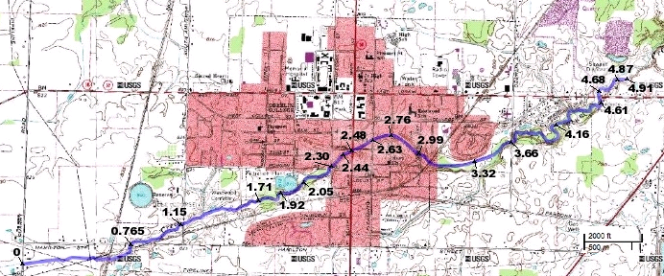

FIGURE 1. This shows the mileage of Plum Creek as it flows through the varying land use patterns of the Oberlin Township. The blue dots signify our sampling sites along the creek. We sampled at all marked sites on the low flow day and omitted the third, fourth, seventh, ninth, twelfth, fourteenth, sixteenth, and eighteenth sites on the high flow day. On the graphs in the results section, these locations are labeled by the roads that the stream intersects, and go in order from upstream to downstream.

Results

Fecal coliform

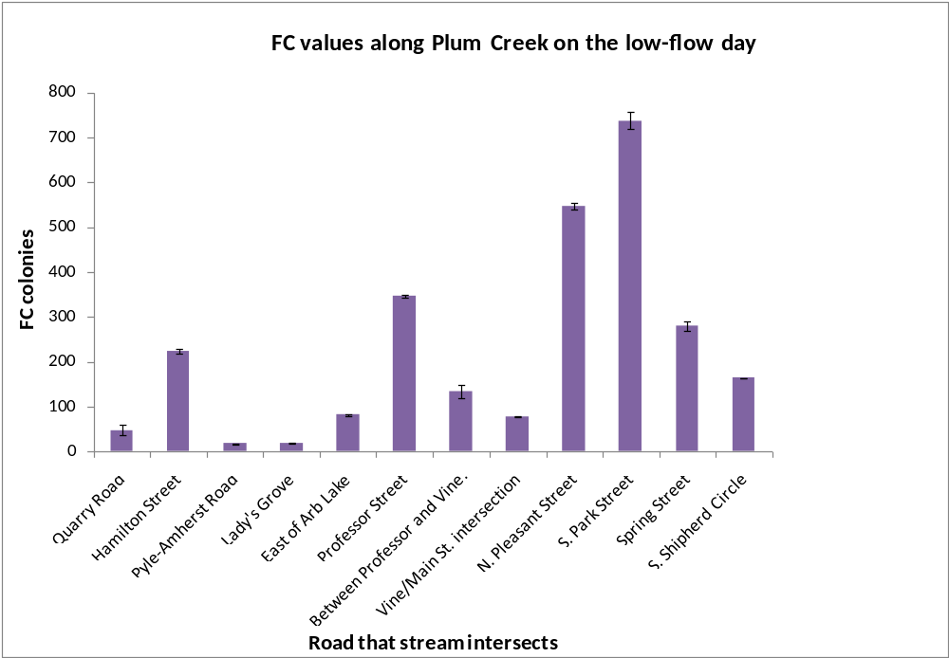
FIGURE 2. Average FC counts along Plum Creek. Error bars were calculated using the range between [?Be specific, how were these calculated?] duplicates of each sample.

The FC results on the day with low-flow showed high variability [Might have been nice to calculate a coefficient of variation among all sites on each of the two sample days and then you could discuss differences in the degree of variability on the two days]. Due to extenuating circumstances, we were only able to test for FC in the first 12 samples. Despite the variability, the FC count peaked at N. Pleasant Street and S. Park Street, which are both close to the center of town. The lowest values occur outside of town. Although the error bars are small, they represent a descriptive analyses and not an analytical one. That is, they show the error in analyzing the data, as only one sample was taken from each site and was split up into duplicates [good that you describe this].

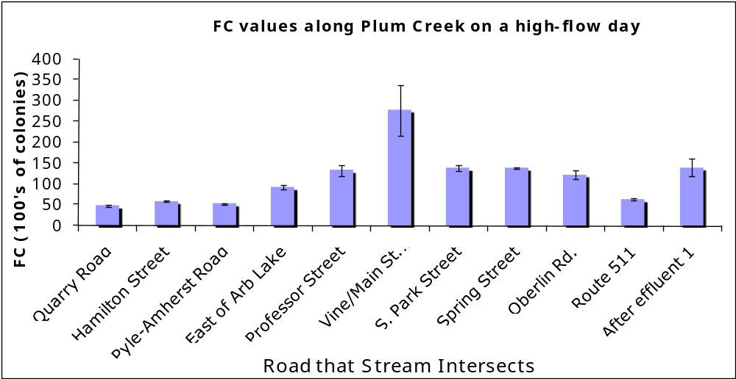
FIGURE 3. This data shows FC colonies (in 100’s) along Plum Creek on a high Flow day. Scale was reduced so the error bars could be made out. Error bars were calculated from duplicates of each sample.
The data for the high-flow day show a similar curve as the low-flow day but with less variability. For the sake of time we sampled fewer sites, but based them on where we saw the greatest shift is FC from the previous day. Still the highest FC values were measured at the Vine and Main Street intersection, which is also in the center of town. For some analyses we decided this point was an outlier and ignored it, but it is left in the graph here for sake of completeness. Even when it is deleted, the pattern remains similar. The highest values occur within the Oberlin city limits, and the lowest FC values occur in agricultural areas.

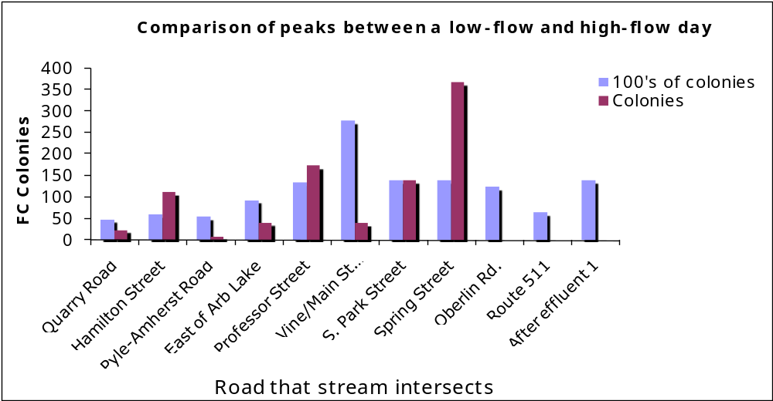
FIGURE 4. This figure places the data from figure 1 and 2 in the same graph so that spatial variability can be more easily analyzed. The high-flow days were put on a lower scale (each number on the Y-axis represents 100 colonies) so that both of the trends can be compared. [Since the data are identical in the two sets of graphs, best to just use this one and leave previous two out.]

When FC data from both days are combined, the pattern of higher FC counts within urban areas remains. Although counts along the stream, relative to each other, are variable between days, during each sampling period the highest FC counts were within Oberlin City limits. It is important to note that the two series are in very different scales. The FC counts for the high-flow period are larger than the counts for the low-flow day by a magnitude of 100. We thought it would be useful to express the data this way so that the spatial patterns between two series could be adequately compared. Also, additional sites had to be ignored because we did not have data from the high-flow day to match them with.

FC and Turbidity

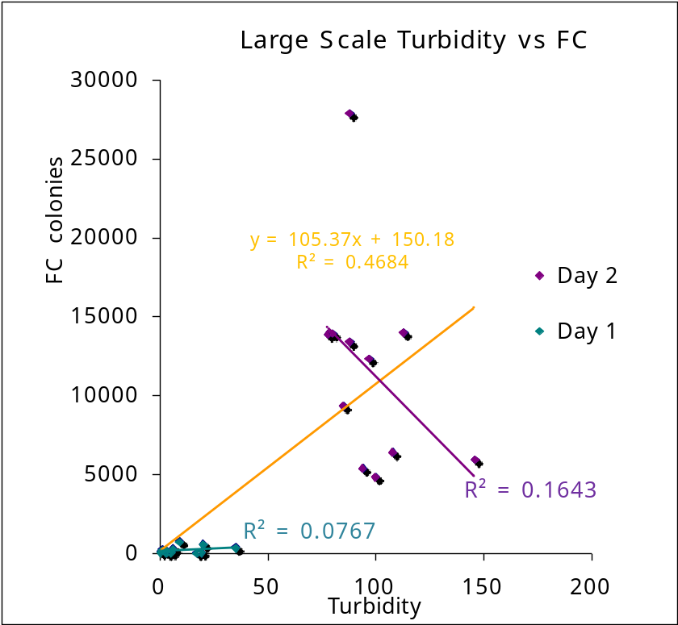

FIGURE 5. This chart shows the relationship for turbidity and FC. The purple data represent the low-flow day [do you mean high-flow day?], while the blue data correspond to the data taken during the high-flow day [Low flow???]. The line in orange is the regression line between the two variables when data from the two days are both included.

On the low-flow day, there was a very slight positive correlation between FC and turbidity, but with a very low R-value, indicating the relationship is quite weak. On the high-flow day, there is a somewhat stronger relationship between the two variables, although the relationship is negative. The data from the high-flow day were all significantly larger, both in FC and turbidity, than the data from the low-flow day. Because of this, when the data are combined an overall positive correlation emerges. The outlier is shown here for sake of completeness. When the outlier is ignored, the patterns remain the same but the R-value for the high-flow trend line changes to 0.22 and the R-value for the average trend line changes to 0.61.

FC and dissolved inorganic ions

The data for nutrients were analyzed using an ion chromatograph (IC), and the regression lines from the standards came out looking very messy [vague – explain more clearly what was wrong]. The regression had to be tweaked in order to avoid negative values. When analyzed against FC, the nutrient data from the low-flow day showed no relationship.

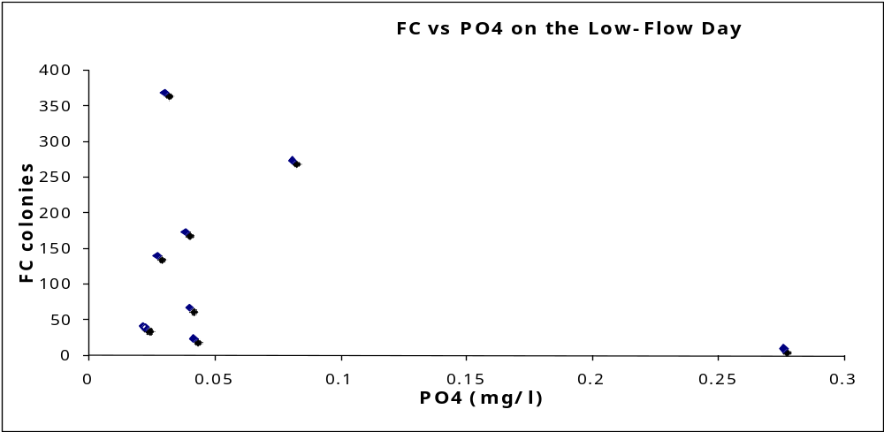
FIGURE 6. An example of nutrient data. This data shows the relationship between PO⁴ and FC on the low-flow day. The R²-value is 0.09. An outlier was deleted from this graph at 33 mg/l.The data between FC and NO₃ and between FC and SO₄ also exhibit similar trends, with R²-values of 0.08 and 0.008 respectively. Levels of NO₂ were too low too be measured on the low-flow day. [Good to include some sort of analysis like this, but in more final paper, you would probably leave this out and simply state there were no apparent relationships between CF and ions measured]

On the high-flow day, the relationships between nutrients and FC all exhibit a negative correlation. However, the R² values are so low that little information can be gleaned from them. The R² value for FC vs. NO₂ is 0.14, for FC vs. PO₄ it is 0.04, for FC vs. NO₃ it is 0.11, and for FC vs. SO₄ it is 0.04. [This essentially means that they are not correlated, so probably no point in suggesting that the relationship is negative.

Discussion
Fecal coliform

Although the FC data exhibited high variability, both days showed higher FC counts in areas in the center of town, suggesting that FC levels may be higher in urban areas in general. The lows for each day occur outside of town, in the agricultural and golf zones. This evidence further suggests to us that urban areas are in some way responsible for elevated FC levels [good]. Because there are distinct peaks in urban land zones, we speculate that there are more sources for FC in urban areas, although those sources are not known [but you speculated on these in your introduction]. The peak on the low-flow day is further downstream, which was counterintuitive; we would expect to see the peak move further downstream on a high-flow day due to more rapid flow. We are unsure of the cause of this shift.
Visually there appears to be more variability on the low-flow day, but this could be due to the difference in scale [see earlier comment about coefficient of variation as a tool for comparing variability when averages are very different]. Because the high-flow day uses a much larger scale, the differences between the peaks are actually much larger than the difference in peaks for the low-flow day. Nonetheless, the trendline for the low-flow day does not exhibit as clear a line as does the high-flow day. This could be because on a low-flow day the runoff is bound to be more sporadic, and will not be immediately mixed in with the rest of the stream water but remain localized. On a high-flow day with more turbulent water, anything being introduced to the stream will be more quickly mixed with the rest of the stream. In essence this could cause a smoother peak.
A possible mechanism that would increase FC in urban areas is runoff. Due to paved roads and decreased areas of water catchment like soil and vegetation, more water flows to the creek faster. The water carries with it anything that it picks up off the pavement, including excrement [so you DO have an explanation. This is inconsistent with wording two paragraphs earlier in which you state, “sources not known”]. This mechanism is consistent with our hypothesis that FC will be higher in urban areas due to more sources of animal and human wastes [good]. Waste in a densely vegetated area with a thicker riparian zone would likely decompose before entering the stream.

FC and Turbidity

On the low-flow day, the correlation between FC and turbidity was virtually nonexistent. Although there is a very slight positive correlation, the R² value is so low (0.08) that little information could be confidently extrapolated from the data. This is inconsistent with our original hypothesis that FC would be positively correlated with turbidity. Because we do not feel confident in the correlation, it appears that judging by our data there is no clear relationship between the two variables on a low-flow day.
On the high-flow day we found a moderate negative correlation between FC and turbidity, with an R² value of 0.16 [this is also very low]. This is the opposite of what we were expecting. Because sediments were thought to be a reservoir for FC (Smith et al. 2007) we expected the release of those sediments due to the turbulence created by a rain event to produce a positive relationship. Since neither of the days’ data support this hypothesis, we were curious to find an alternative explanation. One possibility is that in urban areas, although increased runoff carries more FC, it does not carry as much soil and organic matter as in rural areas. As a result turbidity does not increase as much in these areas, creating an inverse relationship.
Although during different days the trends were not strong, when we combined the data from both days a significantly stronger positive relationship between FC and turbidity emerged (R²=0.47). We believe that both turbidity and FC are positively affected by increased runoff on a larger scale. For turbidity increased runoff translates into increased flow, which churns up sediments and carries in FC containing organic matter [these are two potentially very different mechanisms]. For FC, increased runoff carries more FC into the stream. While this relationship may not hold at smaller scales, it is apparent over a larger range of values. Therefore, we think the relationship between FC and turbidity is not causal, but rather both are the dependent variables positively affected by increased runoff. [Good]

Nutrients

Both because our regressions between nutrients and FC were weak on the high flow day (R² for FC vs. NO₂=0.14; FC vs. PO₄ =0.04; FC vs. NO₃ =0.11; FC vs. SO₄ =0.04, Appendix B), there were no clear relationships on the low-flow day, and because we experienced technical difficulties with our IC standards, we thought that no decent [?] interpretations could be gleaned from our data. If the negative regressions on the high flow day were more pronounced, we might be able to explain them by relative land use in Oberlin. For example, nutrient regression may be negative on a high-flow day because while agricultural areas have high nutrients, they also have low FC.

Future Research and Management

The temporal and spatial variability of FC concentrations in Plum Creek displayed in our data signifies that further testing needs to be done at this high resolution [good conclusion, but needs an explanation of why – something like, “in order to more completely understand mechanisms that might be responsible for delivering FC to Plum Creek….]. We only captured the patterning during the course of two autumn days, instead of having a full year picture of the fluctuations. We also only captured the change between low flow and high flow, where a more complete understanding of how weather affects FC would call for sampling several times before, during and after the same weather event.
Although we can see that the portions of the stream running through the more highly populated, urban landscapes had higher FC both during a high and low flow period, the mechanism for those high levels is unclear, no sure point source was identified. We can only speculate that the FC is entering the stream in those locations and that the increase during a rain event brings in runoff from the surrounding areas. However, it is also possible that it is flowing downstream from a different location.
In order to reduce runoff into Plum Creek in the urban areas of Oberlin, we would suggest that the city invests in creating a riparian buffer surrounding the edges of the stream [Speculate on feasibility]. In effect, the riparian buffer would ensure that more FC is processed before entering the stream. Hopefully with the backing of further research, the presence of FC in Plum Creek will become a more serious concern for the city to amend.

APPENDICES:

- Division of Labor…………………………………………………….. A
- Low-Flow Nutrient Graphs………………………………..………….. B
- Acknowledgements………………………………………………..…..C

Appendix A)

Beresin, Glennon: Experimental design, author of Methods section, group editing of final paper, collaborative writing of Discussion section, FC processing, text editing of poster, layout of poster

Fenster, Andrew: Experimental design, author of Introduction section, group editing of final paper, collaborative writing of Discussion section, created map figure, layout of poster, helped edit graphs

Santino, Ian: Experimental design, author of Results section, group editing of final paper, collaborative writing of Discussion section, Excel and PowerPoint expert, layout of poster, helped edit graphs
[Sounds good]

Appendix B) High-Flow day

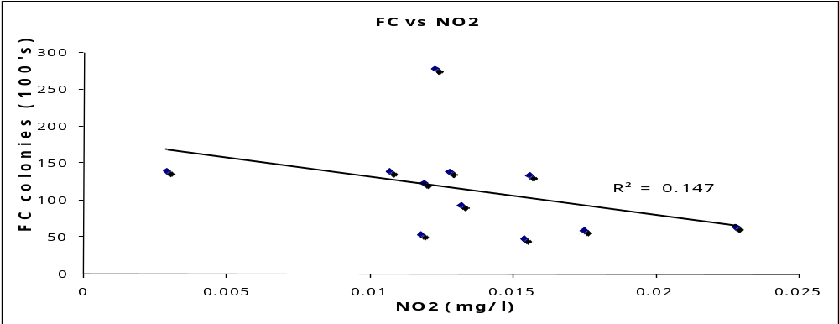

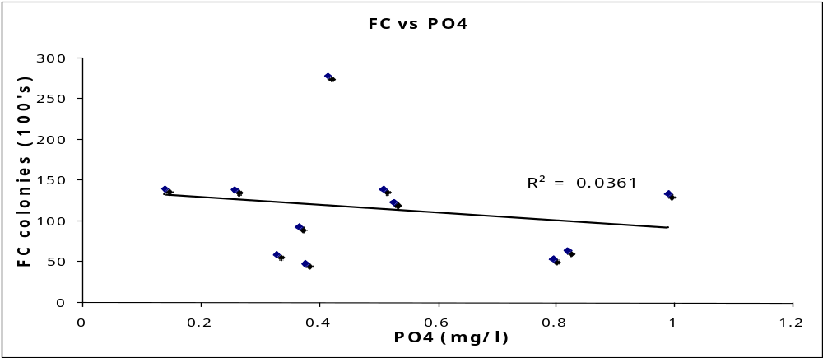

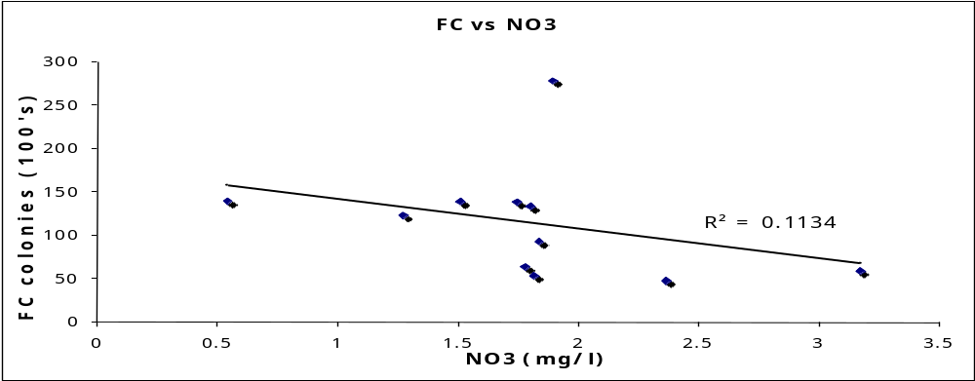

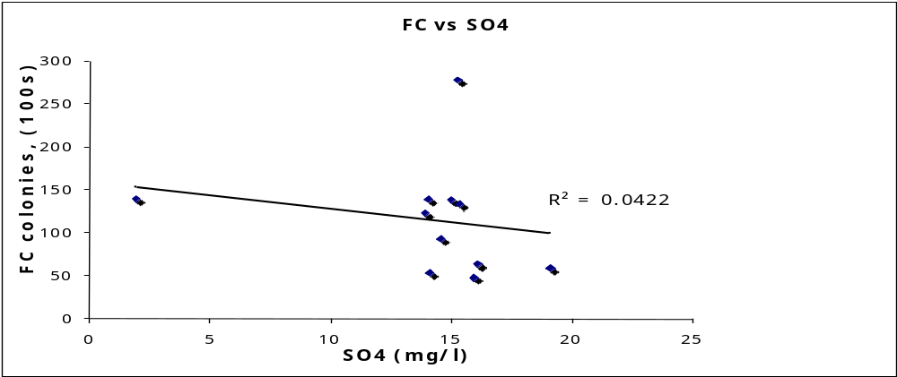

Appendix C) We would like to thank John Petersen for creating a class that provided us with resources and time to devote to this project. We would also like to thank him all the students of 316 2008 for advice and editing throughout the semester.

Literature Cited [include only works actually cited]

Allen et al. Seasonal Dynamics of Water Quality in the Plum Creek Tributary of the Black River in NE Ohio as a Function of Land Use Practices. Oberlin College, Systems Ecology (ENVS 316), Fall 2007. [Cut because not cited]

Cummings, Reed and Weinberger. 2004. The city of Oberlin’s effect on the Plum Creek watershed during a storm event: variation in upstream and downstream water quality during and after storm water run-off as a function of urban land cover, Oberlin College, Systems Ecology (ENVS 316), Fall 2004.

Feeser et al. Nutrient concentrations along an agricultural/urban stream during low flow and post-storm periods as a function of varying land-use and biological processing. Oberlin College, Systems Ecology (ENVS 316), Fall 2006.
Fessenden and Timberlake. A preliminary examination of the effects of land use on water quality using rather primitive analytical equipment, Oberlin College, Systems Ecology (ENVS 316), Fall 2000. [Cut because not cited]

Frenzel SA, Couvillion CS. 2002 Fecal-indicator bacteria in streams along a gradient of residential development. JOURNAL OF THE AMERICAN WATER RESOURCES ASSOCIATION (38) 265-273. [use consistent formatting]

Gregory and Frick, 2000 Gregory, M.B., Frick, E.A. 2000. Fecal-coliform bacteria concentrations in streams of the Chattahoochee River National Recreation Area, metropolitan Atlanta, Georgia, May–October 1994 and 1995. US Geological Survey Water-Resources Investigations Report. 00-4139.
Plum Creek Water Quality Report, 2004. [Need more info for this citation – not possible to identify source!]

Ohio’s Natural Resources & Energy. 1997. Land use in Ohio mostly agricultural, but trend indicates loss of farm land overall. [Need more info for this citation – not possible to identify source!]

Schoonover JE, Lockaby BG. 2006 Land cover impacts on stream nutrients and fecal coliform in the lower Piedmont of West Georgia. JOURNAL OF HYDROLOGY. (331) :3-4, 371-382, .

Smith J, Edwards J, Hilger H, et al. 2008 Sediment can be a reservoir for colifrm bacteria released into streams. JOURNAL OF GENERAL AND APPLIED MICROBIOLOGY (54) 173-179. 2008

Tufford DL, Marshall WD. Fecal coliform source assessment in a small, mixed land use watershed. JOURNAL OF THE AMERICAN WATER RESOURCES ASSOCIATION (38) 1625-1635, 2002 [Cut because not cited]

U.S. Geological Survey flow and water quality data for Plum Creek for a 3 month period in 1977 [What is your source?]

1. Title & Names of investigators
>Clearly indicates what you did and ideally what you found. [Fine, but could more clearly indicate findings]
2. Abstract (250 word max)
>Summarizes what you did, how you did it, what you found, and why it is important. [See specific comments,
3. Introduction/Background
>Sets context by describing the overall problem that research addresses and appropriately situates this in larger ecological and societal context. Y
>Cites relevant primary and secondary literature to support arguments (minimum of four citations). Y, see comments on where additional literature should be cited
>Problem statement establishes gap in knowledge, need for research, and describes how your research fills gap. Y
>Clearly states mechanistic hypotheses explaining what you expected to observe and why. Y
4. Methods (revised from proposal)
>Describes what you did in sufficient detail that someone could repeat your experiment. Y
>Answers what, where, when, and how you made your measurements. Y
>Includes diagrams, maps of sampling, tables, timelines as appropriate (only if appropriate). Y
>References literature where appropriate (who’s procedure did you follow?). Y
5. Results:
>Includes text, tables, graphs & figures that describe but do not explain results. Y
>Explains calculations. See comments on error bars
>Indicates statistical significance. NA
>Does not present same data in both tables and graphs. Condense graphs to fig 3.
6. Analysis & Discussion:
>Interprets and critically analyzes your findings. Y
>Explores connections between your findings and those of other studies (agreement, disagreement, relevance). Could flesh out further
>Addresses the usefulness and limitations of the methods you used. OK
>Addresses limitations of findings and suggests further research that might extend or more conclusively addresses your initial hypotheses and findings. Y
7. Literature cited: [Should include only literature actually cited]
>Uses the same format described in the “How to write ecological site assessments” handout. [Not consistently]
>Does not use footnotes.
8. Figures and figure legends: (tables, graphs, conceptual models, etc. that appear in introduction, results, and analysis & discussion sections).
>Text legend below each figure describes content in sufficient detail that reader can understand what the figure represents without reference to text in manuscript. See comments
>Symbol legend within the frame of each graphic indicates what different color bars, lines or shapes represent.
>Figures are numbered sequentially in the order in which they appear in the paper. [OK]
>Every figure that appears in paper is directly referenced within the paper. Y
>Units are indicated either within the figures (often in the x and y axis labels) or in the text legend. Y
9. Appendix 1: Division of labor:
>Describes role of each group member in developing and implementing the project. Y
10. General comments:

Andrew, Glennon and Ian:

Overall, this paper is well-organized, and provides thoughtful analysis and conclusions regarding your research. I have numerous specific comments within the text regarding how it might be further improved. Your poster itself was nicely organized, clear and concise. Great job of linking data to the physical map – very clear for the reader. In the poster presentation, Andrew’s introduction was nicely rehearsed and set a clear context for the work. Glennon’s presentation of methods was solid, but came across as somewhat less rehearsed and probably contained a bit more detail than warranted for a poster (detail can obscure main points). Ian’s presentation of conclusions and recommendations included a nice brief discussion of the problems with mechanistic hypotheses that was helpful to the audience. All of you did a nice job of maintaining eye contact with audience. Your group’s answers to questions demonstrated that you had a solid understanding of your research.

Nice work!

