Plum Creek Water Quality
Fessenden, R.B. and Timberlake, R.T.
December 16, 2000

ABSTRACT

We used a spatially intensive approach to monitoring the water quality, particularly the nutrient levels, in Plum Creek, a small stream located in the Black River Watershed…. [I like the way "spatially intensive" sounds, but its meaning is a bit ambiguous here]. Our samples covered a wide range of ecosystem and human influences and represented much of the 9.72 mile long creek. We identified three main sources of pollution. The agricultural/pastoral lands surrounding the headwaters we identified as a non-point source of pollution. At this site, all the factors we measured indicated the lowest water quality observed, with nutrients and turbidity at the highest levels in the system. The Oberlin Waste Water Treatment Plant is a point source of pollution. The plant’s effluent drains directly into the creek and although this water has been cleaned to EPA standards, it is still contributing increased levels of phosphate, nitrate, and ammonium to the system. The pipes which run under the golf course lawns and drain into the creek may also be point sources of pollution. Further study is needed to evaluate this hypothesis.

[You need to provide sufficient context so that someone reading this anywhere in the world will understand what you did and what you found – don't assume your reader knows Plum Creek, the attributes of the watershed, or why this work is important.]

INTRODUCTION

Rivers face a number of threats as a result of the growth and activities of human populations. Among these are changes in water chemistry, operating on varying temporal and spatial scales, physical alteration of the river or surrounding landscape, and introduction of exotic species (Giller and Malmqvist, 1998). The changes in water chemistry, as a result of inputs from a variety of sources, are perhaps the most widespread and possibly the most serious for aquatic life in the affected streams. Pollution, an example of change in water chemistry, is broadly classified according to the nature of its input. If a pollutant can be traced to a single known point of entry, then this location is termed a point source and the process is referred to as point source pollution (Giller and Malmqvist, 1998). Pollution arising from diffuse sources is known as nonpoint source pollution.

In many areas the primary pollutants are inorganic plant nutrients, especially forms of nitrogen and phosphorus (Giller and Malmqvist, 1998; Holas et al., 1999). Nutrient enrichment causes an increase in primary production initiating "eutrophication" [eutrophication is more than just an increase in productivity], a process characterized by a directed and continuous change in the water chemistry and biotic community of the stream (Giller and Malmqvist, 1998). This occurs because the additional detritus from an increase in biomass of both macrophytes and phytoplankton results in increased sedimentation (Giller and Malmqvist, 1998).This, in turn, increases biological oxygen demand (BOD) as oxygen is consumed by microorganisms breaking down this material (Ricklefs and Miller, 1999). The sources of cultural eutrophication (eutrophication that results from human activities) include excess nutrients in groundwater and surface runoff of fertilizers and animal wastes from intensive agriculture, sewage discharge into streams (Norton and Fisher, 2000), and urban runoff (Holas et al., 1999). It is typically most pronounced at the stream reach most directly affected by a point source of pollution, especially if the point source is a continuous discharge. The problem of excess nutrients can be compounded when organic matter is broken down to release inorganic nutrients through decomposition (Giller and Malmqvist, 1998). Eutrophication from point sources has been reduced through improvements in wastewater treatment and a ban on phosphorus in detergents [indicate time and space scale – e.g. "Since passage of clean water act and subsequent legislation starting in the 1970s…… on a national scale"], but in many rivers nonpoint sources of nitrogen and phosphorus from agriculture continue to be the largest contributors (Norton and Fisher, 2000).

The foregoing discussion of eutrophication is presented to illustrate one of many means through which human activity can negatively impact water quality, in this case through increased levels of NH₄, NO₃, and PO₄. Our study of Plum Creek focused on concentrations of these nutrients as well as other water quality factors as a preliminary step in assessing the health of the creek. The condition of the creek is vitally important to the organisms which depend on the creek ecosystem, including humans, and our research was an attempt to contribute to the little that is known about this system.

Lake Erie and the rivers and streams that drain into the shallowest of the great lakes have been focal points for concern over cultural eutrophication (reference). The Black River drains into the South Eastern shores of Lake Erie….. [set the complete context]. Plum Creek is a small tributary of the West Branch of the Black River. Its headwaters are located on the westernmost edge of the Black River watershed, and it flows north and east through the town of Oberlin and under State Route 511 until it joins the West Branch. According to an assessment of the watershed conducted by the Environmental Protection Agency (1997), Plum Creek is 9.72 miles long and drains 14.5 square miles. However, it may only be this long during the spring when flow is highest. Plum Creek is very shallow and has a low flow rate for much of the year. In our experience sampling the water of Plum Creek, it began just south of Hamilton Street [so how many miles and square miles is this?].

Proceeding from its headwaters, Plum Creek flows through agricultural land, the grounds of a golf course, forested areas and buffer strips, downtown and residential areas, and past a waste water treatment plant. At its headwaters Plum Creek is a very narrow, shallow, slow moving stream of water with grasses, moss and other vegetation crowded both along the banks and in the water. Here the creek is in a ditch, the banks rise about one and a half feet on either side. Pasture land from a beef farm surrounds the headwaters; runoff from this land drains immediately into the creek.

The first forested area that Plum Creek flows through is the Oberlin Arboretum. At this point the creek has both more total volume – it is wider as well as deeper – and a higher rate of flow. The channel varies greatly in width but is usually between ten and twenty feet across and the banks are three to five feet high. The riparian forest surrounding it is roughly divided into three regions based on distance from the water’s edge. At the edge of the banks to about fifty feet from the creek is the floodplain community which is dominated by sugar maple trees and, in the herb layer, goldenrod. Beginning approximately fifty feet from the creek the vegetation changes as the land begins to slope gradually upward. Basswood becomes the dominant species as one moves into this region between floodplain and upland forest that we have called the transition zone. The upland forest is primarily oak and beech (see Appendix 2 for a list of plant species in each community).

Our principal objectives were to measure selected factors affecting water quality in Plum Creek. [Was your principle objective to "measure", or to characterize and gain insight into stream condition? Think of data as a means to the end of greater understanding of system function]. We sampled the water at strategic sites to investigate the effects of specific land use practices on water quality. Another objective was to trace the observed nutrient levels to specific inputs. Our study addressed the following questions: How do the selected water quality factors vary at each site studied? What are the implications of the variation of these factors through time and space? [Yes!]

RESEARCH APPROACH

We chose to conduct our research project using a spatially intensive approach. This approach allows us to gain an overall view of the system and to quickly identify “the key causes of poor water quality in a system. This then allows resources to be directed towards critical problem areas” (Eyre and Pepperell, 1999). We conducted an initial sampling of 10 sites throughout Plum Creek. These sites were chosen for the diversity of nearby land use practices [you could be more specific and say that they were chosen for location at transition points between different land uses – for instance immediately before and after golf course, before and after arb, etc.]. After conducting minimal tests on these samples we narrowed them to eight. Three of these sites were chosen for their proximity to possible point or non-point sources of pollution. The other five were chosen to gain an idea of the system’s functioning in response to various land use practices as well as to compare them to the sites which are possible sources of pollution. The numbers before each of the following sites corresponds with the number of the site on the map in Appendix 3.

- The headwaters were tested because of their proximity to pastoral lands and because this was the first accessible location on the creek. 2.) Downstream, approximately a quarter mile, we sampled again in the golf course[is that at the start of the golf course?]. There were two reasons for the selection of this site. First, golf courses typically add fertilizers and herbicides to their lawns that could, potentially, affect the health of nearby water systems. Second, there were five pipes draining into the creek from unknown sources. 3.) A sample was taken in the Arboretum adjacent to the golf course in order to observe the effects of golf course run-off on the creek within the riparian forest system of the Arboretum. It is also the only site along the creek which has not, in the past 30-40 years, been severely altered by humans. 4.) The Main Street bridge was chosen to gauge the effect of the City of Oberlin on the creek. 5.) The Spring Street bridge was also used to gauge the effect of the city. 6.) The 511 bridge site is affected by run-off from the highway and residential areas upstream. We chose the south side of the bridge because of the presence of a gas line running above the creek and a steel drum corroding along the side of the creek. 7.) The effluent of the Waste Water Treatment Plant, WWTP, was measured to determine what the plant was adding to the system. 8.) Just 30 feet past the effluent we measured again to determine how the WWTP effluent affects the water chemistry downstream.

Using the eight sites described above, we conducted our tests every two to three weeks, a total of three times during the testing period of approximately eight weeks [provide specific sampling dates, mention the crucial fact that data collection was done in the fall which is typically a low-flow period for the stream]. All of our samples were collected below the surface of the water in the area of the creek with the swiftest flow. In the laboratory, we tested five different variables in order to measure the relative health of the creek. Those factors were NH₄, NO₃, PO₄, Turbidity, and pH. The first three, in excess, can cause cultural eutrophication and can have detrimental effects on biotic communities within the systems. The methods employed were the Vernier Ion Selective Electrode (ISE) for NO₃ and NH₄, the Vernier Turbidity sensor, the Vernier colorimeter for PO₄, and the Vernier pH sensor. The procedures used came from the modified Vernier Manual.

RESULTS

Our data displays variation over both time and space. We thought it more appropriate to analyze the data with a spatially intensive approach as is explained above.

Ammonium, NH₄ , concentration measured 0.50 mg/L at the headwaters. Directly after the headwaters ammonium levels gradually decrease to 0.30 mg/L at the 511 Bridge and then rise sharply to 0.51mg/L at the WWTP, before dropping off once more (Fig. 1).

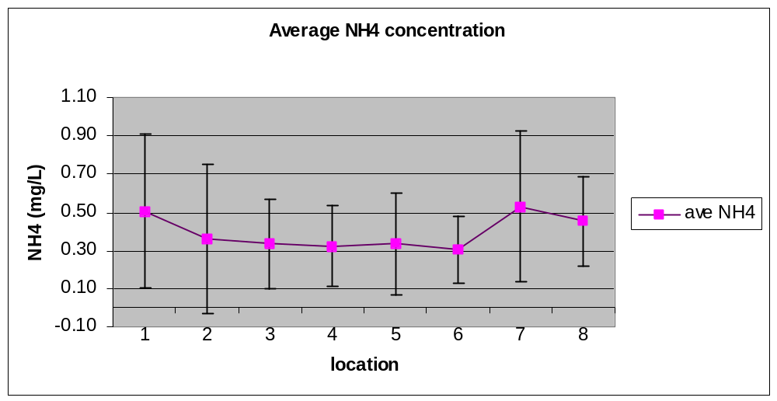Fig. 1. Ammonium concentration in Plum Creek averaged over the three testing dates. Samples were collected and tested from left to right, starting at the headwaters and progressing downstream to the Waste Water Treatment Plant. Error bars represent the standard deviation for samples taken at each site over the three times sampling was conducted (i.e. large bars indicate variability over time) [You need to say something like this because normally one would assume that the error bars were for replicate samples taken at one time]. Concentrations are measured in mg/L NH₄.

[It would have been helpful to include a legend with sample site names associated the numbers – it is a pain to have to keep flipping back to the numbers to find out what these numbers mean]

The nitrate, NO₃ , concentration remained relatively constant. It peaked at the headwaters at just over 10 mg/L (Fig. 2).

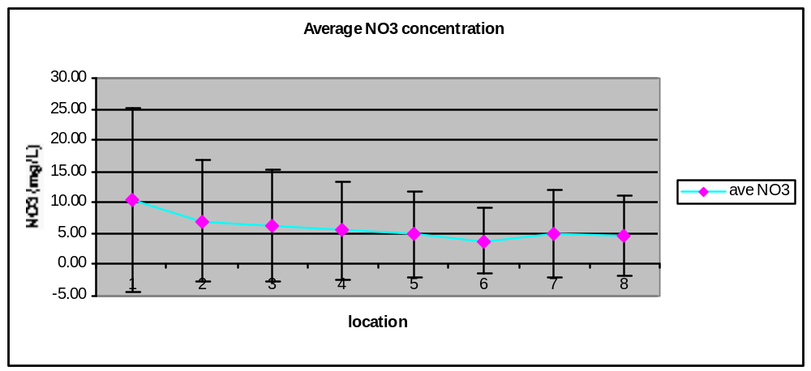

Fig. 2. Average Nitrate concentrations for Plum Creek. Samples were collected and tested from left to right, starting at the headwaters and progressing downstream to the Waste Water Treatment Plant. Error bars represent standard deviation for each of the samples taken at each site. Concentrations are measured in mg/L NO₃. [Hmm, I'm surprised NO3 is not elevated at wastewater plant. The data in fig 6 are so off the wall that I don't think an average is appropriate for this data.]

Turbidity varied greatly throughout the creek and throughout the duration of the research period. The WWTP coincides with a drop in turbidity while the headwaters and the Spring Street bridge produce peaks (Fig. 3).
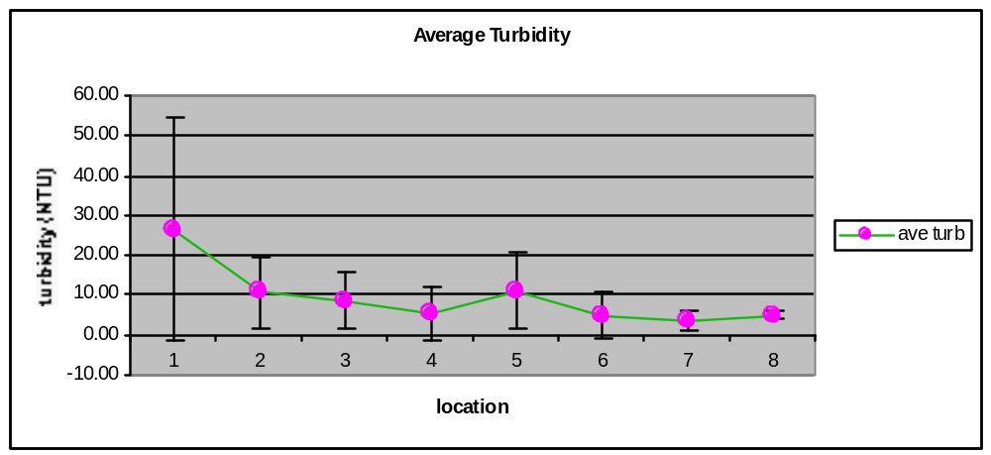Fig. 3. Average Turbidity for Plum Creek. Samples were collected and tested from left to right, starting at the headwaters and progressing downstream to the Waste Water Treatment Plant. Error bars represent standard deviation for each of the samples taken at each site. Turbidity is measured in Nephelometric Turbidity Units (NTU).

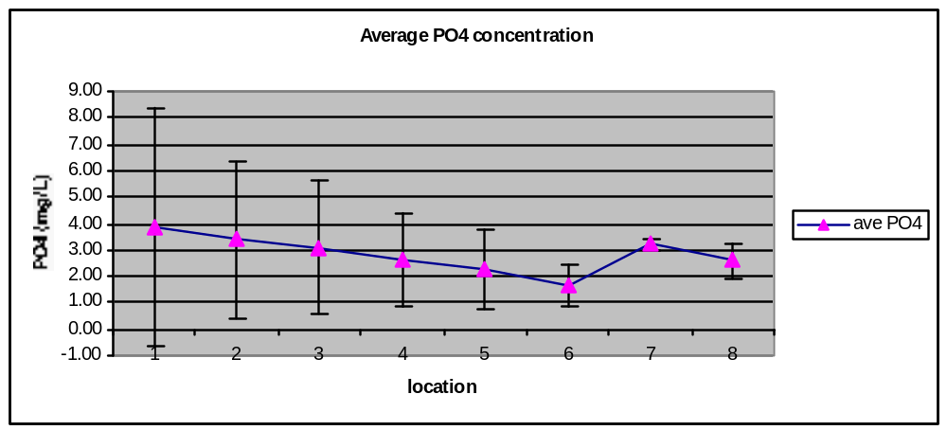Phosphorus, PO₄ , peaked at the headwaters at 3.9 mg/L and decreased gradually to 1.62 mg/L at the 511 Bridge. It sharply increased at the WWTP to 3.22 mg/L (Fig. 4).
Fig. 4. Average Phosphorus for Plum Creek. Samples were collected and tested from left to right, starting at the headwaters and progressing downstream to the Waste Water Treatment Plant. Error bars represent standard deviation for each of the samples taken at each site. Concentrations are measured in mg/L PO₄. [It is interesting how little variation over time there is at the WWTP]

pH was consistently between 7 and 8. Figure 5 shows that the pH drops at the WWTP with a pH of 7.14 (Fig. 5).

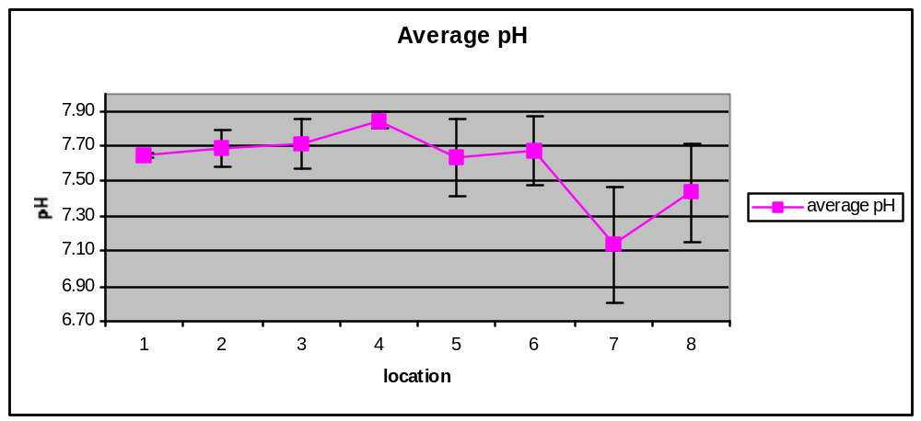Fig. 5. Average pH for Plum Creek. Error bars represent standard deviation for each of the samples taken at each site. pH is measured in pH units.

DISCUSSION

Sources of NH₄ are decaying plants and animals, animal waste, industrial waste effluent, agricultural runoff, and atmospheric nitrogen. Swift moving streams and rivers have a low ammonium concentration at approximately 0.1 mg/L [Reference?]. Slower moving streams, such as Plum Creek, have slightly higher concentrations. This difference is due to the organic matter that settles out in a creek bed when the flow is lower energy. Organic matter releases ammonium into the water as it decomposes. The concentrations of NH₄ within Plum Creek all exceeded 0.30 mg/L [provide the reader with a range concentrations that might be "healthy" for a stream of this size and flow rate]. The above argument can account for such a high number, as the flow of Plum Creek is minimal. The headwaters experienced a peak due to the run-off from the pasture lands within its drainage. Animal waste is a major source of NH₄. The wastes of the animals flow through the groundwater and overland as runoff into the creek at the headwaters. Another peak is seen at the WWTP effluent. This could be due to the high levels of NH₄ in the wastewater before treatment; perhaps the cleaning process does not fully address the presence of NH₄. [some description of the processes occurring in the wastewater treatment plant that might result in elevated NH4 would be appropriate.]

Sources of NO₃ are agricultural runoff, urban runoff, animal feedlots and barnyards, municipal and industrial wastewater, automobile and industrial emissions, and decomposition of plants and animals. NO₃ levels in freshwater systems are typically less than 1 mg/L, but sources such as those mentioned above can produce concentrations of greater than 3 mg/L [Reference?]. According to the Vernier manual, if NO₃ concentrations are greater than 10 mg/L in freshwater, that water can be fatal if ingested(?), especially among children. In our first measurements taken at Plum Creek the lowest concentration of NO₃ was 3.83 mg/L at the Spring Street bridge. This area of the creek is, perhaps, less affected by human than other sites along the creek as it is located on a small street downstream from the city, and the golf course. The site at which the creek enters the Arboretum has slightly higher concentrations of NO₃, 6.36 mg/L, presumably because of the effects of the land use practices in the golf course. High NO₃ concentrations could result in cultural eutrophication, plant and algal blooms. However, our second sampling found concentrations at or near 0.0mg/L. Experimental error may be a factor in this discrepancy, but it is likely that the probe has been damaged or is defective, as the results from the first two sample sessions varied so greatly (Fig. 6).
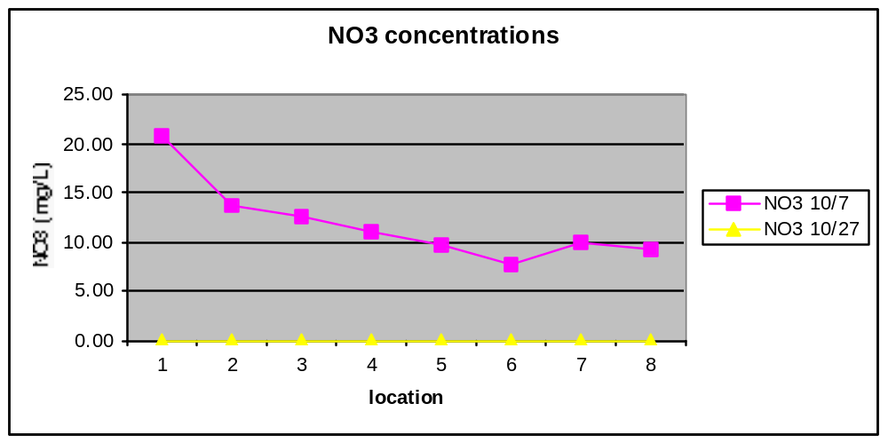

Fig. 6. NO₃ concentrations taken on two days, 10/7 and 10/27. The variability demonstrated in this graph is most likely due to human error or a malfunction of testing equipment. For this reason a third sample was not taken. Samples were collected and tested from left to right, starting at the headwaters and progressing downstream to the Waste Water Treatment Plant.

[Invoke your knowledge of the nitrogen cycle to try to explain the concentration of ammonium at the various sites]

Turbidity is a measure of how much light absorbing material including sediment is suspended in the water column. Sources of turbidity include sediment loading associated with soil erosion, urban runoff, industrial waste, as well as resuspension of sediment by bottom-dwellers, and local production of organic material. Turbidity measurements vary greatly depending on the conditions and influences affecting a stream. The average turbidity for Plum Creek is 9.46 NTU. The Vernier manual gives three examples to demonstrate variation in Turbidity. The Sacramento River measures 4 NTU, the Rio Grande measures 80 NTU, and the Colorado River measures 180 NTU. Turbidity often increases as flow regime and sediment load increase. Plum Creek has a very low flow regime through much of the year including the fall season during which we sampled and its overall low turbidity reflects this. The headwaters had an average turbidity of 26.33 NTU. Most likely this is due to soil erosion and the abundance of organic matter (refer to the introduction) on the streambed at that site.

This study measured the concentration of ortho-phosphates rather than total phosphates. Ortho-phosphates are inorganic forms of phosphate which come from fertilizers and detergents and enter the system through run-off. Total phosphates measure both inorganic and organic. Overall sources of PO₄ are human and animal wastes, industrial wastes, agricultural runoff, and human disturbance of land. If concentrations of phosphates exceed 0.1 mg/L cultural eutrophication may result [Reference?]. Runoff from agricultural areas may receive even higher levels of PO₄. Our PO₄ concentrations varied from 1.64 mg/L to 3.90 mg/L. As these concentrations are exceptionally high, human error has likely played a large role. It is possible that the standards, taken from the Vernier manual, are simply the absorption rates rather than the concentrations [??? not sure what you are getting at here. I made the standards up, so I am pretty sure they are correct]. Regardless of whether the numbers are accurate, the graph in Figure 5 clearly demonstrates the comparative relationship of PO₄ concentrations throughout Plum Creek. The high concentrations at the first two sites, the headwaters and the golf course, may represent runoff from both agricultural lands and the highly manicured lawns of the golf course [good]. PO₄ is one a key component of wastewater, which accounts for the peak at that location [I don't think you meant to write this last sentence. As you know, PO4 is a key component of wastewater resulting from decomposition and certain detergents. Many modern wastewater treatment plants are designed to REMOVE PO⁴, even the old ones do not ADD it!.]

The pH in a freshwater system is typically(?) between 7 and 8. pH values reflect the inverse of the concentration of hydrogen ions and are affected by acid rain, algal blooms, hard-water minerals, industrial wastes, carbonic acid from respiration and decomposition, and oxidation of sulfides in sediments [Reference?]. The pH of Plum Creek is consistently between the desired [desired by whom?] levels. It can therefore be inferred that Plum Creek is not receiving a great influx of hydrogen ions, which would lower pH, and perhaps the input it does receive is buffered by alkaline minerals in the soil. [So what significance does this have for the creek? Why does pH go down at the wastewater outflow?]

An overall depiction of the relative levels of the factors measured demonstrates the effect of site location on the factors. (Fig. 7). The headwaters and the surrounding agricultural and pastoral lands contributed high levels of nutrients and sedimentation. These levels then exhibit a general downward trend until reaching the WWTP. Here, NH₄, PO₄, and NO₃ all increase drastically indicating the direct effect of the effluent on the creek’s water quality. The pH remains basic but it does drop at the WWTP. Based on Figure 7 it can be concluded that the agricultural and pastoral lands are non-point sources of pollution in Plum Creek and that the WWTP is a point source of pollution [Good]. We speculate that the pipes draining into the creek from under the golf course are also point sources of pollution but their effects have been obscured by the high concentrations at the headwaters of the creek.
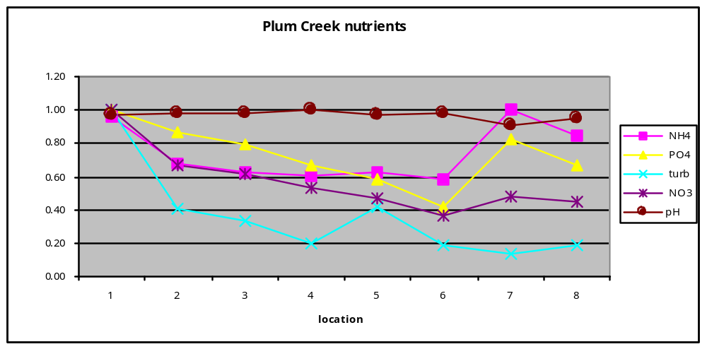Fig. 7. The data was relativized to one in order to demonstrate the comparative values at each point. [Good]

FUTURE RESEARCH

Were this project to be continued in the future it would be important to sample more frequently to obtain more accurate results [I'm not sure "accurate" is the word you want – you could sample infrequently, but accurately. Maybe you mean, "a clearer indication of the time scales over which this system exhibits change" (?)]. Samples should be taken once a week in order to account for small scale (short term) variation. To compensate for more frequent testing, the number of factors tested for could be limited. For example, pH could be tested for once a month while NO₃, NH₄, and PO₄ would be tested once a week. Turbidity could be tested for when there have been substantial changes in weather or flow regime. [You are hinting at it here, but the most important factor to a sampling regime might be to include all seasons. Flow is clearly a function of season. For instance, the dynamics of the system may be completely different in the spring when flow is high].

Weather events should be taken into consideration and documented. During a storm samples should be taken at various locations, like downtown Oberlin, in order to chart the change of nutrient levels due to increased runoff. The phosphorus load often increases during storms (Norton and Fisher, 2000) because of runoff from agricultural lands. The pH may be lower after a storm, depending on the acidity of the rain water.

The project should have a longer duration, perhaps two years or more. Graphing the variations and patterns over seasons would not only produce more complete results, but also improve our understanding of the system as a whole. [Yup, disregard my earlier comment] [Also critical to developing a nutrient "budget" for each section of the stream would be to measure flow rates as well as nutrient concentration. With flow and concentration you can calculate how much is added or removed in a given section, i.e. whether a reach is a source or sink.]

Key to future research would be to measure the effects of the water quality on the biological community using indices such as species diversity and indicator species [good point]. One way to undertake this would be to “compare reaches of the same stream…and examine differences amongst animals and plants in abundances, biomass, species richness, and functional groups” (Giller and Malmqvist, 1998). This could then be correlated with the observed water quality at each location, paying close attention to the spatial patterns of abundance of species known to be particularly sensitive to slight decreases in water quality and those known to be more tolerant (Haslam, 1990).

One final suggestion would be to examine land use more quantitatively in order to better understand and identify the point and non-point sources of pollution. As part of this the researchers could create a land use/land cover map as used in Norton, 2000. It is paramount to integrate “hydrological, geological, land cover and soil properties” in order to fully understand “the anthropogenic effects on water quality” (Norton and Fisher, 2000). According to J.R. Webster, et al, (1995) non-point sources of nutrient pollution appear to be quantitatively more important than point sources [seems like a very general statement – is this for the U.S. as a whole or for certain types of streams?]. If a future research project includes an attempt to reduce certain sources of pollution it may be most important to begin with the non-point sources, although reductions of these are harder to implement than for point sources.
Literature cited

Eyre, B.D. and Pepperell, P. “A spatially intensive approach to water quality monitoring in the Rous River catchment, NSW, Australia.” Journal of Environmental Management 56 (1999) : 97-118.

Giller, P.S. and Malmqvist, B. The Biology of Streams and Rivers. Oxford: Oxford University Press, 1998.

Haslam, S. M. River Pollution: An Ecological Perspective. London: Belhaven Press, 1990.

Holas, J.; Holas, M.; and Chour, V. “Pollution by phosphorus and nitrogen in water streams feeding the Zelivka drinking water reservoir.” Water Science Technology. Vol. 39, No. 12, 1999 : pp. 208-214.

Norton, M.M. and Fisher, T.R. “The effects of forest on stream water quality in two coastal plain watersheds of the Chesapeake Bay.” Ecological Engineering 14 (2000) : 337-362.

Ohio EPA Online. 9 December 2000. Environmental Protection Agency. 1997. <http://www.epa.state.oh.us/dsw/watershed/attain/305b86.htm>

Ricklefs, R.E. and Miller, G.L. Ecology. 4th ed. New York: W.H. Freeman and Company, 1999.

Vernier Manual on Water Quality with Calculators, modified by Dr. John Petersen, 2000.

Webster, J.R.; Wallace, J.B.; Benfield, E.F. “Organic processes in streams of the Eastern United States.” Ecosystems of the World. Vol. 22: River and stream ecosystems. Ed. C.E. Cushing, et al. Amsterdam: Elsevier Science B.V., 1995.

APPENDIX 1 : Division of labor
Both Fessenden and Timberlake drafted the original proposal and decided on the experimental approach. Both took samples each time. In the lab Timberlake measured PO4, turbidity, and NH4 while Fessenden measured pH and NO₃.
Fessenden and Timberlake collaborated on nearly all aspects of the project including the preparing the oral presentation and the written report.

APPENDIX 2 : Plant species of the riparian forest

Overview of plant species within the Arboretum. Those in bold type are the dominant species. [This is nice, but as it is not really drawn on in the report, it could probably be left out]

Floodplain

Sugar Maple Acer saccharum
Black Cherry Prunus serotina
American Beech (saplings) Fagus grandifolia
Bur Oak Quercus macrocarpa
Goldenrod Solidago sp.
Eastern Poison Ivy Toxicodendron radicans
Privet Ligustrum sp.
White Mulberry Morus alba

Transition zone

American Basswood Tilia americana
Northern Red Oak Quercus rubra
Mapleleaf Viburnum Viburnum acerifolium
Virginia Creeper Parthenocissus quinquefolia

Upland

White Oak Quercus alba

American Beech Fagus grandifolia
Northern Red Oak Quercus rubra
Running Strawberry Euanamous alatus
APPENDIX 3 : Map of sampling locations
[Nice map, what is the source for this? A reference would be useful!]

5
7
8
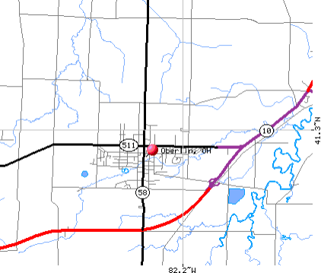
1
2
3
4
6

All of the information on expected levels and influencing factors contained within the “Discussion” section was taken from the Vernier Manual on Water Quality with Calculators, as modified by Dr. John Petersen 9/14/00.

