Oxygen Consumption in the Living Machine:
A Comparison of Nitrification and Carbon Metabolism using BOD₅ method
Ruth Draper, Juliette Beale and Jessica Milne
[Good, clear title. For a general audience you might have included a more descriptive term than “Living Machine” – e.g. something like “ecologically engineered wetland wastewater treatment system”.
ABSTRACT

Oberlin College’s “Living Machine” is a wastewater treatment system that utilizes the interactions between diverse organisms in a wetland ecosystem to break down organic matter, remove nutrients and eliminate pathogens. In order to understand how wastes are processed by the Living Machine (LM), we examined the difference in oxygen consumption between carbon metabolism and nitrification. We used the standard 5-day BOD method on samples from five tanks (AN1, CA1, OA1, OA3, and Eff) [this tank designation would not make sense to anyone not already familiar with the system. You might say, “Water flows through a modular series of anaerobic then intensely aerated open water tanks and finally through a constructed marsh. Of the ten chambers, we took regular water samples….”], and added a nitrification inhibitor to additional sample sets from four tanks (AN1, CA1, OA1, and OA3) to determine amounts of oxygen used by nitrification and carbon metabolism. Overall, we found that BOD, CBOD, and NBOD decrease over the system as one might expect. However, the percentage of oxygen consumption attributed to nitrification and carbon metabolism varied among tanks. Nitrification uses a higher percentage of oxygen than carbon metabolism within the CA1 (61%) and OA1 (65%) tanks. Our results also correlated to changing influent levels due to events such as dormancy, start-up, a campaign to raise influent levels, and fall break.
[Nice abstract, last sentence is vague – what is it about your results that is correlated, total removal? %nitrification?]

INTRODUCTION

Oberlin College’s Living Machine is an ecologically engineered wastewater treatment system. It consists of a series of aerobic and anaerobic tanks as well as a constructed wetland that serve as ecosystems for diverse communities of organisms. These organisms break down solids, process nutrients and eliminate pathogens from the human waste produced at the Adam Joseph Lewis Center. [Say something about system being designed to recycle flush water in the building]
Proper wastewater treatment is critical for a number of reasons. Untreated wastewater can have detrimental effects on the environment and humans. For example, an excess of nutrients in wastewater causes eutrophication in aquatic ecosystems, a bloom of algae that will ultimately render waters anoxic and therefore unsuitable for aerobic organisms. In addition, ammonia, when present in large amounts, can be toxic to fish and nitrate in drinking water is hazardous to small children (Austin 1999) [The point of citations is to direct your reader to the source of your information. It is always preferable to cite literature that is publicly available – cite manuals and hard to get reports only if the information can not be obtained elsewhere. In this case, a general text book would have been appropriate and would have indicated to the reader that this information is commonly accepted]. Pathogens in wastewater can also spread diseases in humans. Overall, freshwater is crucial for life’s processes, yet is a finite resource [needs explanation, if we did not pollute and extract from non-recharging aquifers, the water cycle would provide an infinite supply, no?]. Therefore, wastewater treatment is necessary to cycle clean water back into systems [vague, what systems?].
Wastewater treatment in both the LM and in sophisticated municipal plants consists of up to four steps: primary treatment invo1ves the removal of inorganic, solid, and floating matter; secondary treatment then removes remaining suspended dissolved and solid wastes through biological processes; and tertiary treatment consists of the removal of nutrients and the destruction of pathogens (Ramalho 1983) [so what’s the 4th step?]. Generally, in both municipal and ecologically engineered systems, organisms play key roles in each treatment step [not primary and not always tertiary either], but the community complexity differs between the two systems. Municipal wastewater treatment involves only colonies of bacteria, while the Living Machine involves an entire ecosystem of plants, bacteria, producers and grazers. In fact, the trademark for Living technologies, manufacturer of Living Machines, is “waste equals food” implying that there is a complex role [?] within the ecosystem that contributes to dynamic nutrient cycles [vaguge]. The Living machine also differs from conventional wastewater treatment in its on-site, closed-loop cycling of treated wastewater back into the toilets. Thus, the potential for downstream ecosystems to be harmed is eliminated since water does not leave the system. Finally, the water is not pumped long distances, saving energy.
A characteristic of Oberlin’s Living Machine is that it incorporates the functions of a wetland into wastewater treatment processes. Wetlands are used throughout the world for wastewater treatment mainly because they support highly productive vegetation that is capable of taking up large amounts of nutrients (Verhocen ?)[???] [you imply here that the nutrients are mostly removed via plant uptake – for nitrogen, plant facilitated denitrification is the critical mechanism, and for P, the process probably has more to do with immobilization rather than direct uptake]. There are a variety of types of wetlands used for wastewater treatment, ranging from surface to subsurface flow [references?]. Oberlin’s Living Machine is a hybrid: the tanks, where BOD removal occurs, are open flow while the marsh area, where denitrification takes place, is subsurface flow.
Wastewater is treated by the Living Machine as it is passes through a series of tanks. Each tank is engineered to fulfill one or more of the following processes: carbon metabolism, nitrification, denitrification or phosphorous binding. (See Figure 1) The process begins when influent raw sewage flows into the anaerobic reactors, AN1 and AN2. Here solids settle out and fats and grease are removed by floatation [how does this work, where do they go?!] (Austin 2000). Bacteria in these tanks begin to metabolize labile carbon and organic material; however, since anaerobic respiration proceeds very slowly in comparison to aerobic respiration, most labile carbon is not broken down in these tanks. In addition, bacteria begin to convert organic nitrogen to ammonia in the process of mineralization:
Organic nitrogen→ NH₄⁺
Next, wastewater flows from AN2 into the closed aerobic reactors, CA1 and CA2, which are designed to adapt the waste from an anaerobic to an aerobic environment (Austin 2000). In these tanks organic matter is metabolized and pungent odors are retained. Labile carbon is broken down through aerobic respiration:
C₆H₁₂O₆ + 6O₂ → 6CO₂ + 6H₂O + energy
The nitrogen cycle continues- mineralization is followed by nitrification, in which ammonia is oxidized into nitrite by Nitrosomonas and then into Nitrate by Nitrobacter:
2NH₃⁺ + 3O₂ → 2NO₂⁻ + 2H⁺ :2H₂O (N₃⁻ → N₃⁺) Nitrosomonas
2NO₂⁻ + O₂ → 2NO₃⁻ Nitrobacter (Young, 1973)
After water is treated by the Closed Aerobic Reactors, it is pumped progressively through the open aerobic reactors (OA1, OA2, OA3) where nitrification and carbon metabolism continue. Next, wastewater moves through the clarifier, where all remaining biosolids are removed. Active organisms are then recycled back to AN1. Finally, water passes [filter implies physical rather than biological or chemical action] through a marsh wetland into an Effluent holding tank, from which the toilets are replenished. Neither the clarifier nor the wetland is aerated; they are designed for denitrification, in which nitrate is reduced to dinitrogen gas (NO₃⁻ → N₂) and is released into the atmosphere [clarifier is designed for settling, but probably denitrification does occur there].
Up to this point, research conducted assessing the carbon dynamics within the Living Machine has specifically addressed the spatial dynamics of BOD (biological oxygen demand) as it progresses through the machine (Kolker Monk, and Tong 2000). However, in order to fully understand the carbon and nitrogen processing dynamics of the LM it is crucial to distinguish between the oxygen used for carbon metabolism versus that used for nitrification [explain in a little bit greater detail why this is important information – who benefits, how and why?]. A preliminary test was conducted to determine the amount of oxygen used for nitrification, but the results were inconclusive (Kolker Monk, and Tong 2000). [This paragraph should probably be moved up – this is a bit late to be introducing the core of your research]
Through our research we hoped to expand on previous knowledge by examining carbon and nitrogen dynamics on both spatial and temporal scales, and by comparing CBOD (carbonaceous biochemical oxygen demand) to NBOD (nitrogenous biochemical oxygen demand). Overall, we predicted that total BOD would be high in AN1 and decrease progressively through CA1, OA1, and OA3 as the amount of carbon and nitrogen remaining in the system decreases. We expected to see little or no change in BOD from OA3 to Effluent because most of the carbon and nitrogen will already have been metabolized. We also believed that, overall, carbon metabolism would consume more oxygen than nitrification because we assumed more carbon enters the system. However, we predicted that nitrification would account for more than fifty percent of BOD in OA1 and OA3 because the aerated environment is ideal for nitrification, and by this point we believed most carbon would already be metabolized [did you genuinely predict this? I would not have guessed it before seeing your results]. Furthermore, prior research shows that nitrification requires a lot of oxygen. According to David Austin (1999), 4.6 mg of oxygen are required for every milligram of nitrogen that is oxidized through the process of nitrification. [You don’t need to cite Austin on this – just do the math, 1 atom of N requires 3 atoms of O to make one NO3 molecule. Atomic weight of N = 12, O = 16. (3x16)/12 = 4). Again, avoid citing technical reports and manuals that others will not have access to]
In addition to analyzing the machines processes spatially, we also were interested in temporal trends. Specifically we were concerned with the effects of varying amount of influent being added to the system over time due to different amounts of toilet use. We anticipated that the magnitude of BOD would be correlated to events such as dormancy, start-up, minimal use over fall break, and heavy use during a LM campaign. By examining the data on this scale, we hoped to learn how the LM responds to change.
We tested our hypotheses by taking BOD readings in five different tanks (AN1, CA1, OA1, OA3, Eff) and then compared the magnitudes across the system to determine where the majority of BOD was being removed. By comparing influent and effluent data we determined the extent to which the LM functions in removing BOD. To determine the amount of oxygen being used for carbon metabolism versus that used for nitrification, we added a nitrification inhibitor to sample sets taken from four tanks (AN1, CA1, OA1, OA3). We then compared these values to total BOD to determine the percentage of oxygen required for nitrification versus carbon metabolism. Finally, we compared our data to events occurring over the sampling period to find correlations between events and magnitudes of BOD, CBOD, and CBOD.
Our findings are useful in helping LM operators better understand the way the system functions as well as providing the foundation for future research on the carbon and nitrification dynamics of the Living Machine. We can also use the results to compare the LM to other wastewater treatment systems, which may highlight ways to maximize the LM’s efficiency, and may potentially challenge municipal treatment facilities to adopt similar strategies. [this last paragraph reads a bit more like conclusion than intro]

METHODS

Over the course of one and a half months, we took ten sample sets from five tanks of the Living Machine: AN1, CA1, OA1, OA3, and Effluent (Eff). We took one while the LM was dormant [explain what you mean by dorman – e.g. the facility had been closed to water exchange for ---days] (Sept. 24), three after it started operating (Sept. 29, Oct. 11, Oct 14), two during fall break (Oct. 21, Oct 25), and four after fall break (Oct 31, Nov. 2, Nov. 12, and Nov 14). The spacing of our sampling is due to the limited number of BOD bottles that were available. For each sample set we performed the standard, 5-day BOD procedure (Clesceri et al. 1995) on three replicates from each tank, and for all tanks but Eff we added a nitrification inhibitor to an additional three replicates to measure CBOD (this was not done on the first sample set). We diluted samples in which we anticipated high labile carbon content using a phosphate buffer solution prepared according to standard methods so that they did not drop to dissolved oxygen (DO) levels below two mg/L(Clesceri et al. 1998, Crites and Tchobanoglous, 1998). We began with sample concentrations of 30 mL for AN1, 50 mL for CA1, 150 mL for OA1 and OA3, and 300 mL for Eff, but as the carbon concentration of the machine changed we had to alter the dilutions. Samples which are too diluted result in such a small change in DO that the calculated BOD values are excessively affected by experimental error, while samples which are too concentrated consume so much DO that they become anaerobic. Anaerobic processes produce byproducts that also consume oxygen, making it impossible to tell how much of the DO change is the result of carbon metabolism [literature citation?]. By our last sample sets our dilutions had changed to 10 mL for AN1, 30 mL for CA1, 100 mL for OA1, 150 mL for OA3, and 300 mL for Eff; however, these concentrations were still too large for OA1 and OA3, both of which became anaerobic in our last sample set. Unfortunately, these dilutions were too high for the Oct 31 and Nov 2 runs, and the results for these data sets are unusable. [Specify complete set of dates on which samples were taken]
We added 3 mg of the nitrification inhibitor 2 chlror-6-(trichloro methyl) pyridine (TCMP) (Clesceri et al. 1998) to three replicates from each tank except Eff in order to determine the quantity of DO consumed by nitrification, using the same dilutions as given above. We transferred the samples to 300 mL BOD bottles after aerating them and took initial DO readings using a polarographic DO probe (YSI-1500), starting with the eflluent samples and ending with influent. For each new run of samples we calibrated the DO probe, and between individual samples we rinsed the probe with deionized water to prevent cross-contamination. We sealed the bottles and placed them in a dark incubator at 21ºC for five days. Within this time we checked the intermediate DO levels; if the DO was below 3 mg/L we poured the sample into another container, re-aerated it, and took a second DO reading. At the end of the five days we took DO readings for all samples using the techniques described above.

We calculated BOD₅ for each replicate using the equation:
BOD=(DO_{i}-DO_{f})/F
where DO_{i} is the initial DO concentration, DO_{f} is the final DO concentration, and F is the dilution fraction (mL sample/300 mL). When we re-aerated samples within the five day incubation period, the intermediate DO readings were taken into account using the equation:
BOD=[(DO_{i}-DO_{intermediate})+(DO_{after remixing}-DO_{f})]/F
Once the BOD value for each sample was determined, we calculated the mean BOD value for each set of three replicates. For each individual reactor, the difference between BOD and CBOD is the amount of total oxygen demand due to nitrification, NBOD.
Figure 2 is a graph of the averages of initial, intermediate, and final DO readings for three replicates of a CA1 sample, showing a linear drop in DO over the five days (R=0.9814). The standard error bars show that variability in DO change between replicates increases over time.

RESULTS

We analyzed our data in terms of both time and space. We observed a high variability of total BOD, CBOD, and NBOD values over time (figs 3,4,5), and found no consistent trend between the changes in total BOD in the different tanks among data sets [looks to me like in several tanks over the course of the semester the BOD initially went up, then down, then up]. CBOD and NBOD values for different tanks show a more correlated [not sure what you mean by correlated here – this term has a technical term used in statistics and should be avoided in papers unless you intend its statistical meaning] rise and fall over time, but the magnitude of this change differs among tanks. We calculated the coefficient of variation (CV) of BOD over time within each tank (fig. 6). The CV is a measure of variability relative to the magnitude of average values. As the water progresses through the LM, CV decreases until it reaches the effluent, which has a significantly higher CV than any other portion of the system.
Our data exhibit [“data” is plural] clearer trends over space than they do over time. The average total BOD remains approximately the same from AN1 to CA1 and then decreases through OA1, OA3 and Effluent (fig. 7); the average effluent value is 1.3% of the average influent value. The average values for CBOD and NBOD generally decrease over space in the LM (see fig 8), though the CBOD values decrease steadily while the NBOD values rise from AN1 to CA1 before declining. As figure 8 shows, the average values for NBOD relative to CBOD change as wastewater moves through the LM. Nitrification accounts for an increasing percentage of oxygen demand from AN1 (43%) to CA1 (61%) and OA1 (65%), decreasing in OA3 (?%). Comparison of our average NBOD data to average ammonium concentration (unpublished data, Maly et al 2001), shows a strong correlation between ammonium level in the LM tanks and NBOD values (fig. 9).

DISCUSSION

Considerations for extrapolating LM functioning from BOD data

In order to draw conclusions about the functioning of the Living Machine from our BOD, CBOD, and NBOD data, it is first necessary to consider the relationship of BOD data to the actual processes occurring in the LM. Our BOD measurements are not a direct measure of what is happening in the machine, but are descriptions of the potential demand for oxygen that a given part of the system would have were it fully aerated [Excellent]. For example, the BOD of AN1 is high, but because AN1 is anaerobic and the rate of carbon respiration is slow, we would expect little consumption of carbon. Thus the high CBOD value for this tank indicates that a high concentration of labile carbon is present, not that a high rate of metabolism is actually occurring within this tank.
The amount of labile carbon that is actually metabolized in a given tank is best reflected by the difference in CBOD between that tank and the next adjacent tank in the machine [excellent, but how about the different between influent and effluent]. However, we are unable to draw solid conclusions about the amount of carbon metabolized in a given tank using this method of calculation for two reasons. First, we only sampled five out of the nine tanks of the LM, none of them adjacent, and thus our data cannot pinpoint how much carbon was consumed in a specific tank. Second, the difference in CBOD between two tanks of the LM calculated from one sample set does not take into account the lag time as fluctuating influent volumes move through the LM [excellent]. The change in BOD between different tanks from one sample set is not a reflection of the amount of labile carbon from AN1 metabolized between tanks because any carbon in the other tanks remains from earlier influent. Thus time operates on two levels in the LM, as the influent to the machine simultaneously varies over time and moves through space over time.

Trends in BOD over time

Our graphs of BOD, CBOD, and NBOD over time (figs 3,4,5) reflect the complexity of a system with two scales of time. The magnitude of BOD for the individual tanks over time is highly variable, which we attribute to changes in influent volume, since the rise and fall of AN1 measurements correlates with events over the semester that affected the LM (see fig 3). Our first data set was taken when the machine was dormant, and it shows the lowest BOD values of any data set; because the machine was receiving no influent, it makes sense that there was little labile carbon in the system. Our next data sets (September 28 and October 11) show increase in the oxygen demand of the system, as it began receiving influent and concentrations of nutrients started to build up within the tanks and cycle through the machine [Hmm, the LM seems to anticipate fall break – looks to me like the big drop occurs BEFORE break even starts]. The magnitude of the BOD values dropped over fall break (Oct 21 and Oct 25 data sets), when fewer students were using the Lewis Center bathrooms. The last two data sets we took during the beginning of a campaign in which students were encouraged to use the Lewis Center bathrooms, and these two data sets exhibit the rise in BOD we would expect from increased influent. This correlation of the AN1 data over time to events affecting the influent volume suggests that measuring BOD does yield data relevant to the processes occurring within the Living Machine. [There is another complication here and that is that the QUALITY as well as quantity of water may have been affected by the poop campaign – one might anticipate an increase in the BOD of influent waters to AN1 as a result of increased % of water being feces].
The relationship between the BOD levels of AN1 and the levels of the other tanks over time, however, is unclear. The relative ordering of BOD magnitudes for AN1, CA1, OA1, and OA3 does not remain constant, nor is there a strong pattern to explain why AN1 is sometimes lower than CA1. Our graphs of CBOD and NBOD over time (fig 4,5) also show no consistent relationship between the relative changes in the different tanks. We think that this is due to the time it takes water to flow between tanks, but our data is too inconclusive to provide evidence of how long it takes a given load of influent to progress through different parts of the system [you need the flow data for this]. We attribute this to the uneven and distanced spacing of our data sets, which were taken 3-18 days apart, and conclude that many more sample sets would be needed to study lag time in the LM.
We analyzed the high variability of BOD values over time by calculating the coefficient of variation (CV) of the mean BOD for each tank over time. CV is a standardized measure of variation within a set of data, calculated by dividing the mean by the standard deviation [vice versa]. A higher CV indicates a greater relative variability over time. As figure 6 shows, the CV decreases over space in the LM from the AN1 to OA3 tanks, and is significantly higher in the effluent. This decrease in CV shows that, as wastewater progresses farther from the influent, it is subject to decreasing fluctuations of labile carbon concentration. The wide range of variation in the input to AN1 becomes progressively tempered through the system, suggesting that the progression of water through the machine has a stabilizing effect on labile carbon levels. The CV value for the Effluent tank, however, is inconsistent with this trend. We hypothesize that the actual BOD values of the effluent are so small (a range of –0.183 to 1.653 mg/L/5 day) that the experimental error inherent in the DO probe is the primary factor inducing variability in this data, whereas the data for all other tanks is of a high enough magnitude that its variation must reflect actual variability in the system.

Trends in BOD over space

To analyze BOD in the LM over space we used the mean of data from different sample sets because there was such a high variability of BOD magnitude over time. Figure 7 shows the average total BOD of all eight data sets; however, the average OA3 and OA1 values are missing data points from our last sample sets. This is because there was a dramatic increase of labile carbon within these tanks that caused the samples to become anaerobic over five days. Because we did not change our OA1 and OA3 dilutions for this set, the fact that these samples became anaerobic means that their BOD values would have been higher than other values we obtained for these tanks. This means that the average BOD for OA1 and OA3 should be slightly higher than indicated by figure 7 [info in last two sentences might go better in the results section]. Even without taking this into consideration, though, this graph exhibits a clear decrease in oxygen demand as the water travels through successive tanks of the LM, indicating that labile carbon is being respired by the system. The similarity in BOD between AN1 and CA1 reflects the fact that AN1 is anaerobic, and that most dissolved labile carbon in this tank flows into CA1 without being consumed. By the time wastewater reaches the effluent an average of 98.7% of BOD is removed; in comparison with similar wastewater treatment systems, which reduce BOD by 73-95% (Neralla et. al 2000 and Verhoeven et. al 1999), this suggests that the LM is performing its function of removing labile carbon from wastewater quite effectively. However, preliminary research on the residence time of the LM estimates that the residence time of the system is 122 days (unpublished data, Maly et. al 2001). This would mean that all effluent values we measured in this study are from summer influent, when use of the Lewis Center was quite low; comparing effluent data from a low use time to influent data from a high use time does not yield an accurate percent removal of BOD. We conclude that, to obtain an accurate measurement of the LM’s effectiveness at removing BOD, samples would need to be taken over a much longer time period [excellent].
.

Trends in nitrification over space

A comparison of average values of total BOD, CBOD, and NBOD values (fig 8) shows a general trend of decrease of oxygen demand for consumption of both nitrogen and carbon in tanks farther from the influent. However, CBOD decreases steadily, whereas NBOD rises between AN1 and CA1 before decreasing. Because AN1 is anaerobic, no nitrification is actually occurring in the tank, and thus the NBOD value only reflects a potential rate of nitrification. The mineralization of organic nitrogen in AN1 produces the ammonium sent into the aerated CA1 tank, where nitrification begins. Since all of the ammonium from AN1 flows into CA1, we would expect little change in the NBOD value between these tanks. We attribute the rise in NBOD to additional ammonification in CA1, which increases ammonium concentration [yes, I think this makes sense]. Figure 9 supports this mechanism by showing the strong correlation between ammonium concentration and NBOD values throughout the LM, and specifically showing the rise in ammonium concentration between AN1 and CA1 (unpublished data, Maly et al, 2001). [Great graph. Also useful would be a regression of NH4 vs. NBOD]
Percentages of oxygen consumption due to nitrification were higher than we predicted in some tanks. We predicted that carbon metabolism would be a greater consumer of oxygen in CA1, but found that 61% of oxygen is consumed by nitrification. The percentage of oxygen consumption due to nitrification peaks in OA1, 65% and decreases to its system low of 26% in OA3. As figure 8 shows, this drastic change in percent of oxygen used for nitrification between OA1 and OA3 is due to the differences in the patterns of decrease of CBOD versus NBOD over time. CBOD decreases significantly from AN1 through OA1, but decreases only a little between OA1 and OA3, while NBOD decreases significantly from CA1 through OA3. The OA tanks are designed to maximize nitrification, and these results confirm that this is what they are doing: the fact that little carbon is removed from the system within the OA tanks while a large amount of ammonium is removed shows that the OA tanks are much better at nitrification than at carbon metabolism. This could be due to the plants in these tanks. Studies have shown that plants may increase nitrification by up to 38% (Hunter, 2001, Reddy, 1989) because bacteria use the oxygen leaked from plant roots to nitrify ammonium to obtain the energy released from this reaction (Reddy, 1989, Brix, 1993, Crites and Tchobanoglous, 1998). Though this increase in nitrification would be concentrated in the root zone of a static system (Reddy, 1989), increased nitrification occurring within the root zone in OA1 may be increasing nitrification within the entire water column because the water within OA tanks is moving due to aeration. However, the fact that the OA tanks are saturated with oxygen leads us to question the significance of these plants on the rate of nitrification, since the primary reason for the symbiosis between bacteria and plants is the increased oxygen concentrations around plant roots. The drop in NBOD is also high between CA1 and OA1, indicating that plants do not have to be present for nitrification to occur. Comparative research between systems with and without plants would have to be done to prove or disprove the contribution of plants to nitrification in this system. [Excellent]

Further Research

Our research provides a preliminary study of the distribution and interaction of carbon metabolism and nitrification in the Living Machine. Future studies could calculate the amount of total BOD, CBOD and NBOD in each tank in order to further pinpoint where metabolism and nitrification are being maximized. Sampling could also be designed to monitor an influent pulse of high use moving through the machine by measuring BOD at even intervals over a time period of at least 122 days (the residence time estimated by Maly et al) [Yes, good thinking, we might combine a pulse of labile organic matter with a fluorescent tracer dye to track movement]. Such an experiment would allow researchers to better compare CBOD and NBOD removal among tanks because they could analyze how each tank treats a single pulse, and examine how influent variability is stabilized throughout the LM.
Further research could also be directed to assess the contribution of plants to the nitrification of the Living Machine. This could partially be studied with a set of four tanks - two aerated, two anaerobic and one of each of those planted with vegetation. Using a controlled sewage influent with organic material and a known amount of ammonium, researchers could compare the effluent for each tank’s effectiveness in removing ammonium. Finally, researchers could study the role plants play in nitrification to determine whether aeration of the OA tanks is excessive. Then, plants could be better integrated into the LM design to maximize nitrification so aeration periods can be reduced, thus saving energy.

CONCLUSION

Overall, we found a progressive decrease in BOD levels over the LM system. By the time water reaches the effluent tank, there is a significant decrease in BOD- an average of 98.7% removal. The percent oxygen demand attributable to carbon metabolism and nitrification varies over the system because various tanks are designed to maximize certain processes. Overall, the highest NBOD and CBOD values occur at the beginning of the systems in the AN and CA tanks. However, relatively speaking, CBOD is highest in the CA tank while the NBOD is highest in the OA’s. In analyzing our data over time, we found correlations to events that varied the amount of influent entering the system.
Our results demonstrate that the Living Machine is effective at wastewater treatment, specifically at removing BOD (although more research on residence time is needed to affirm these results). Although water cycles through the LM in a closed loop so that it will never enter natural systems, the technology behind the Living Machine, as corroborated by our results, is a viable alternative to municipal wastewater treatment. We hope that through further research done on the LM and similar systems, these technologies can be incorporated elsewhere. [FYI, so far, water has not cycled through the LM and building in a closed loop. Further, the loop will never be closed because influent volume = [(toilet flush) + (all non-flush water used in building for hand washing and sink)] whereas [recycled water] = [flush water]. So the LM will always have an excess of water flowing out of it = [all non-flush water used in building for hand washing and sink].]

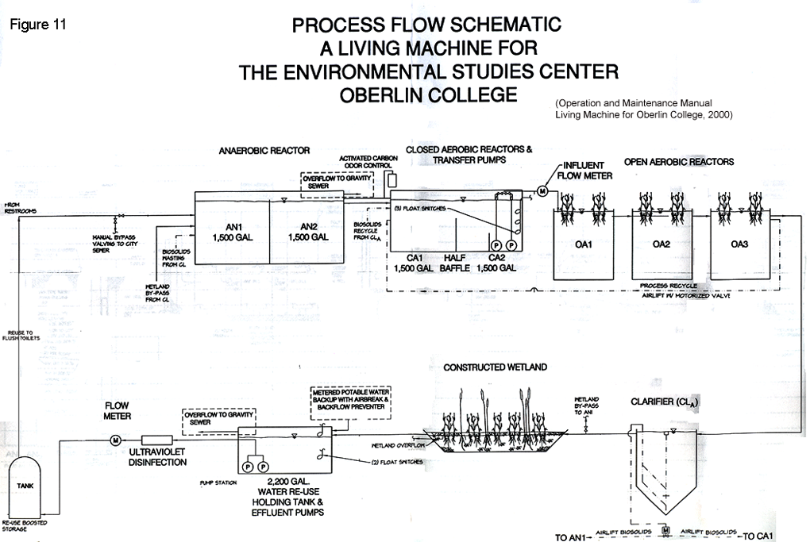

Figure 1

Figure 2: Graph of the average of 3 replicates for initial, intermediate, and final DO readings in CA1, showing linear decrease in DO concentration and standard error among replicates
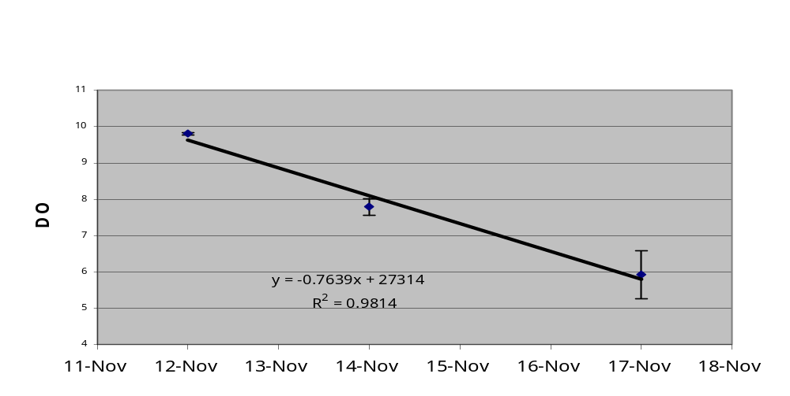

Figure 3: Graph of total BOD over time, showing relationship between changes in BOD and events affecting input to the LM
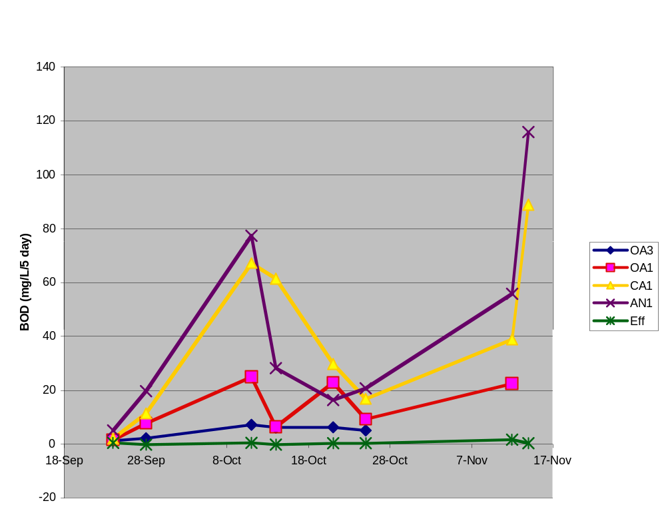
LM DORMANT
LM RUNNING
FALL
BREAK
LM CAMPAIGN

Figure 4: CBOD over time, showing an overall increase in CBOD in AN1, CA1, OA1, OA3.
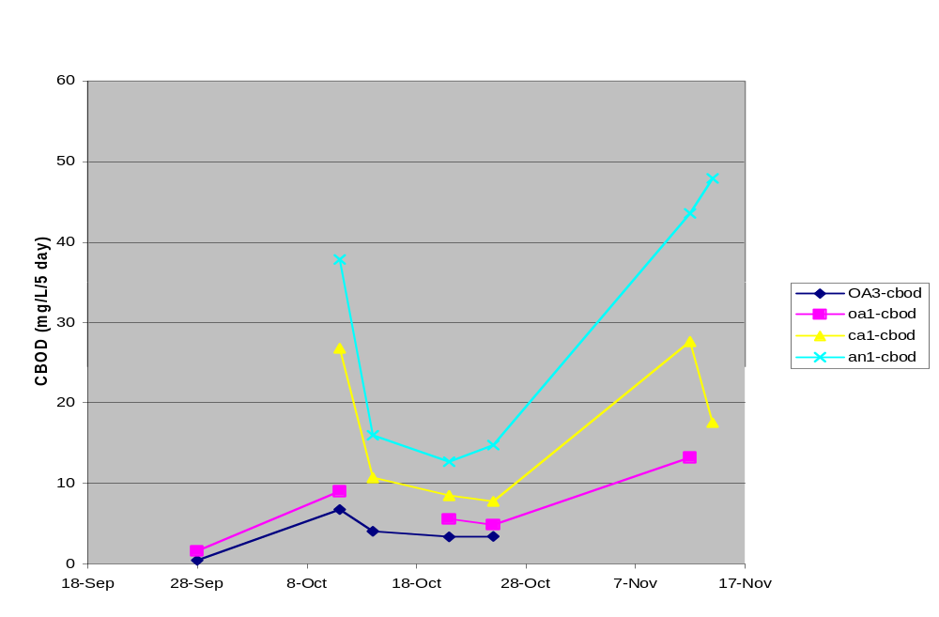

Figure 5: NBOD over time, showing an overall increase in AN1, CA1, OA1, and OA3 over the entire sampling period, with a drop in AN1, CA1 and OA1 during Fall Break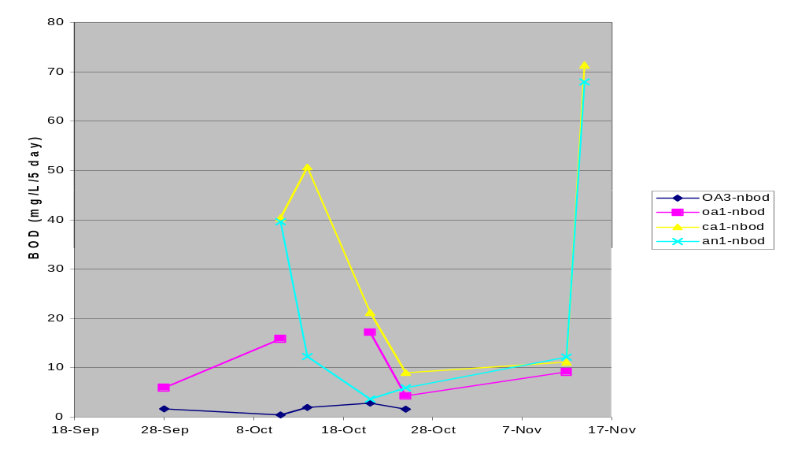

Figure 6: Coefficient of Variation for each tank over time reflecting a decrease in the variability of BOD as wastewater is processed by the system. The high variability of the Effluent tank is due to experimental error within the DO probe.
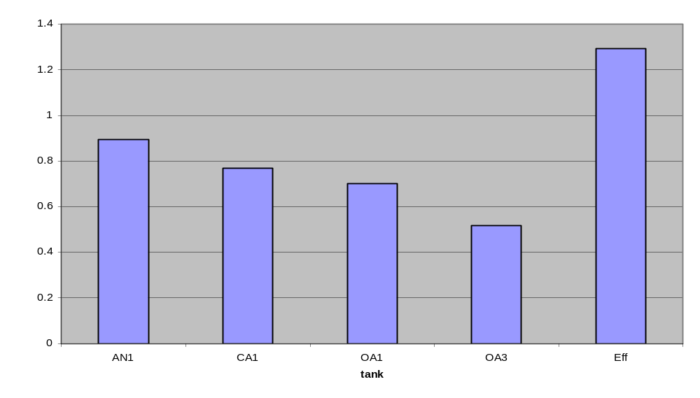

Figure 7: Average BOD over space showing an average decrease in BOD as wastewater progresses through the system.
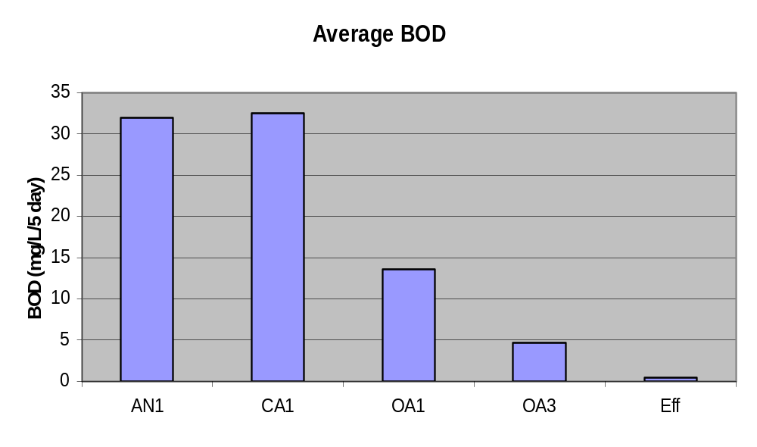

Figure 8: Comparison of average total BOD, CBOD, and NBOD showing a general decrease over space. Carbon metabolism drops steeply from AN1 to OA1, but slows in the OA tanks while nitrification increases in CA1 and then drops steeply thereafter.
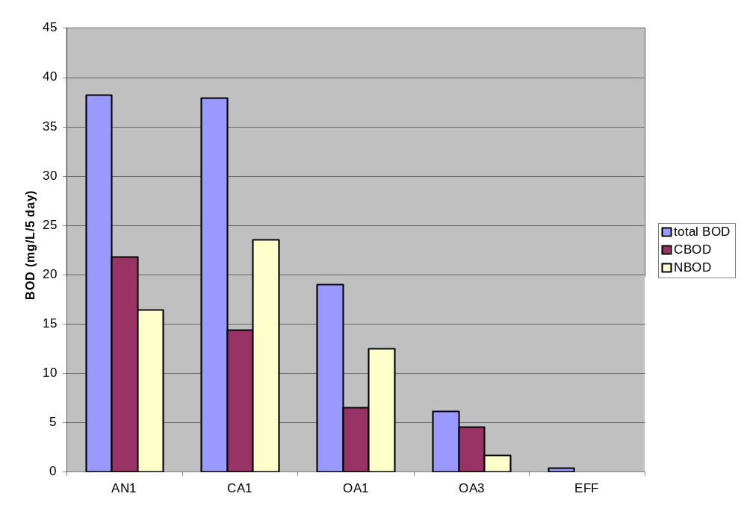

Figure 9: Strong correlation between NBOD and Ammonium concentrations over space.

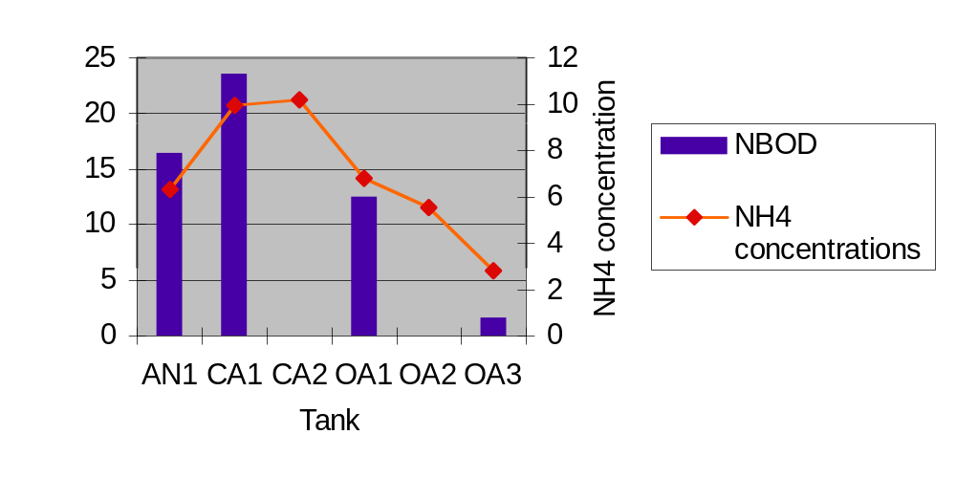

Literature Cited

Austin, D. 2000. Operations and Maintenance Manual: Living Machine for Oberlin College. Oberlin, OH. Oberlin College.
Brix, H. 1993. Macrophyte-Meidated Oxygen Tranfer in Wetlands: Transport Mechanisms and Rates. Constructed Wetlands for Water Quality Improvement. Ann Arbor. Lewis Publishers.
Clesceri, L.S., Greenberg, A.E., and A.D. Eaton. 1998. Standard Methods for the Examination of Water and Wastewater. 20th ed. American Public Health Assoc., American Water Works Assoc., Water Environment Federation.
Crites, R and Tchobanoglous, G. 1998. Small and Decentralized Wastewater Management Systems. Boston. McGraw-Hill.
Hunter, R.G., Combs, D.L and D.B. George. 2001. Archives of Environmental Contamination and Toxicology, 41: 274-281
Kolker, K., Monk, J, and E. Tong. 2000. Carbon Dynamics in Oberln College’s Living Machine: Biological Oxygen Demand (BOD) and Total Systems Metabolism (TSM). Unpublished.
Maly, A, Wright, K, Teter, J and Gershik, V. 2001. Nutrient Dynamics in the Living Machine. unpublished.
Narkis, N., Rebhun, M., and C. Sheindorf. 1978. Denitrification at various carbon to nitrogen ratios. Water Research, 13: 93-98 [I can’t find this citation in your paper]
Neralla, S., Weaver, R.W., Lesikar, B.J., and R. A. Persyn. 2000. Improvement of domestic wastewater quality by subsurface flow constructed wetlands. Bioresource Technology, 73: 19-25
Peterson Petersen!, J.E. and C.C. Chen. 1999. A method for measuring depth-integrated community metabolism in experimental planktonic-benthic ecosystems. Journal? Volume?
Ramalho, R.S. 1983. Introduction to wastewater treatment processes. N. Y. Academic Press.
Reddy, K.R., Patrick, W.H., and C.W. Lindau. 1989. Nitrification-Denitrification at the Plant Root-Sediment Interface in Wetlands. Limnology and Oceanography, 34: 1004-1013
Sedlak, R. 1991. Phophorous and Nitrogen Removal from Municipal Wastewater: Principles and Practice. N.Y. The Soap and Detergent Association.
US EPA. 1976. Process Design Manual for Nitrogen Control. Washington, DC. Office of Technology Transfer, US EPA.
Verhoeven, J. A. T., and A. F. M. Meuleman. 1998. Wetlands for wastewater treatment: Opportunities and limitations. Ecological Engineering, 12: 5-12
Yang, Z., Suzuki, H., Sasaki, S., McNiven, S., and Karube, I. 1997. Comparison of the dynamic transient- and steady-state measuring methods in a batch type BOD sensing system. Sensors and Actuators B, 45: 217-222.
Young, J.C. 1973. Chemical methods for nitrification control. Journal/ Water Pollution Control Federation, 45: 637-646.

GROUP CONTRIBUTION

All members of the research group performed an equal amount of work on this project. Specifically, each member gathered samples and ran the same number of BOD tests. We worked as a team to quantify and analyze our data. Spreadsheets and graphs were created as a group and conclusions were drawn from this information together. Work was divided evenly for the production of the paper. Juliette focused on background information, while Ruth and Jess worked on the discussion. All members gathered research sources and shared information from their findings. The final paper was edited by all members. The presentation was divided evenly among members and then synthesized by the group. All group members feel that contributions were equitable.

Ruth, Juliette, Jessica

See specific comments in text. It is clear that the three of you completely wrapped your head around this topic and thought deeply about the patterns, mechanisms and implications. Excellent analysis. Good suggestions for future study. Overall comment: outstanding work!

