Soil analysis of an urban landscape to evaluate its potential in supporting an educational low-input, high-yield biofuel garden.
[Fine title, but given the scope of your work, it would be nice to get something in the title about recommendations for crop selection, management, education and research.
E. D. Hoffman, G. Skoirchet, and L. S. Williams
December 15, 2008
Abstract
Considering the U.S.’s unsustainable reliance on fossil fuels and its role as one of the largest global CO2 emitters, the need for alternative and renewable energy resources is imperative. Research has been done on low-input and high-yielding plants that can be converted into biofuels, such as perennial grasses: Panicum virgatum (switchgrass) and Miscanthus giganteus and hardwood trees: Salix spp. (willow) and Populus spp. (poplar). We propose Oberlin College create an educational biofuel garden featuring these four plants on the site north of the AJLC Annex, which could serve as a research and educational tool for Oberlin students, faculty and the greater community. We took initial measurements to quantify soil organic matter (SOM), pH and soil texture of the AJLC Annex landscape in order to establish baseline data for future research. The pH and %SOM levels we found are suitable for growing these four biofuel plants [should say something about variability]. In this report, we will provide background information about each biofuel plant, baseline soil analysis data from the AJLC Annex site, recommendations for how to cultivate and manage the garden, potential garden designs and future potential research. This garden could provide a framework [not clear what “framework” might mean in this context] for future researchers to examine the effects of growing different biofuel crops on the soil and to examine how different soil properties affect the growth of the crops. For example, researchers could examine changes in pH and %SOM over time.
[Nicely worded abstract. However, you should also say something about recommendations regarding planning, for example, “we conclude that the educational and research value of the site can be maximized by planting multiple crops in combination and we explore the educational, research and aesthetic advantages and disadvantages of several alternative planting arrangements.”]
Introduction/Background
In light of the non-renewable and environmentally degrading nature of fossil fuels, biofuels are becoming an increasingly worthwhile alternative fuel source (Giampietro et al., 1997). Biofuel results from the conversion of plant biomass to energy, a process that, if conducted with zero fossil fuel inputs, has a net CO2 [CO₂] emission of zero (Kamm, 2004) [most biofuel production in the U.S. via corn and soybeans, has a very low solar/fossil fuel energy return on investment (EROI). This is a critical thing to consider and should be addressed, even in one sentence]. A biofuel is considered any type of fuel that can be produced from a biomass substrate and that can be either mixed with or replace fossil fuels (Giampietro et al, 1997). Biofuel can be used as a solid fuel source, to be burned to make heat or electricity, and as a liquid fuel source such as ethanol and biodiesel. Perennial grasses such as Panicum virgatum (switchgrass) and Miscanthus x giganteus and hardwood trees such as Salix spp. (willow) and Populus spp. (poplar), are considered useful biofuel crops (Kamm, 2004). These plants can grow in temperate to warm climates, yield high amounts of biomass relative to corn and soybean and promote soil fertility through carbon sequestration (Yates, 2008). [Two additional key issues you need to address: 1) make the case that these crops can be grown with relatively low fossil fuel input in the form of fertilizer, pesticide, mechanical equipment, transportation and processing. 2) make case that they are high yield (productivity/area) and, as perennials, can be grown on marginal lands that would not be suitable for growing food crops – this second point is critical given the political tensions around the “food vs. fuel” debate.]
Short-rotation woody crops and herbaceous perennial crops have received much attention for their potential to be converted into alternative fuels as well as their range of environmental benefits. Crop cultivars and herbaceous perennial biocrops can improve soil fertility and decrease soil erosion (Tolbert, 1995). These biocrops can also reduce global levels of green house gases due to their ability to sequester carbon below ground [if the upper portion is being burned, then it is not, ultimately, sequestering (storing long term) carbon]. Additionally, these plants serve to provide cover and habitat for wildlife and are generally less demanding of water, fertilizer and energy [how are you distinguishing energy – probably good to enumerate energy inputs (see above) and then discuss which are reduced] than corn, a major ethanol source (McLaughin, 1992; Tolbert and Downing, 1995). Furthermore woody and herbaceous perennial crop species are not seen as competitors for agricultural land, due to their ability to grow in and improve degraded soil (Tolbert and Schiller, 1995). [OK, you have this covered!].
When selecting biofuel species it is important to consider plant-soil interactions, especially their potential to sequester carbon [good]. Corn must be replanted annually after harvesting, however, perennial grasses and trees require only a harvesting of their above ground biomass allowing for retention of below ground carbon (Sciencedaily, 2008) [Only the above ground portion of corn is harvested too – you need to make the case that the perennials put more organic matter into the soil]. A high cellulose content, necessary for making ethanol, is another important factor defining biofuel crop candidates that will be used to create liquid fuels (Kintisch, 2008). Annual planting associated with traditional biocrops like corn, degrades soil quality, increases erosion and releases carbon into the atmosphere, contributing to global green house emissions. Perennial grasses such as switchgrass and Miscanthus yield more net usable energy per acre [i.e. higher EROI] than biodiesel derived from corn or soybeans (NSF, 2006). Tree species such as poplar and willow that exhibit rapid growth and have the ability to re-sprout continuously are ideal harvesting and converting into a solid fuel source (Mercker).
[How did you select these particular four – would be nice to have a larger list and then the set of criteria you used to come up with these four] Each of the four biocrop species we examined require minimal fertilizer and herbicide inputs during their establishment phases and minimal long term soil amendments. These characteristics make them ideal candidates for growing in an urban setting with marginal soils [good]. We have included a detailed profile (Appendix 1) for each plant that can be referred to. These profiles should be referred to during crop cultivation and management, and can be combined with observed baseline soil measurements when developing future research projects.
We set out to establish a baseline pH, soil organic matter (SOM) and soil texture at the proposed garden site, to assess heterogeneity of soil properties at the site, and to assess conditions on a reference site on the same property that will not be planted with biofuels. SOM in particular is an important characteristic governing soil health, and will help us infer whether the AJLC landscape is suitable for growing crops. This information, and a thorough literature search, helped us to make informed decisions about which biocrops this garden should include.
Finally, we made recommendations on garden design, crop management (mono vs. poly) and future research to assess effects of biofuel crops on soil development. These decisions should take both aesthetics as well as procedural components associated with research when considering different design and cropping possibilities.
Implementation of an educational biofuel garden at Oberlin would offer students, faculty and the community opportunities to learn about the botany, ecology and environmental benefits of biofuel crops and their application as an alternative fuel option. The proposed garden would be situated on the northern turf of the AJLC Annex landscape, adjacent to the environmental studies center. The proposed garden should take into account educational and research purposes as well as aesthetics of the garden. [Great!]
Methods
In order to measure spatial variability in pH and %SOM across the AJLC Annex landscape, we created a sampling grid. The north site was partitioned into twelve 5 x 5.5 meter plots, and the south site into two 11 x 5 meter plots (see Figure 1). Within each plot, we took five subsamples in order to capture heterogeneity within each plot. One subsample was taken at the exact center of each plot and at four points radiating out from the central sample site (each 0.5m from central sample site, aligned with lines of intersecting X drawn from the four corners of the sample plot) (see Figure 1). Each subsample was collected to a 15 cm depth using a soil corer with a 2 cm diameter. The five subsamples were combined into one representative sample of each plot. We had to occasionally repeat attempts at subsamples because the soil was rocky and would sometimes jam the corer. We allowed these samples to air-dry (24 h) and then determined pH using the potentiometer method (using a Vernier LabPro pH sensor) as outlined in Methods of Soil Analysis (Klute, 1986). We determined %SOM using the loss-on-ignition method as described in Methods of Soil Analysis (Klute, 1986).
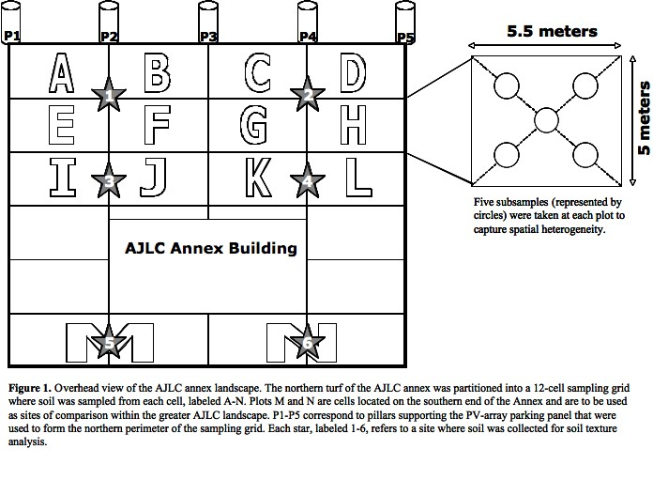
We sampled for soil texture at six points (see Figure 1) because we expected there would be less heterogeneity within the landscape for soil texture [explain why]. We dug out the first 10 cm of soil at the sampling points in order to avoid organic matter and then collected 1 auger-full of soil. Each sample was dried (105° C for 24 h) and ground for texture analysis. We determined texture according to the Bouyoucos densimeter method (Klute, 1986) and determined soil class using a soil class pyramid.
Results
pH and %SOM
We found some variation in pH between the north and south sites (see Figure 2). pH at the biofuel garden site was higher, ranging from 7-7.8 while the south site was acidic, with site M at 6.0 and site N at 6.9. The optimum range for Miscanthus is pH 5.5 to 7.5, but is tolerant of a wide range, so we won't need to modify the pH of the soil (DEFRA, 2007). Switchgrasses can tolerate a wide pH range as well, but slightly acidic soil is optimum (Lawrence et al., 2006). We were unable to find optimum pH ranges for willow and poplar, but predict that they should be able to grow within this moderate pH range. [These are conclusions/points of discussion rather than results. In the results section you should simply state your findings and in the discussion section you should discuss their implications for planting. Given the scope of your work, there may be some justification for a non-standard overall report format, but it still makes sense to have results as a simple statement of findings without analysis. You could then divide discussion into a section analyzing the implications of the soil and a different section making more general recommendations regarding the garden]
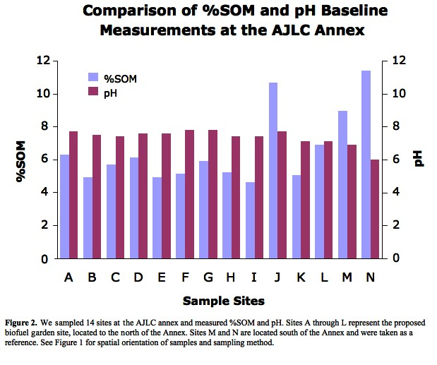
[In figure above, refer reader back to figure #1 to explain lettering]
We found that the %SOM ranged from 4.6% to 11.4% across the landscape (see Figure 2). Since the average %SOM over the proposed biofuel site is 6%, we expect that the four crops will be able to grow here, because the threshold for adequate soil fertility is typically about 5% SOM (Petersen).
We did a linear regression of pH x SOM among the plots and found that there was a weak inverse relationship between these variables (the R2 value was 0.33) (see Figure 3).
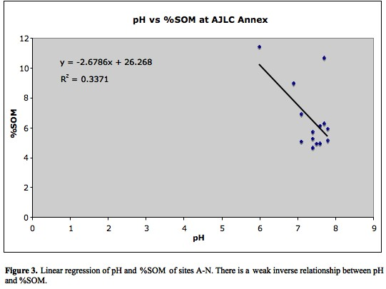
[Fill the graph so that it does not have wasted space. If you have no points below 5, then you should graph from 5-9. You report too many significant figures in your regression equations and R2 values. In your analysis of findings (discussion section), you should explain these findings]
Soil Texture
We found that soil texture over the landscape is heterogeneous, with the biofuel garden site ranging from clay to clay-loam and the south site as clay loam and silty clay loam (see Figure 4). On average, the biofuel garden site is 39.6% clay, 26.6% silt, and 33.8% sand. Miscanthus has been reported to produce high or reasonable yields on a range of soils (DEFRA, 2008), so we expect it to tolerate the conditions of the Annex landscape. Switchgrass grows best on well-drained loam and sandy loam soils but can also tolerate a range (Lawrence et al., 2006). Willow and poplar seem to be more constrained by moisture than texture (OSU; Abrahamson, 2006). The clay-rich soils of the Annex will tend to hold water, which will be advantageous for growing willow and poplar. [Again, good analysis, but the analysis should be in the discussion and not the results section]
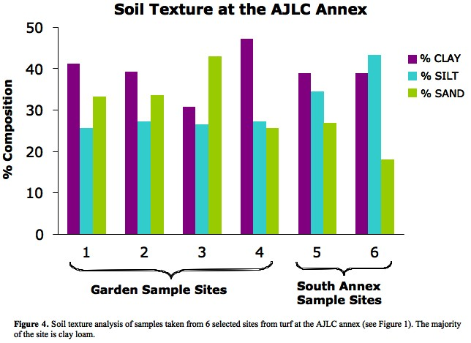
Discussion:
[This is where you should analyze the meaning of your results]
Recommendations:
Planting and Management
We chose to include these specific four biofuel crops in the potential biofuels garden design because they require fairly low management input, can grow in marginal soils and in a range of climates, produce significant amounts of biomass fast and sequester carbon (see Appendix 1 for more details).
The soil texture analysis showed heterogeneity in the soil in the north AJLC annex site. Before any garden construction begins, we recommend thoroughly homogenizing the soil by tilling the site. This will help have more consistent and dependable data for comparison experiments conducted on the site in the future that examine change in soil properties as a function of species. Tilling would also help improve drainage, which is desirable for growing switchgrass (Lawrence et al., 2006). In order to address topographic inconsistencies at the site, we also recommend that the ground be leveled before planting crops.
We also propose that the soil receive some amendments in order to increase fertility. Both Miscanthus and switchgrass require fertilizer during the establishment years in order to sufficiently build up their rhizomes (see Appendix 1 [nice appendix]). [How do you propose amending the soil?]
Also, both willow and poplar have high water demands (Abrahamson, 1998; OSU website), so irrigation might be appropriate, especially during the establishment phase.
Setbacks associated with monocropping involve intensive management during the initial establishment phase. We recommend exploring different crop cultivation techniques with relation to polycropping and intercropping. Switchgrass in particular has been shown to yield greater above ground biomass and sequester more carbon below ground when planted in a mixed grass environment (Tilman, 2006). We recommend planting monocrops and polycrops of various switchgrass species, including genetically modified, hybrid and Ohio native species. [Do we have space to do this?]
Appendix 3 contains useful guides for planting strategies for each biofuel crop.

Garden Design
[Would be ideal to set out a very clear set of objective criteria for assessing the design in terms of education, research, aesthetics, etc (e.g. yield, input, ease of harvesting, C sequestration, etc.). and then apply these criteria to assess each plant individually and then in combination.]
There are endless possibilities for potential garden designs, however there are some important factors to consider when designing an appropriate garden layout. Necessary factors to consider are Miscanthus' significant height over switchgrass, switchgrass' extensive root system, and poplar and willow's height, which could cause over-shading. Because Miscanthus grows significantly taller than switchgrass, we recommend planting it to the north of the switchgrass plot. Willows and poplars, at maturity, [need recommendations regarding when to harvest; if they are regularly cut down in stature, then they may never get tall. How are people growing them?] are tall and can shade out shorter plants; we suggest planting them on the perimeter of the garden.
Due to the confines of the small area available, it is necessary to consider how many different crop combinations can be grown while having enough of each individual crop to be able to get any sort of scientific data [good]. For example, just planting two or three willows scattered along the edges of the garden will not be enough to study soil dynamics beneath the trees, however, the site may be too small to grow multiple rows of willows.
Because the garden will also be an educational tool to the greater public, it is also important to take aesthetics into account for the design. The garden and each individual plot should be accessible for research soil sampling as well as easy viewing access for visitors. For research reasons, it would be most practical to plant each crop in rectangular plots in rows (see Appendix 2: Garden Designs).
Future Research
The biofuels garden could serve as a valuable tool for future research. There has already been a lot of research done with biocrops (Karp and Shield, 2008), but none about how these four specific plants grow in close proximity and in these soil conditions. Due to the limited size of the garden site, research on the actual production of biofuels may not be appropriate because one would need multiple large scale plots to get any respectable data on conversion of biomass to fuel. In light of this, we suggest future studies focus on how different biofuel crops and planting strategies affect soil fertility and how much carbon they sequester in their biomass and in the soil relative to each other [excellent recommendation].
Further studies should continue to monitor the variables we measured in the baseline study [presumably, if your advice regarding homogenization is followed up on, a new set of samples would need to be taken to establish baseline conditions]. In general, we predict that as biomass accumulates in the soil, pH should decrease due to the increase in labile carbon, which would lead to an increase in the acidic products of microbial activity [get more specific in mechanisms, e.g. soil decomposition and uptake of base cations]. We also would expect to see %SOM to increase as pH decreases based on the relationship we saw in baseline measurements among the sites. [Causality is probably reversed here – pH decreases as SOM increases as a result of decomposition of SOM]
Since plants increase stored carbon pools both through their below ground rootstock and by increasing SOM (Clifton-Brown et al., 2007) [be clearer on how you are distinguishing these], SOM might not be an appropriate measure for total below ground carbon sequestration among the biofuel crops in the garden, but could be useful for determining how these biofuel crops add fertility. SOM might be added more quickly depending on the roots' surface area and to the degree that biomass gets incorporated into the soil [Note: can use, “in growth cores” to measure root biomass as well as SOM. In growth cores need to be set in the ground before the plants are established. They then get yanked, including rood tissue. . This could vary tremendously among the trees and grasses. If estimating carbon sequestration is a goal of future studies, they could estimate total biomass of a tree crop using the mean-tree technique (Fang et al., 2007), which involves destructive sampling of trees, that best represent the mean tree-size of the crop [Good ideas[. This procedure might be difficult to do at this small-scale garden but it could be the most effective way of correctly estimating carbon storage (Fang et al., 2007). Biomass for the grasses can be estimated by excavating a given area of soil, separating out the roots, and measuring the biomass (Clifton-Brown et al., 2007). Other studies could focus on methods of harvesting and the quantity of only the above-ground biomass, which could be logistically easier to do.
We expect the most below-ground carbon sequestration to be associated with switchgrass due to its extensive root system (Parish et al, 2005) [does this study actually compare this species against specific group of others you are considering, or does it merely indicate that switchgrass has high belowground accumulation?]. We predict that the perennial grasses in general will sequester more carbon (above and below ground) than the tree species because carbon storage in poplar plantations has been measured at about 1.247 tC ha-1 yr-1 (Fang et al., 2007) [all these numbers include both above and belowground?] while Miscanthus's below ground C storage has been estimated at 5.2-7.2 tC ha-1yr-1 (Clifton-Brown et al., 2007). Little is known about below-ground biomass or long-term carbon sequestration for willow (Heller et al., 2003). Future studies can compare how both woody species contribute %SOM, and if feasible, perform mean-tree estimation of biomass.
Educational Possibilities
Not only is the construction of this biofuel garden important for providing research possibilities for students, but it will also play an important role in educating the greater public about biofuel plants by providing an easily accessible, hands-on learning space. The garden may serve to supply general information on biofuels as well as more focused research opportunities to students and faculty. In order for this garden to be fully effective, it should be made accessible to all ages of varying levels of education. We suggest making the garden available as a learning tool to visitors by installing informative plaques which could include species type, management, planting techniques, harvesting, efficiency compared to corn, and the fuel type that the biocrop may be converted to. In order to increase participation in the garden, knowledgeable students could facilitate community workshops and tours of the biofuel garden. In addition, the biofuel garden could be featured in campus tours as part of the AJLC complex.
REFERENCES
Abrahamson, L., Robison, D., Volk, T., et al. 1998. Sustainability and environmental issues associated with willow bioenergy development in New York (USA). Biomass & Bioenergy. 15:17-22.
Catalano, Cosmo. The Power of Poplar, The Biofuel Tree. July 2008. Energy.
Clifton-Brown, J., Breuer, J., and Jones, M. 2007. Carbon mitigation by the energy crop, Miscanthus. Global Change Biology 13:2296-2307.
DEFRA, 2007; Parish, 2005; OSU; Abrahamson, 1998; Mercker; Karp, 2008; Pyter et al., Growers Guide; Iowa State University, 2003; Fege, 1983.
Fang, S., Xue, J., and Tang, L. 2007. Biomass production and carbon sequestration potential in poplar plantations with different management patterns. Journal of Environmental Management 85:672-679.
Fege, Anne. The Practice and Physiological Basis of Collecting, Storig and Planting Populus Hardwood. Graduate Research Assistant, Department of Forest Resources, University of Minnesota, St. Paul, MN, 1983.
Giampietro et al. Feasibility of Large-Scale Biofuel Production. BioScience 47:9 1997. p.587-600.
Hansen, Edward A., ed. Intensive plantation culture: 12 years research. Gen. Tech. Rep. NC-91. St. Paul, MN: U.S. Department of Agriculture, Forest Service, North Central Forest Experiment Station: 1-11. 1983.
Heller, M., Keoleian, G., and Volk, T. 2003. Life cycle assessment of a willow bioenergy cropping system. Biomass and Bioenergy 25:147-165.
Kamm, J. A New Class of Plants for a Biofuel Feedstock Energy Crop. Applied Biochemistry and Biotechnology. 113-116 2004.
Karp, A. and Shield, I. 2008. Bioenergy from plants and the sustainable yield challenge. New Phytologist 179:15-32.
Kintisch, Eli. Sowing the Seeds for High Energy Plants. Science 25 April 2008: Vol. 320. no. 5875, p. 478.
Klute A. 1986. Methods of Soil Analysis Part I. American Society of Agronomy. Madison, Wisconsin. 404-411.
Klute A. 1986. Methods of Soil Analysis Part III. American Society of Agronomy. Madison, Wisconsin. 485-487, 1004-1006.
Lawrence, J., Cherney, J., et al. Establishment and Management of Switchgrass. Agronomy Fact Sheet Series: Fact Sheet 20. Cornell University Cooperative Extension (US); [updated 2006; cited 2008 Dec 7]
Available from: nmsp.css.cornell.edu/publications/factsheets/factsheet20.pdf
Lewandowski et. al., Miscanthus: European Experience With a Novel Energy Crop. Biomass and Bioenergy. 19:4 2000. p.209-227 (info for table on miscanthus)
McLaughlin, S.B., and M.E. Walsh. Evaluating Environmental Consequences Of Producing Herbaceous Crops For Bioenergy.
Mercker, David. Extension Specialist. Department of Forestry, Wildlife and Fisheries. Biofuels Intiative: Short Rotation Woody Crops for Biofuel. The University of Tenessee Agricultural Experiment Station.
Ohio Trees: Populus (Poplar). Ohio State University Extention Service (US); [cited 2008 Dec 7]
Available from: http://ohioline.osu.edu/b700/b700_20.html
Parish, D., and Fike, J. 2005. The Biology and Agronomy of Switchgrass for Biofuels. Critical Reviews in Plant Sciences. 24:423-459.
Petersen, John. Personal communication. (Dec 10, 2008).
Planting and Growing Miscanthus: Best Practice Guidelines. Department for Environment and Rural Affairs (UK); [updated 2007 Jul; cited 2008 Dec 7]
Available from: www.defra.gov.uk/erdp/pdfs/ecs/miscanthus-guide.pdf.
Press Release 06-171. 2006. Mixed Prairie Grasses Better Source of Biofuel Than Corn Ethanol and Soybean Biodiesel. http://www.nsf.gov/news/news_summ.jsp?cntn_id=108206
Rich Pyter, Tom Voigt, Emily Heaton, Frank Dohleman, and Steve Long. Growers Guide. Growing Giant Miscanthus in Illinois. University of Illinois.
Science News: Replacing Corn With Perennial Grasses Improves Carbon Footprint of Biofuels. ScienDaily. 2008
Tolber V.R., and A. Schiller. Environmental Enhancement Using Short- Rotation Woody Crops and Perennial Grasses as Alternatives to Traditonal Agricultural Crops. From Environmental Enhancement Through Agriculture: Proceedings of a Conference, Boston, Massachusetts, November 15-17, 1995, Center for Agriculture, Food and Environment, Tufts University, Medford, MA.
Tolbert, V.R., and M.E. Downing. 1995. Environmental effects of planting biomass crops at larger scales on agricultural lands. Proceedings of the Second Biomass Conference of the Americas: Energy, Environment, Agriculture, and Industry, Portland, Oregon. NREL/CP-200-8098. National Renewable Energy Laboratory, Golden, Colorado. pp. 1628-1635.
Yates, D. 2008. Miscanthus can meet U.S. biofuels goal using less land than corn or switchgrass. News Bureau: University of Illinois At Urbana-Champaign. 2008.

Appendix 1: Biofuel crop properties (see attached document)
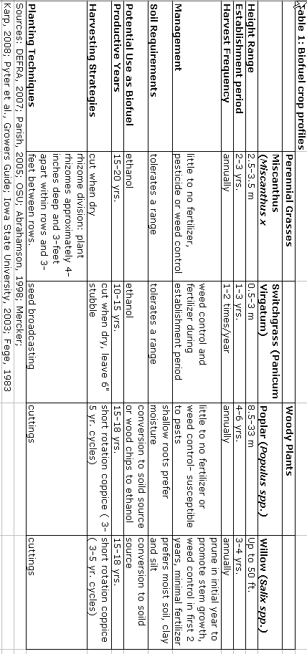
Appendix 2: Garden Designs
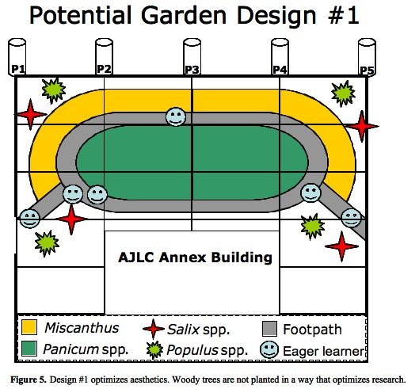
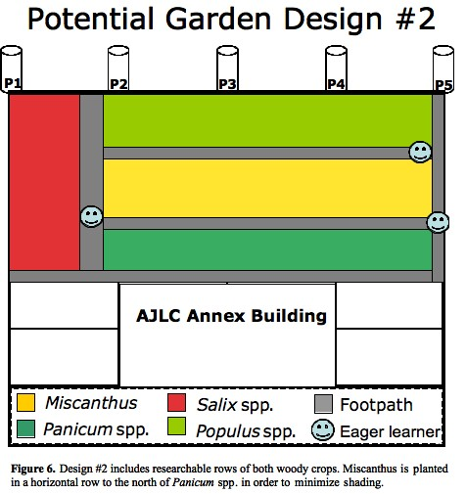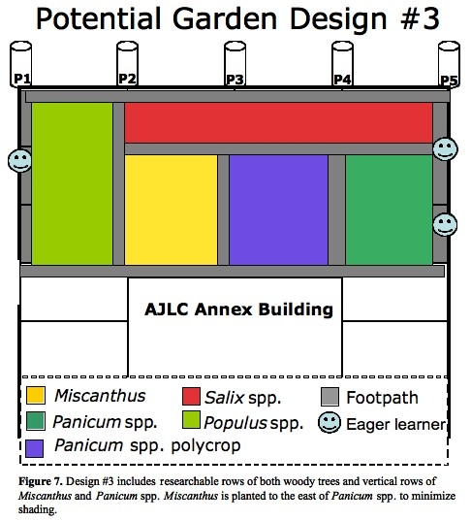

[It would be very helpful to have pros and cons of each design explained, perhaps in a table]
Appendix 3: References for further management
Switchgrass
Management Guide for the Production of Switchgrass for Biomass Fuel in Southern Iowa
Prepared by Alan Teel, Extension program specialist, and Stephen Barnhart and Gerald Miller,
Extension agronomists. Revised by Stephen Barnhart. May 2003.
http://www.extension.iastate.edu/Publications/PM1710.pdf
Miscanthus
Best Practice Guidelines For Growing Miscanthus Under the Bioenergy Scheme (BES). http://www.lcea.ie/docs/2006/2006/JJ%20Leahy.pdf
http://www.agriculture.gov.ie/schemes/bioenergy/BESTPRACTICEMANUALFORMISCANTHUS(2009).doc. Energy Solution Conference 2006.
Poplar
http://www.forestry.gov.uk/srcsite/infd-5jvdnw
Wene, E., Berguson, B., and W. Johnson. Agricultural Utilization Research Institute. Growing Hybrid Poplars as a Crop. http://www.auri.org/poplars/poplars.htm
Willow
Energy Scheme: Best Practice Manual for SRC Willow. December 2007.
http://www.teagasc.ie/forestry/docs/financial_info/BESTPRACTICEMANUALFORSRCWILLOW2008.pdf

(Word Count = 2,756)

1. Title & Names of investigators
>Clearly indicates what you did and ideally what you found. [see comments in text
2. Abstract (250 word max)
>Summarizes what you did, how you did it, what you found, and why it is important. [see comments in text
3. Introduction/Background
>Sets context by describing the overall problem that research addresses and appropriately situates this in larger ecological and societal context. Yes, but see comments
>Cites relevant primary and secondary literature to support arguments (minimum of four citations). Yes
>Problem statement establishes gap in knowledge, need for research, and describes how your research fills gap. Yes
>Clearly states mechanistic hypotheses explaining what you expected to observe and why. See comments
4. Methods (revised from proposal)
>Describes what you did in sufficient detail that someone could repeat your experiment. Y
>Answers what, where, when, and how you made your measurements. Y
>Includes diagrams, maps of sampling, tables, timelines as appropriate (only if appropriate). Y, very helpful!
>References literature where appropriate (who’s procedure did you follow?). Y
5. Results:
>Includes text, tables, graphs & figures that describe but do not explain results. [No, see comments on structure of results section – you have merged results with discussion]
>Explains calculations. NA
>Indicates statistical significance. NA
>Does not present same data in both tables and graphs. Y
6. Analysis & Discussion:
>Interprets and critically analyzes your findings. Y, but see comments
>Explores connections between your findings and those of other studies (agreement, disagreement, relevance). Y
>Addresses the usefulness and limitations of the methods you used. OK
>Addresses limitations of findings and suggests further research that might extend or more conclusively addresses your initial hypotheses and findings. Y, excellent
7. Literature cited:
>Uses the same format described in the “How to write ecological site assessments” handout. Y
>Does not use footnotes. Y
8. Figures and figure legends: (tables, graphs, conceptual models, etc. that appear in introduction, results, and analysis & discussion sections)
>Text legend below each figure describes content in sufficient detail that reader can understand what the figure represents without reference to text in manuscript. Y, see comments on graphs
>Symbol legend within the frame of each graphic indicates what different color bars, lines or shapes represent.Y
>Figures are numbered sequentially in the order in which they appear in the paper. Y
>Every figure that appears in paper is directly referenced within the paper. Y
>Units are indicated either within the figures (often in the x and y axis labels) or in the text legend. Y
9. Appendix 1: Division of labor:
>Describes role of each group member in developing and implementing the project. NO!!!
10. General comments:

Elsa, Georgia and Laila:

You have done an excellent job of setting the stage with important background research for work that will almost certainly be conducted; the information, analysis, conclusions and recommendations in your report provide a wealth of useful information for planning implementation. I appreciate the fact that you clearly dug more deeply into the literature between the time you completed your poster and when you wrote this paper. I have made extensive comments within your text regarding how this work might be improved and expanded on.

Your poster presentation was generally quite good. The introduction was well rehearsed and provided excellent context and justification for understanding why this work is important. Something should probably have been said about cellulosic ethanol since the grass crops were presented as an alternative to corn. Presentation of methods came across as slightly less organized. Recommendations were thoughtful. Consider engagement with audience: Elsa maintained excellent eye contact with audience; Laila, generally maintained good eye contact as well ; Georgia, I don’t mean to single you out, but you need to be aware that your eyes were entirely focused on the poster through your part of the presentation and not on audience which makes it a bit more difficult to feel engaged as an audience member. Answers to questions demonstrated that your group had thought carefully about the project.

Nice work!

